CAREERLINKAI: AI-DRIVEN CAREER AND COLLEGE COURSE
GUIDANCE PLATFORM SYSTEM FOR SENIOR HIGH STUDENTS

College of Technology
Department of Computer Science
BOHOL ISLAND STATE UNIVERSITY
Calape Campus, Calape, Bohol

CARL DINDO L. CEJAS
JOSHUA JHON JUARIZA

April 2026
CAREERLINKAI: AI-DRIVEN CAREER AND COLLEGE COURSE
GUIDANCE PLATFORM SYSTEM FOR SENIOR HIGH STUDENTS

_________________

A Thesis Presented to the
Faculty of the College of Technology
Department of Computer Science
BOHOL ISLAND STATE UNIVERSITY
Calape Campus, Calape, Bohol

_________________

In Partial Fulfillment
of the Requirements for the Degree
in Bachelor of Science in Computer Science

CARL DINDO L. CEJAS
JOSHUA JHON JUARIZA

April 2026
CHAPTER I

INTRODUCTION
Background of the Study
The Philippine K to 12 system has formalized Senior High School as a stage where learners choose pathways aligned with their interests and aspirations. The Department of Education (DepEd) recognizes career guidance as a structured program supporting responsible decision-making, including strand selection and curriculum exit choices. To complement school-based guidance, DepEd administers the computer-based National Career Assessment Examination (CB-NCAE), which includes an interest inventory (CORE-A) explicitly aligned with the RIASEC typology, a formal policy-level recognition that theory-grounded interest assessment is relevant and applicable to Filipino learners.
The assessment design of CareerLinkAI rests on two empirically validated frameworks in career psychology. The first is Holland's (1997) RIASEC model, a person-environment fit theory classifying individuals and occupational environments across six dimensions: Realistic, Investigative, Artistic, Social, Enterprising, and Conventional, with over six decades of cross-cultural validity and predictive power over career choice and academic performance (Lasselle et al., 2021; Wei, 2024). The second is Social Cognitive Career Theory (SCCT), developed by Lent, Brown, and Hackett (1994) and rooted in Bandura's (1986) social cognitive theory, which posits that career interest formation and choice-making are shaped by self-efficacy beliefs, outcome expectations, and perceived barriers all moderated by contextual factors such as family dynamics, socioeconomic realities, and institutional environments (Lent et al., 2000; Wang et al., 2022). Together, these frameworks are theoretically mutually reinforcing: RIASEC maps student interests onto career environments with structural precision, while SCCT adds the cognitive and motivational layer, addressing the recognized limitation that interest-environment matching alone fails to predict actual career choice when self-efficacy or outcome expectations are low (Lent & Brown, 2019; Jemini Gashi et al., 2023).
Despite existing policy frameworks and assessments, many students still struggle to translate results into actionable plans, whether selecting an SHS strand, identifying a college program, or clarifying a career direction. CareerLinkAI is a digital intervention developed to address this need: an AI-driven web application that integrates a structured RIASEC interest assessment, SCCT-grounded self-efficacy and outcome expectation questions, academic profiling, and an explainable AI recommendation engine designed to complement rather than replace the work of human counselors and teachers at Calape National High School.
Objectives of the Study
The general objective of this study is to design, implement, and evaluate CareerLinkAI, an AI-driven career and college course guidance system for senior high students, and to guide students in its use to improve efficiency in college programs, while assessing its effectiveness, user satisfaction, and acceptance.
Specifically, it was guided by the following specific objectives:
- To determine the processes involved in the current career guidance program of Calape National High School.
- To design and develop a web application of CareerLinkAI for senior high school students.
- To evaluate the usability and acceptability of the application through user testing and feedback, focusing on factors such as ease of use, satisfaction, usefulness, and accessibility.
- To create a user manual for CareerLinkAI to guide students and school personnel in navigating and utilizing the system effectively.
Significance of the Study
The implementation of CareerLinkAI: An AI-Driven Career and College Course Guidance Platform System for Senior High Students aims to address the persistent mismatch between students' interests and abilities and their chosen career paths, particularly among learners at Calape National High School. This study bridges the gap between traditional career assessment practices, such as the National Career Assessment Examination, and modern digital solutions that use Artificial Intelligence to improve career guidance. By integrating structured self-assessment with explainable recommendations grounded in the RIASEC Model and SCCT, alongside student academic profiles, the system provides students with an accessible platform for evaluating their interests, beliefs, and potential career paths, and for receiving personalized career and college course suggestions.
For students, the system provides a structured self-assessment mechanism that helps them better understand their personal interests, strengths, and potential career paths. Through AI-assisted analysis of assessment responses, CareerLinkAI generates recommendations for suitable career fields and college courses aligned with the students' profiles. This guidance supports more informed decision-making regarding academic pathways and future professional directions, ultimately reducing uncertainty in career planning.
Teachers and guidance personnel also benefit from the system's implementation. CareerLinkAI provides individual assessment reports that students may share with teachers and guidance counselors to facilitate more meaningful advising conversations. These insights enable educators better to understand students' interest profiles and self-efficacy levels, thereby supporting more targeted academic and career guidance. The system may also help teachers identify areas where students need additional encouragement or skill development.
At the institutional level, the system benefits the school by providing a scalable, updatable digital guidance tool that supports existing career guidance initiatives. By processing aggregated student evaluation data, school administrators can gain a broader understanding of the career interests and confidence levels of the student population. This information may assist the school in aligning its academic programs, guidance services, and curricular initiatives with students' evolving needs and aspirations.
Furthermore, this study contributes to the academic and technological community by presenting a defensible architecture for an explainable AI-based educational recommendation system grounded in established career development theory. Future researchers and developers may draw on the findings of this study when designing similar systems that integrate Artificial Intelligence, career assessment models, and responsible AI practices in educational environments.
Scope and Limitations of the Study
This study focused on the design and development of CareerLinkAI, an AI-driven career and college course guidance system inspired by the evaluation principles used in the National Career Assessment Examination. The system modernized the traditional career evaluation process by providing a digital platform through which students completed interest and skill assessments and received automated recommendations based on their responses. The study was conducted within Calape National High School, which served as the primary environment for system implementation and evaluation.
CareerLinkAI was developed as a web-based system following a Progressive Web Application (PWA) architecture to ensure portability, accessibility, and usability across various devices, including smartphones, tablets, and desktop computers. The system utilized cloud-based data storage to manage user profiles, assessment responses, and recommendation outputs. Its core functionalities included user profiling (students inputted their Math, English, and Science grades and their current SHS strand); a RIASEC-based interest inventory; SCCT-informed questions addressing self-efficacy beliefs, outcome expectations, and contextual supports or barriers; AI-supported career and college course recommendations; and explanations of recommendation results.
The effectiveness and usability of the system were evaluated through testing, interviews, and feedback collected from participating students. These methods aimed to determine whether the system effectively supported career guidance and improved the efficiency of career decision-making among senior high school students.
Despite its potential benefits, several limitations were acknowledged. First, the implementation and testing of CareerLinkAI were limited to a single school, which might have restricted the generalizability of findings to other institutions with different student populations or guidance practices. Second, although the system incorporated artificial intelligence to generate recommendations, it did not rely on a large locally labeled dataset for advanced machine-learning training; instead, the recommendation mechanism primarily used interpretable matching among RIASEC types, SCCT-derived inputs, student academic profiles, and predefined mappings of career fields to college courses.
Beyond these structural constraints, the recommendations generated by CareerLinkAI were designed to serve as decision-support tools rather than definitive career determinations. Career decisions could also have been influenced by other factors, such as personal circumstances, socioeconomic conditions, family expectations, and local employment opportunities, which were beyond the system’s scope. Additionally, since CareerLinkAI operated as a web-based application, its accessibility depended on internet connectivity and available technical infrastructure.
It was also worth noting that the system's knowledge base relied on predefined mappings among RIASEC categories, SCCT constructs, career pathways, and college programs. As new professions, academic programs, and labor market demands emerged, the system requires periodic updates to maintain the relevance and accuracy of its recommendations.

CHAPTER II

REVIEW OF RELATED LITERATURE
Related Literature
Career guidance is a comprehensive and developmental program that assists students in making informed educational and career decisions (Barrera, 2024). It is a lifelong process through which learners develop competencies and align their interests with career opportunities (Nava-Macali et al., 2019). Schools are central to this process, as structured guidance programs equip students with the knowledge and direction needed for career readiness (Uyen & Thu, 2025). Teachers further contribute by serving as role models who shape students' interests and aspirations and provide career-related advice (Zeb et al., 2021). However, socio-economic inequality remains a persistent barrier, as students from low-income families often face limited access to guidance resources, making digital and school-based interventions especially critical (Lee et al., 2021).
One of the most empirically validated frameworks in career psychology is Holland's (1997) RIASEC model, which proposes that individuals and occupational environments can each be classified across six personality types: Realistic, Investigative, Artistic, Social, Enterprising, and Conventional, and that career satisfaction, performance, and persistence are highest when a person's interest type aligns with their work or academic environment. Lasselle et al. (2021), working with 1,306 secondary school students across 18 schools, confirmed the structural validity of Holland's hexagonal model and demonstrated that RIASEC interest profiles meaningfully differentiate students' educational and career inclinations. Wei (2024) further strengthened this foundation by applying machine learning to RIASEC data and finding that personality-interest congruence significantly predicts academic performance in chosen disciplines, establishing a direct empirical rationale for combining interest assessment with academic grade inputs, as CareerLinkAI does. Notably, DepEd's own NCAE interest inventory (CORE-A) is explicitly aligned with RIASEC constructs, positioning the framework not as a borrowed Western model but as a locally endorsed basis for career interest assessment in the Philippine context.
Social Cognitive Career Theory (SCCT), developed by Lent, Brown, and Hackett (1994), serves as the second theoretical pillar of CareerLinkAI. Rooted in Bandura's social cognitive theory, SCCT explains how career interests form and how choices are made through three interlocking constructs: self-efficacy beliefs, outcome expectations, and personal goals, all of which are moderated by contextual factors such as family support, financial constraints, and institutional barriers (Lent et al., 1994; Wang et al., 2022). The theory is organized around an interest model, a choice model, and a performance model, collectively explaining why students with identical interest profiles may make markedly different career choices depending on their perceived supports and barriers (Lent & Brown, 2019). Empirically, SCCT has accumulated over 6,000 citations and has been validated across diverse populations, including adolescents. Jemini Gashi et al. (2023) demonstrated, through an intervention study with 47 high school students, that SCCT-grounded career guidance activities produced significant improvements in career self-efficacy, outcome expectations, and goal clarity, validating the practical utility of translating SCCT constructs into structured guidance tools such as CareerLinkAI.
Also, the integration of RIASEC and SCCT within CareerLinkAI is deliberate: RIASEC provides the structural interest-mapping layer, while SCCT supplies the motivational and cognitive layer. Together, they address a recognized limitation of interest-only assessments that interest-environment matching alone fails to predict actual career choice when self-efficacy or outcome expectations are insufficient (Lent & Brown, 2019; Jemini Gashi et al., 2023). Augmented with students' academic grades and SHS strand information, this dual-theory approach allows CareerLinkAI to generate recommendations that are simultaneously interest-aligned, motivationally calibrated, and academically informed.
Moreover, the advancement of technology has made digital tools increasingly integral to career guidance. AI-driven platforms can deliver personalized career recommendations by analyzing students' skills, interests, and academic performance, offering continuous support and improved accessibility beyond what traditional methods allow (Reddy et al., 2025). Ibrahim (2023) described AI as capable of simulating human intelligence to support decision-making, reduce bias, improve accuracy, and provide tailored guidance pathways. Web-based AI systems further enhance accessibility by operating through browsers without requiring installation, making them practical for school-based deployment, precisely the model CareerLinkAI adopts.

Input
Process
Output
Outcome
- Research Design/Method of Research
- Collection of Data
- Creation of Draft Design
- Application of Software Development Life Cycle

- Identification of Challenges in Career Choice
- Problem Statement and Opportunities
- Interviews of Future Users
- Relevant Literature and System

- Appropriate career choice based on student’s skills and interest
- Increase Career Matching
- Increase student satisfaction due to effectiveness and AI-backed system

Develop an AI-Driven Career and College Course Guidance Platform System for Senior High Students

CareerLinkAI User Manual

Figure 1. Conceptual Framework
The conceptual framework follows an IPOO model, in which identified challenges, problem statements, user interviews, and relevant literature serve as inputs that are processed through research design, data collection, and software development to produce an AI-driven career and college course guidance platform, ultimately resulting in appropriate career matching and increased student satisfaction.

Related Studies
The development of intelligent career guidance systems for senior high school students has gained significant attention in recent years. Acoba et al. (2023) developed an intelligent career guidance system for senior high school students, using a rule-based expert system to map student interest profiles to appropriate career pathways. The study found that the system effectively delivered structured career recommendations and reduced students' uncertainty in academic track and strand selection, demonstrating the practical value of intelligent systems as decision-support tools in school-based career guidance contexts.
Lahoud et al. (2023) conducted a comparative analysis of recommender system approaches, including collaborative filtering, content-based filtering, and hybrid methods. They found that hybrid systems consistently outperformed others in accuracy and personalization, making them more suitable for career and academic recommendation contexts. Singh et al. (2024) similarly developed a machine learning-based course recommendation system for college program selection, finding that data-driven approaches tailored to students' academic performance improve the quality of educational decision-making.
Moreover, Wei (2024) examined how Holland's six RIASEC personality types influence students' academic performance in their chosen disciplines using a Random Forest machine learning algorithm, confirming that personality-interest congruence meaningfully predicts academic outcomes. Ullauri et al. (2025) extended this line of inquiry by proposing a recommender system grounded in psychometric modeling of students' soft skills and competencies, combined with machine learning, to generate career recommendations that account for both personal attributes and academic performance.
Also, Faruque et al. (2024) introduced natural language processing alongside machine learning to analyze textual student data for career prediction, demonstrating that integrating NLP techniques improves the precision and relevance of career recommendations. Nguyen et al. (2024) designed a personalized learning and recommendation system that combines content-based and collaborative filtering, achieving notable improvements in user satisfaction and personalization on educational platforms.
Taken together, these studies reflect the expanding role of intelligent systems in career and academic guidance, each contributing distinct methodological and technical advancements. They collectively establish the growing recognition that personalized, data-driven approaches hold significant promise in supporting students through complex educational and career decisions.

Use Case Diagram
CareerLinkAI is designed to guide senior high school students in choosing a college program and career path through validated interest assessments and explainable recommendations. The following figures illustrate the interactions between each user role and the system. Three actors are involved: the student, who joins a class, completes the assigned assessments, and reviews the resulting recommendations; the counselor, who manages classes, rosters, assessment assignments, and custom assessment instruments; and the administrator, who maintains the academic catalog, the artificial intelligence knowledge base and policy, counselor accounts, and the system audit trail.
USE CASE DIAGRAM INVOLVING STUDENTS JOINING A CLASS
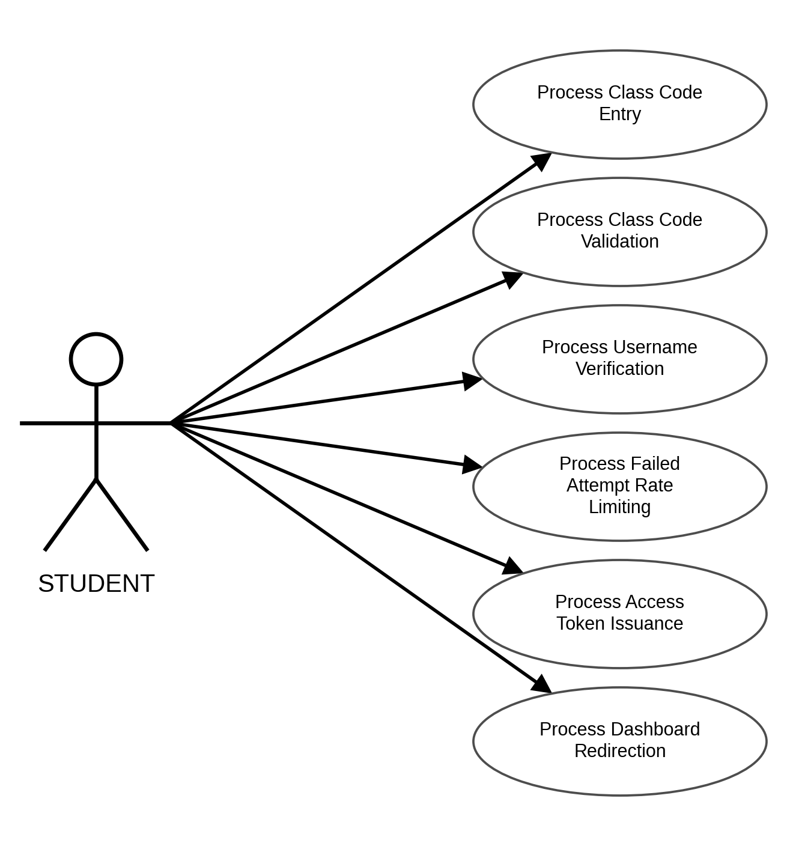
Figure 2. Use Case Diagram for Students Joining a Class
USE CASE DIAGRAM INVOLVING STUDENTS COMPLETING THEIR PROFILE
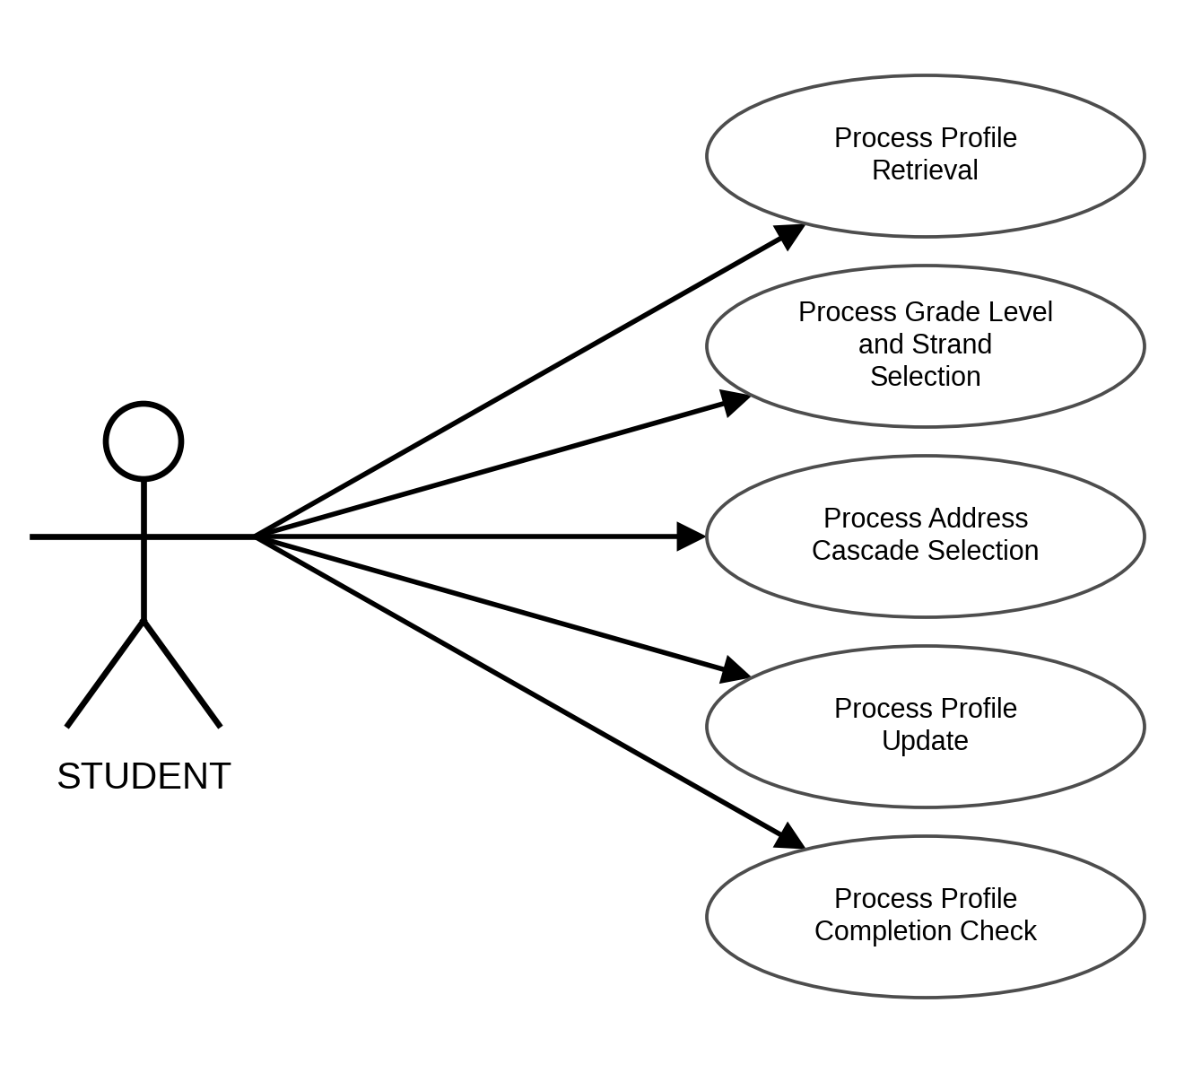
Figure 3. Use Case Diagram for Students Completing Their Profile
USE CASE DIAGRAM INVOLVING STUDENTS VIEWING ASSIGNED ASSESSMENTS
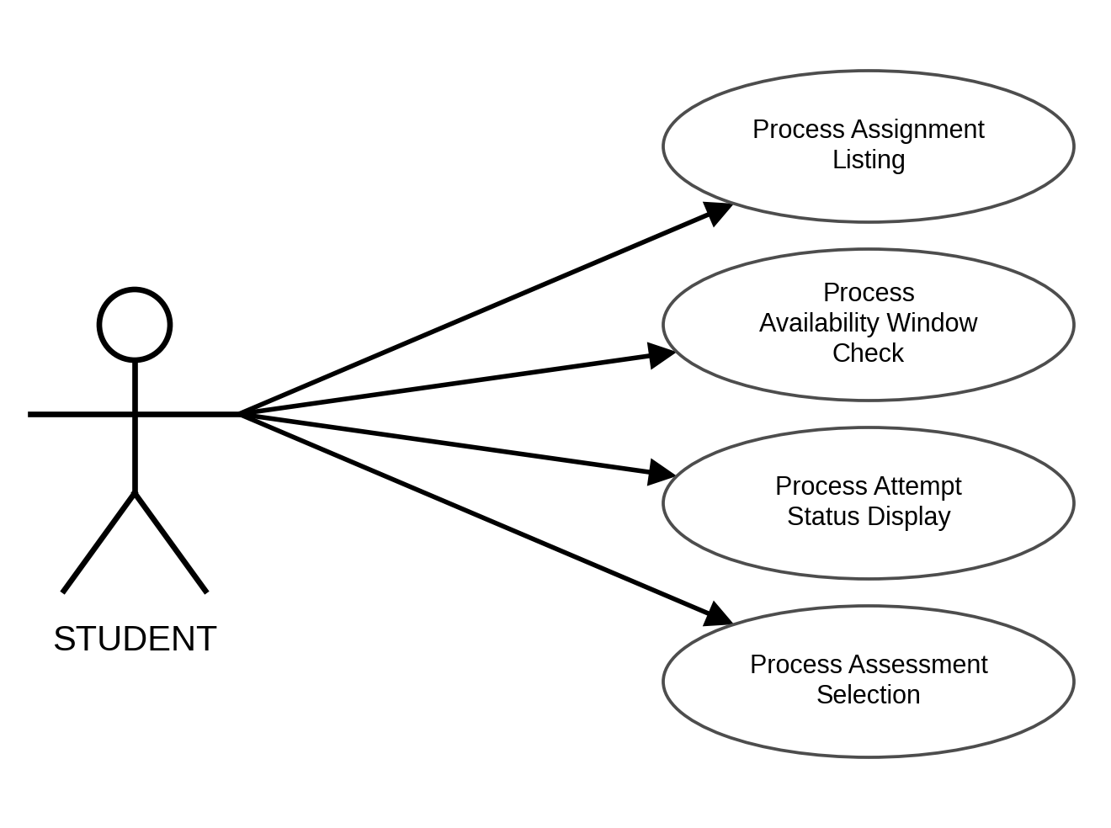
Figure 4. Use Case Diagram for Students Viewing Assigned Assessments
USE CASE DIAGRAM INVOLVING STUDENTS TAKING AN ASSESSMENT
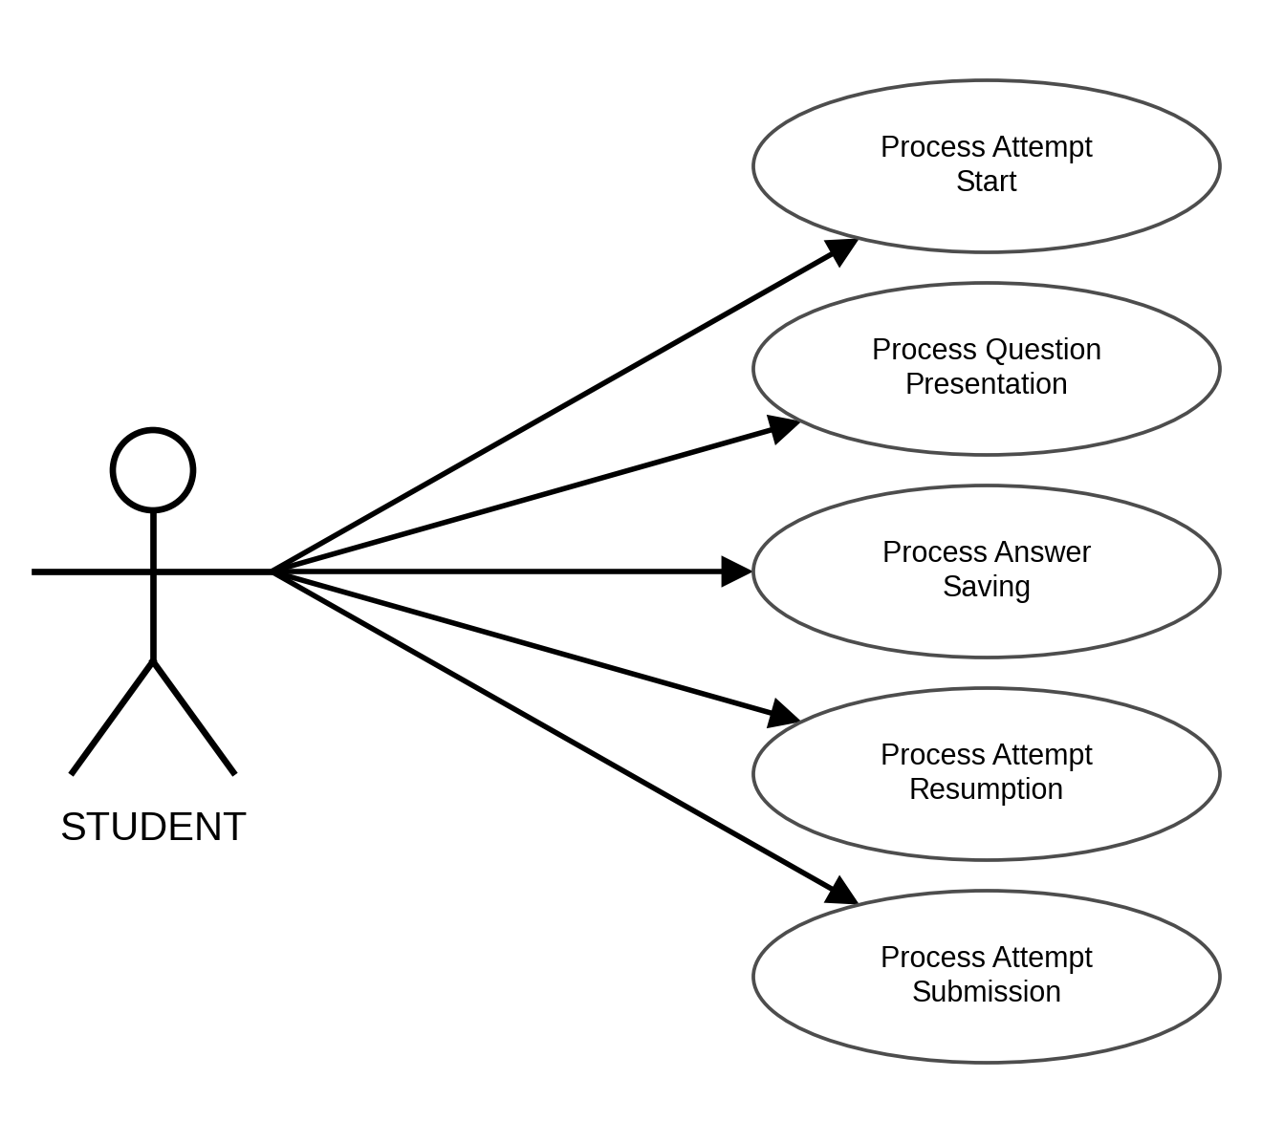
Figure 5. Use Case Diagram for Students Taking an Assessment
USE CASE DIAGRAM INVOLVING STUDENTS VIEWING ASSESSMENT RESULTS
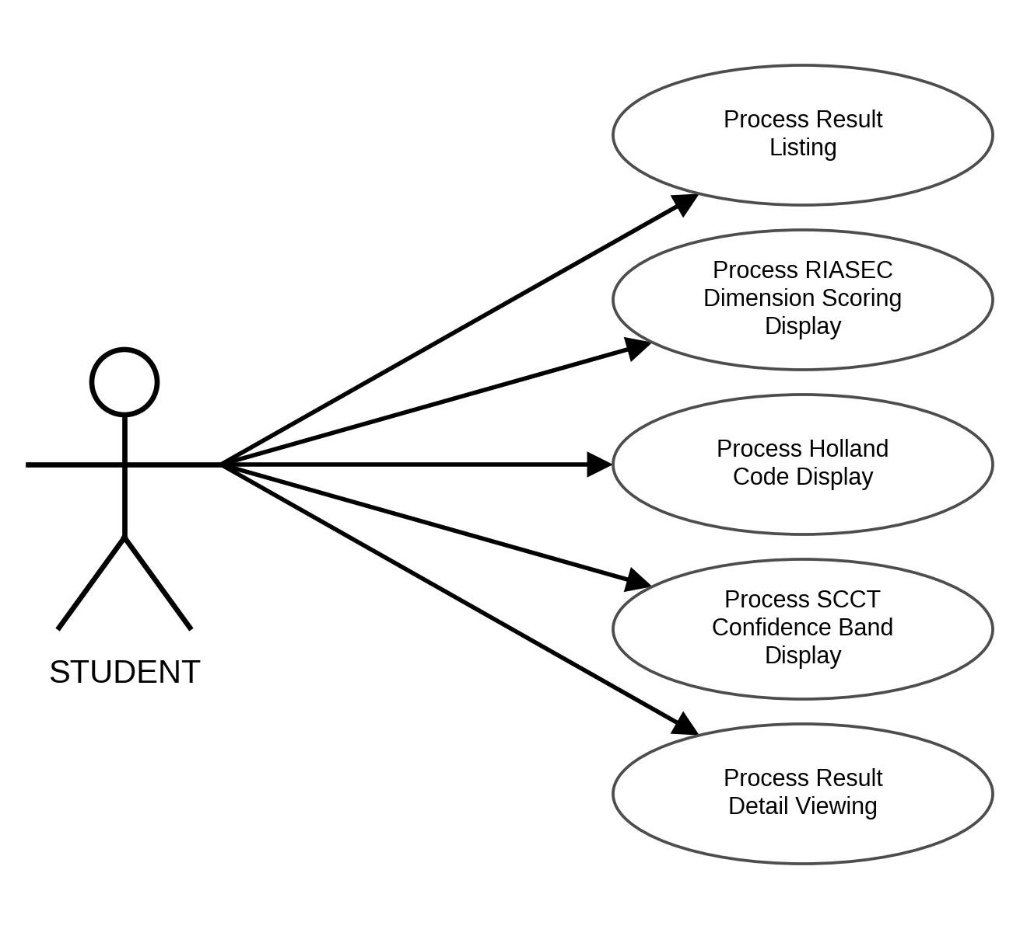
Figure 6. Use Case Diagram for Students Viewing Assessment Results
USE CASE DIAGRAM INVOLVING STUDENTS VIEWING RECOMMENDATIONS
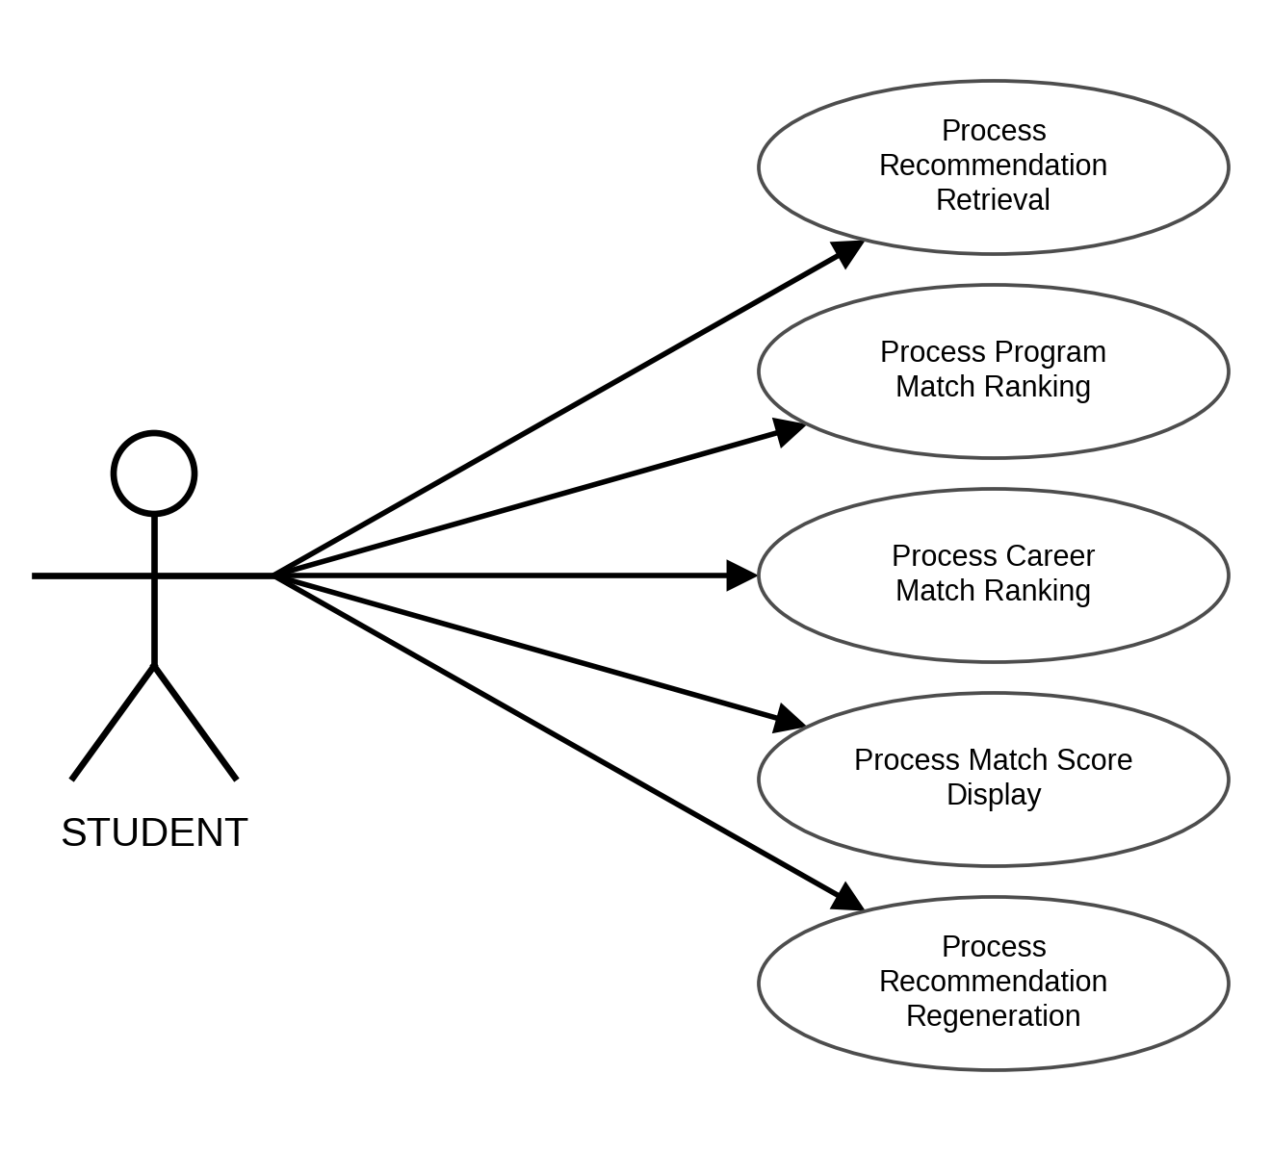
Figure 7. Use Case Diagram for Students Viewing Recommendations
USE CASE DIAGRAM INVOLVING STUDENTS REQUESTING AN EXPLANATION
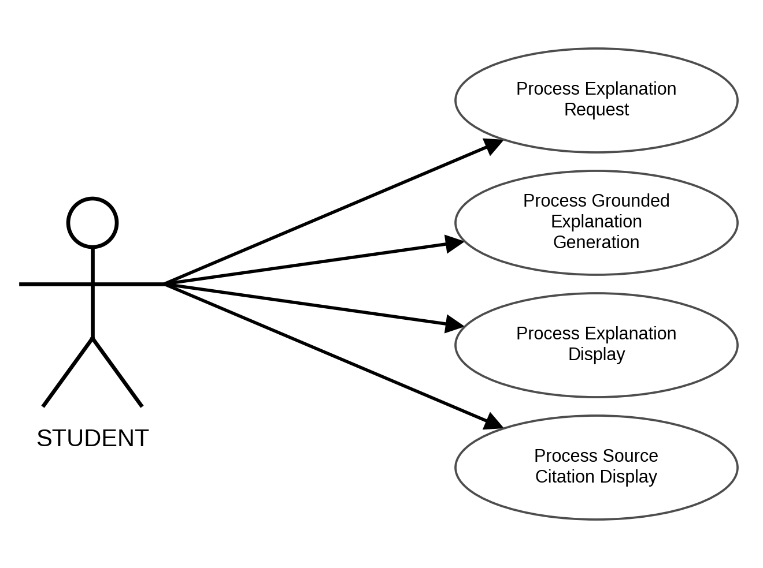
Figure 8. Use Case Diagram for Students Requesting an Explanation
USE CASE DIAGRAM INVOLVING STUDENTS EXPLORING COLLEGES AND CAREERS
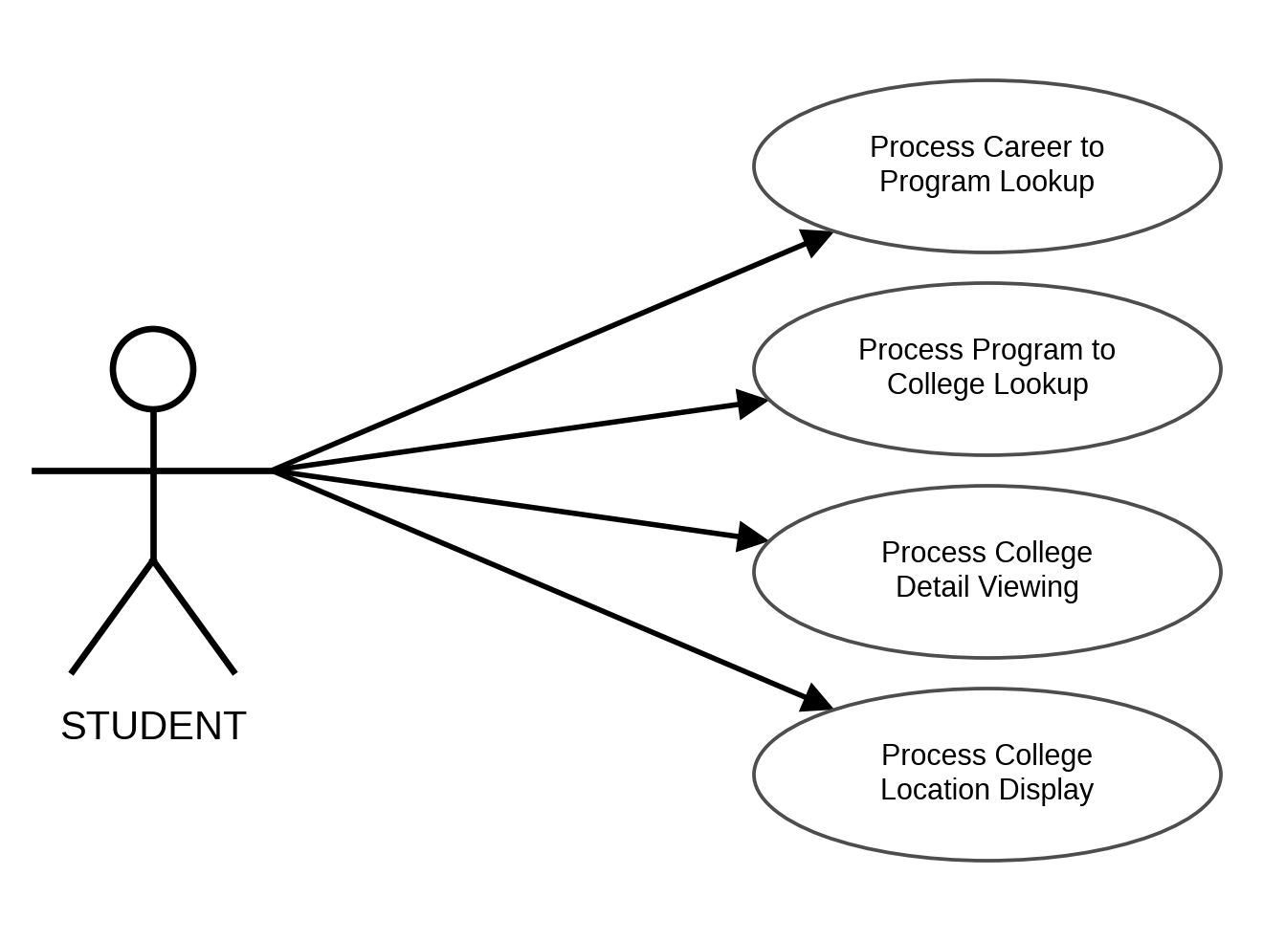
Figure 9. Use Case Diagram for Students Exploring Colleges and Careers
USE CASE DIAGRAM INVOLVING STUDENTS USING THE AI CAREER ASSISTANT
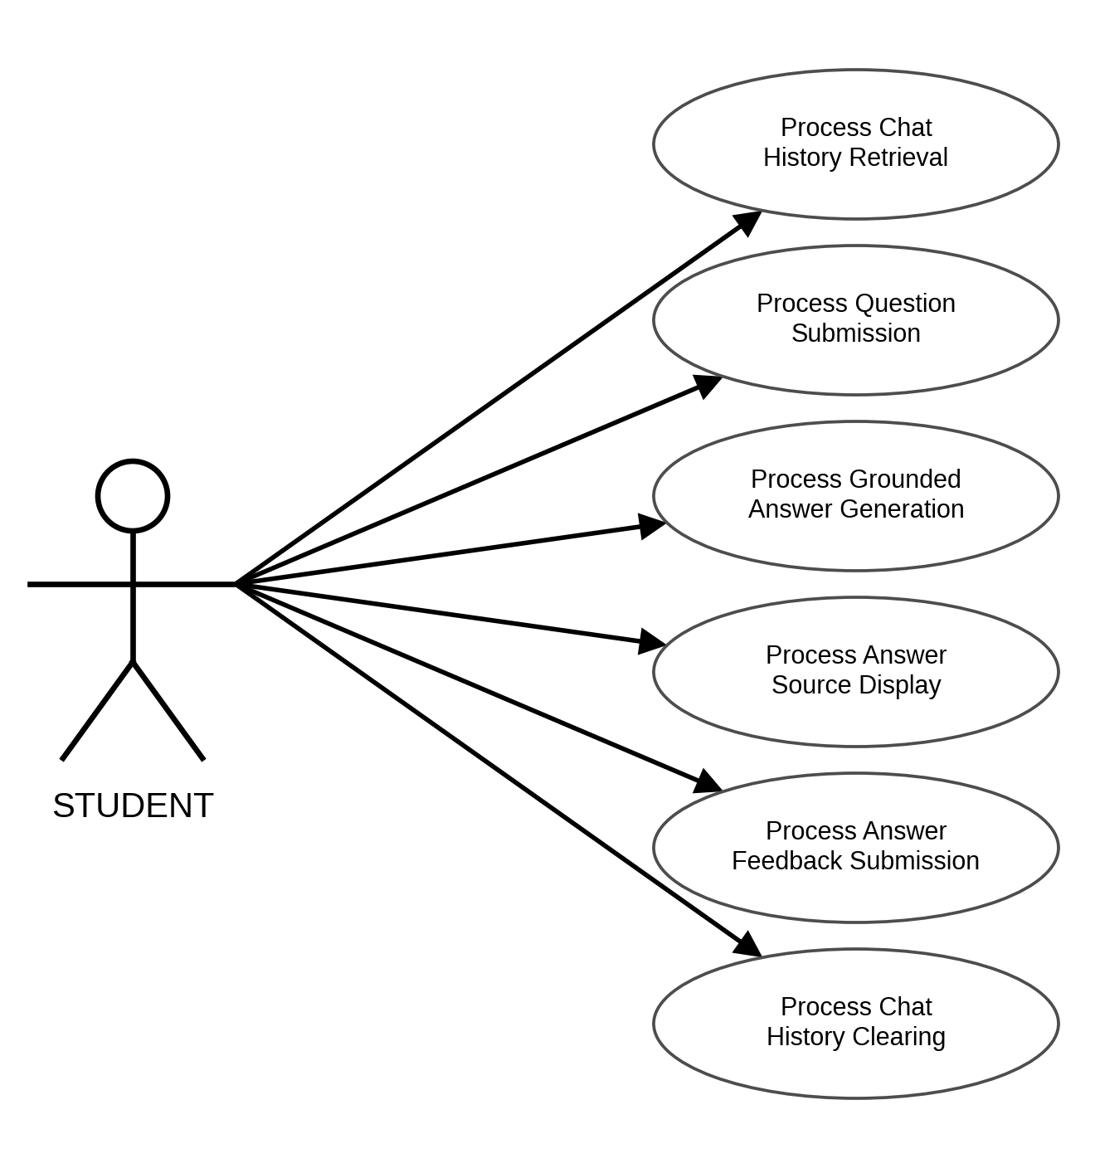
Figure 10. Use Case Diagram for Students Using the AI Career Assistant
USE CASE DIAGRAM INVOLVING STUDENTS RECEIVING NOTIFICATIONS
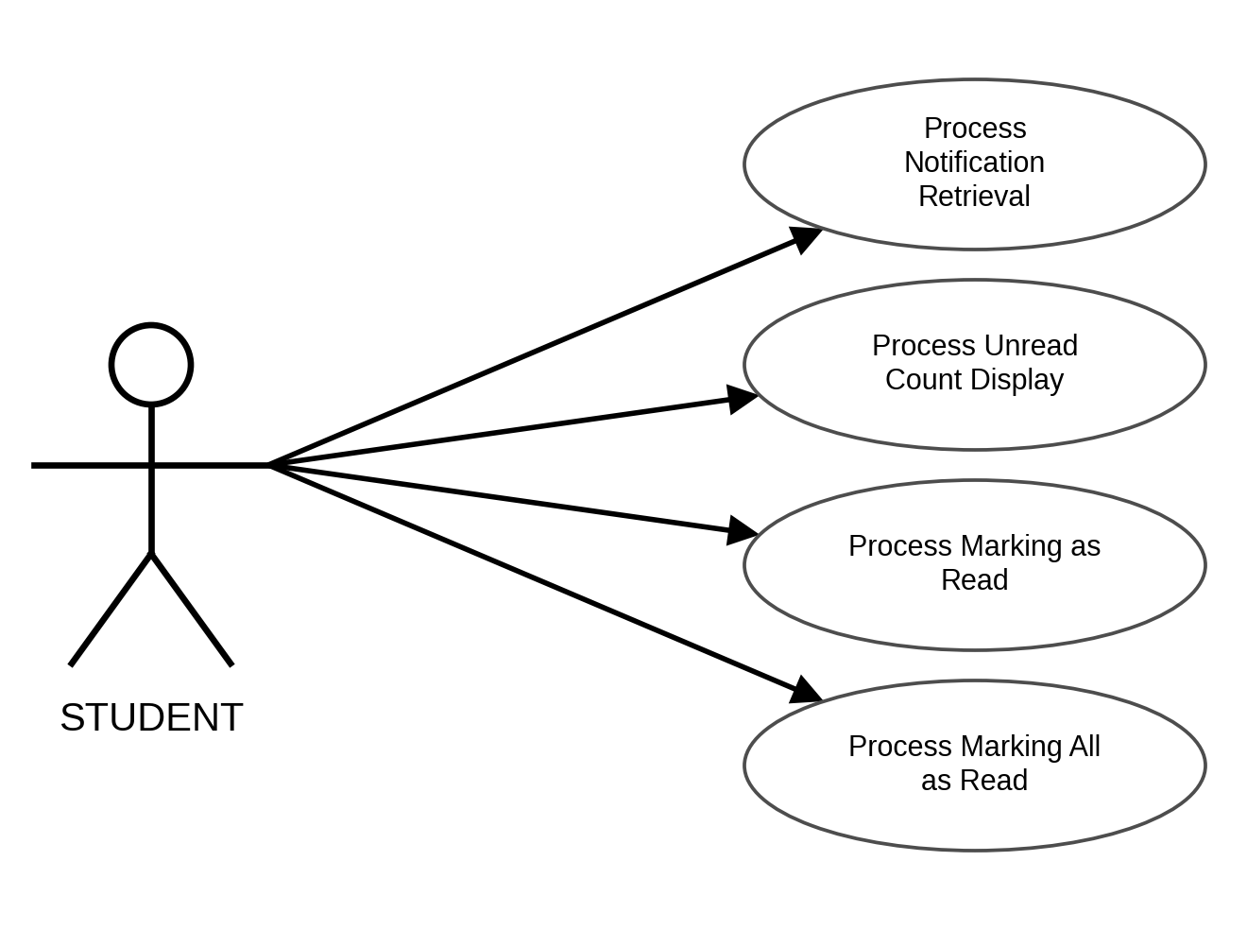
Figure 11. Use Case Diagram for Students Receiving Notifications
USE CASE DIAGRAM INVOLVING STUDENTS VIEWING THEIR DASHBOARD
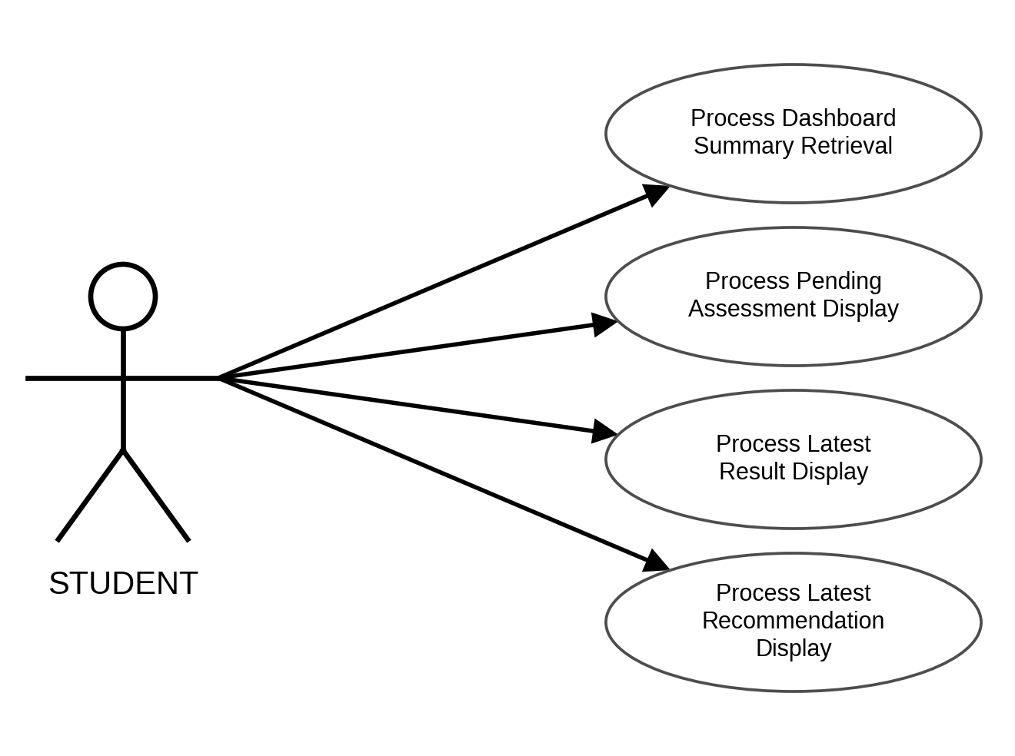
Figure 12. Use Case Diagram for Students Viewing Their Dashboard
USE CASE DIAGRAM INVOLVING COUNSELORS LOGGING IN
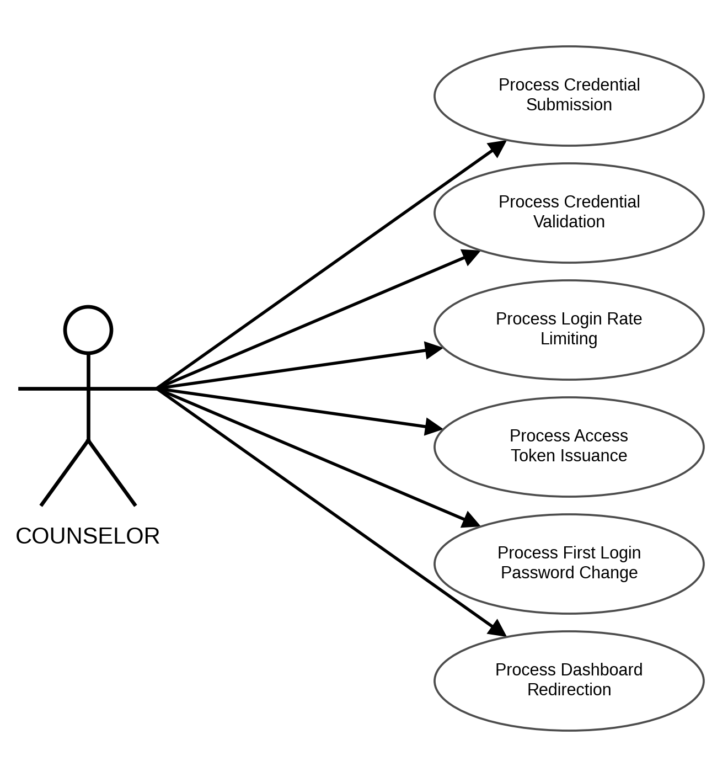
Figure 13. Use Case Diagram for Counselors Logging In
USE CASE DIAGRAM INVOLVING COUNSELORS RESETTING PASSWORD
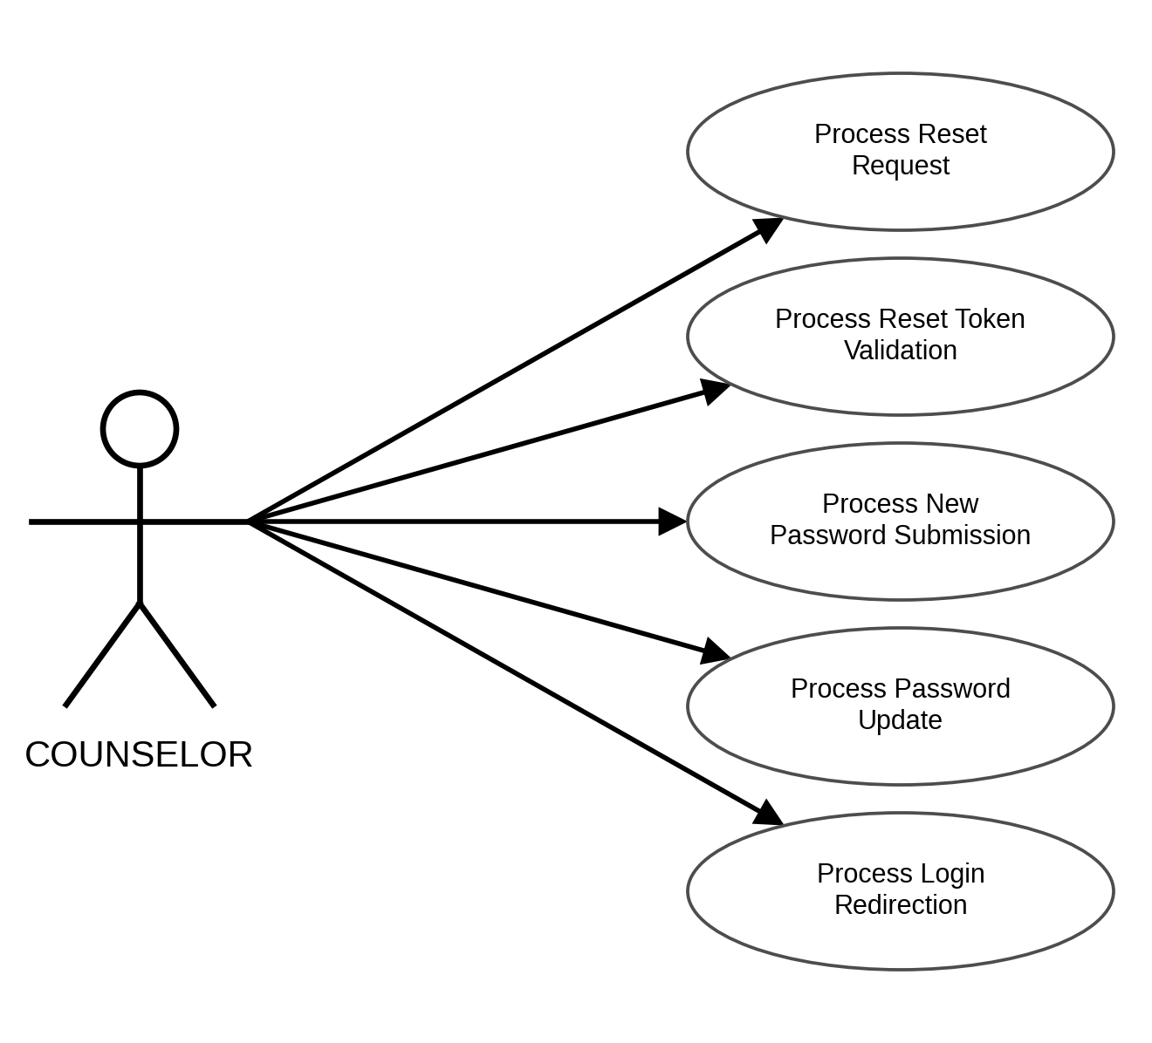
Figure 14. Use Case Diagram for Counselors Resetting Password
USE CASE DIAGRAM INVOLVING COUNSELORS MANAGING CLASSES
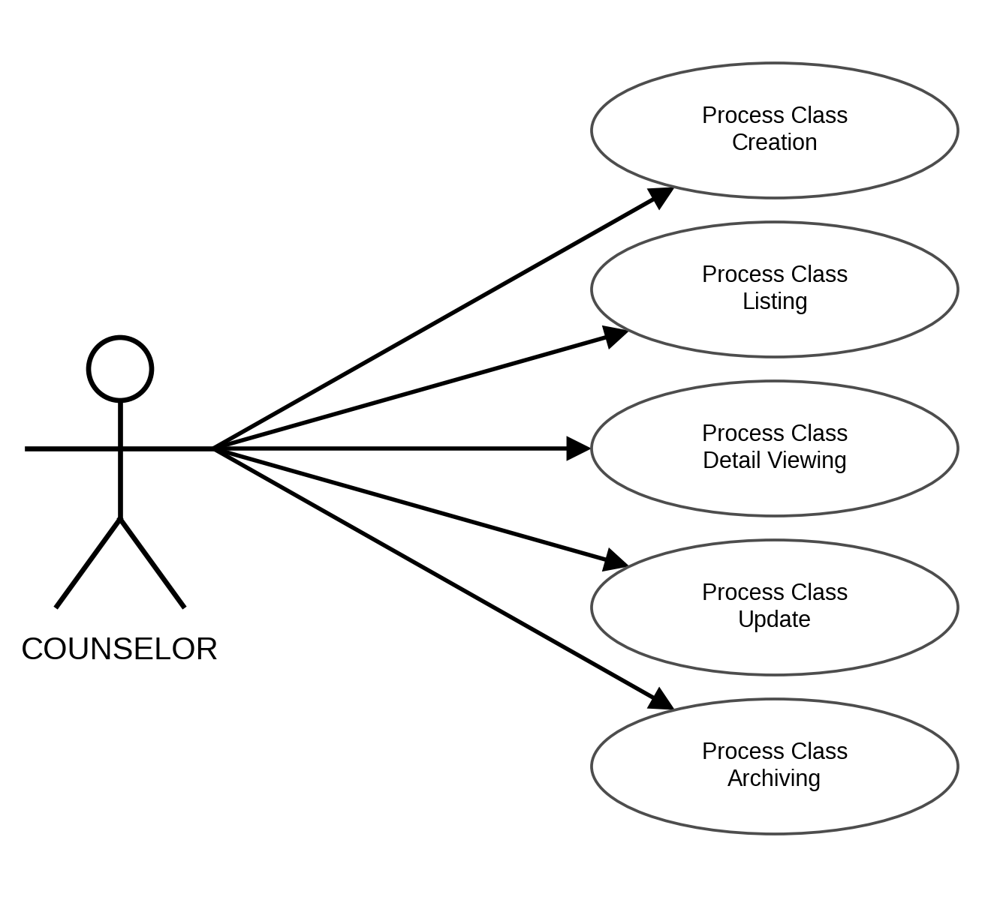
Figure 15. Use Case Diagram for Counselors Managing Classes
USE CASE DIAGRAM INVOLVING COUNSELORS MANAGING THE JOIN CODE
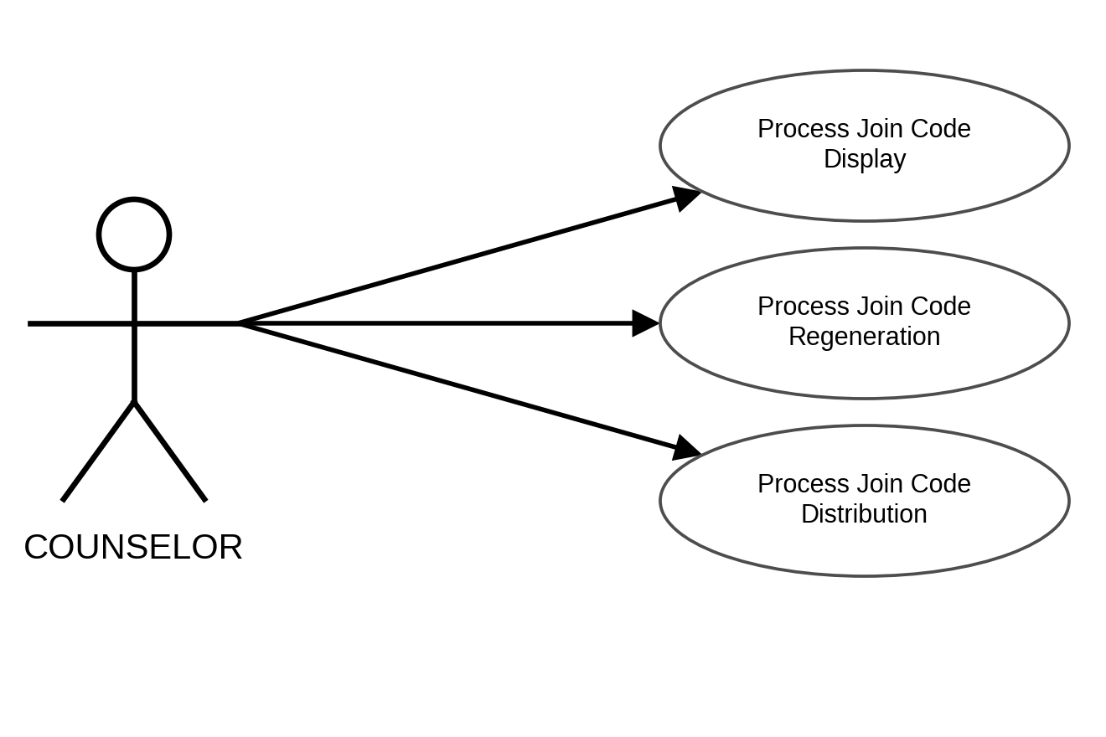
Figure 16. Use Case Diagram for Counselors Managing the Join Code
USE CASE DIAGRAM INVOLVING COUNSELORS MANAGING THE CLASS ROSTER
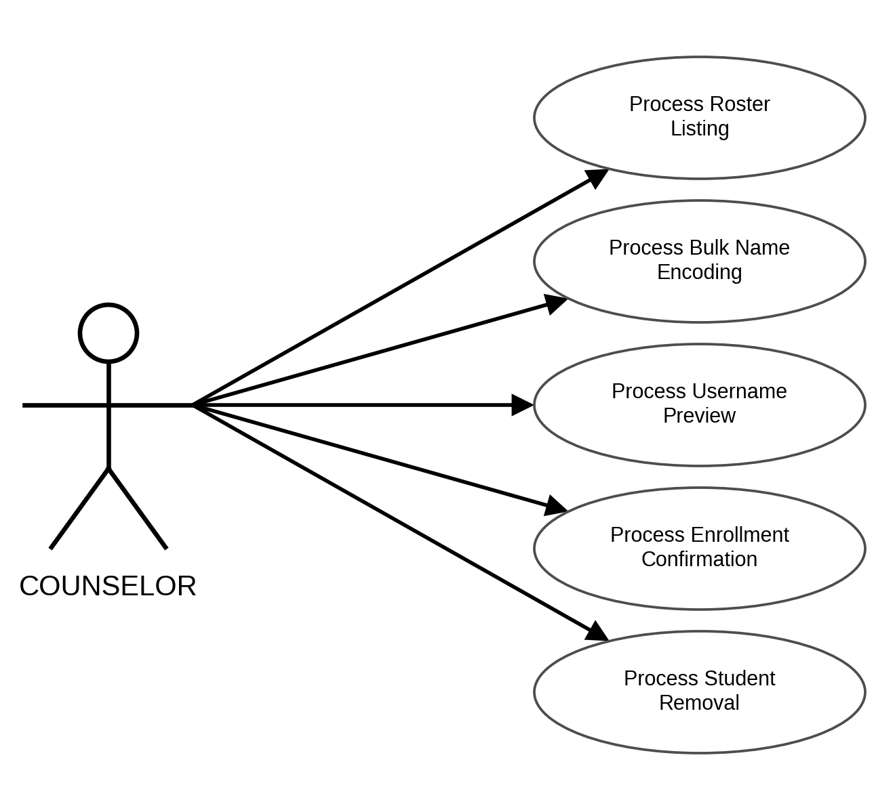
Figure 17. Use Case Diagram for Counselors Managing the Class Roster
USE CASE DIAGRAM INVOLVING COUNSELORS ASSIGNING ASSESSMENTS
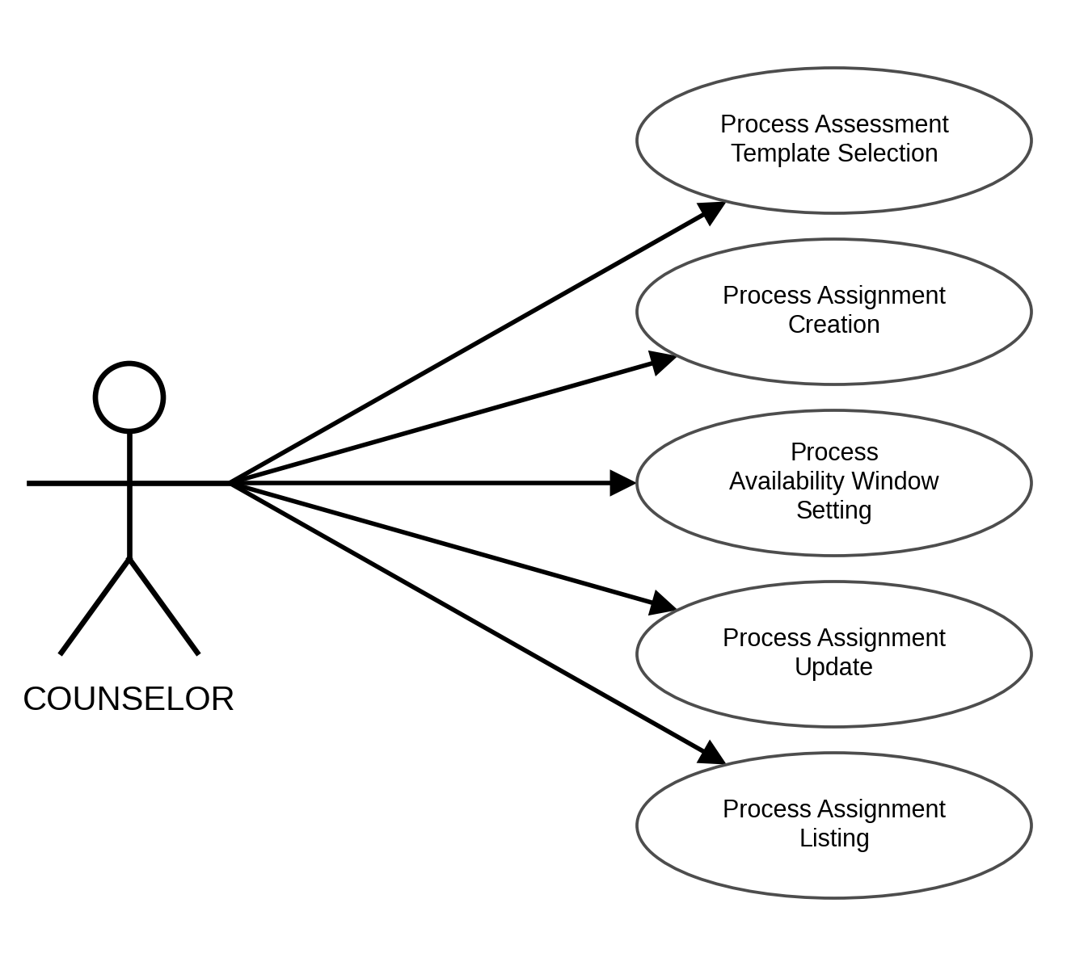
Figure 18. Use Case Diagram for Counselors Assigning Assessments
USE CASE DIAGRAM INVOLVING COUNSELORS AUTHORING A CUSTOM ASSESSMENT
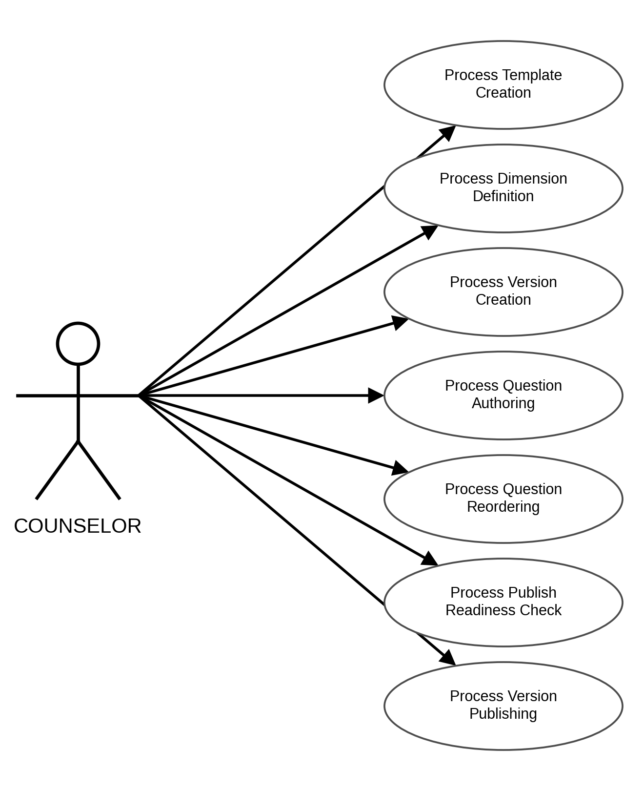
Figure 19. Use Case Diagram for Counselors Authoring a Custom Assessment
USE CASE DIAGRAM INVOLVING COUNSELORS GENERATING ITEMS WITH AI
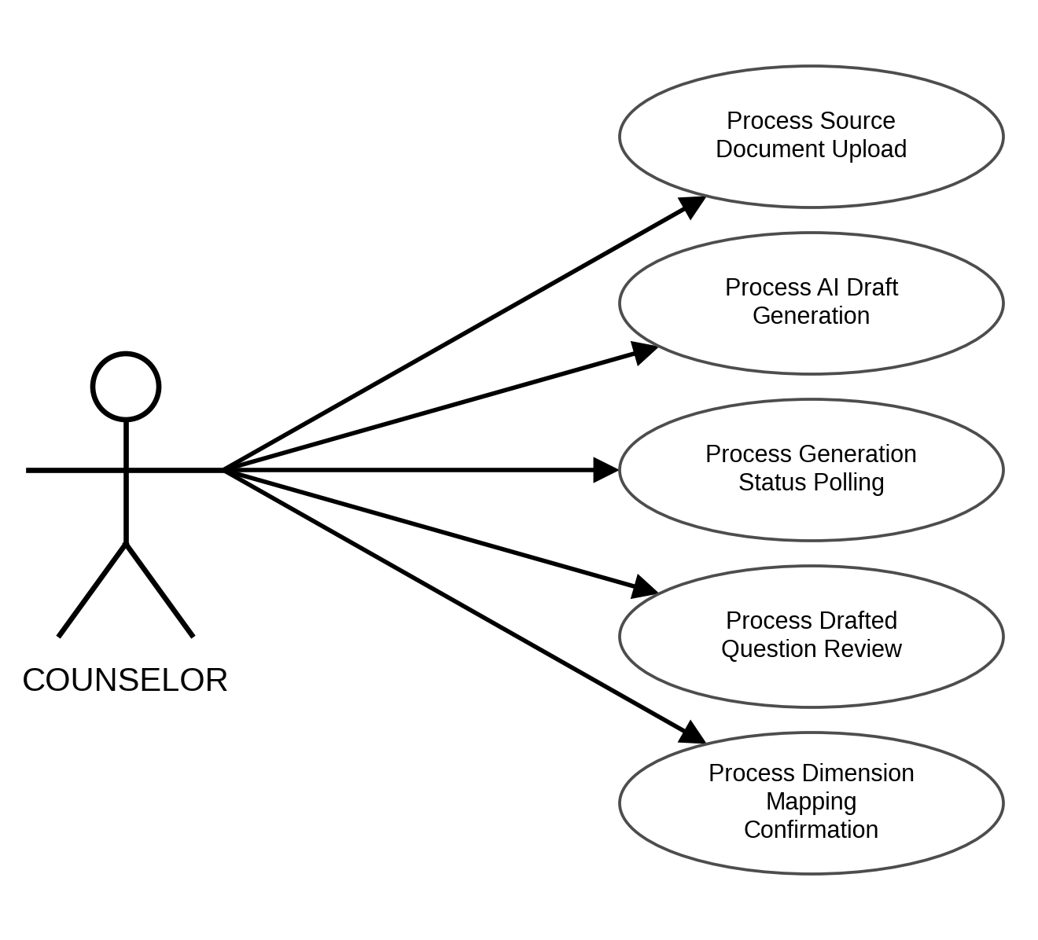
Figure 20. Use Case Diagram for Counselors Generating Items with AI
USE CASE DIAGRAM INVOLVING COUNSELORS MONITORING CLASS RESULTS
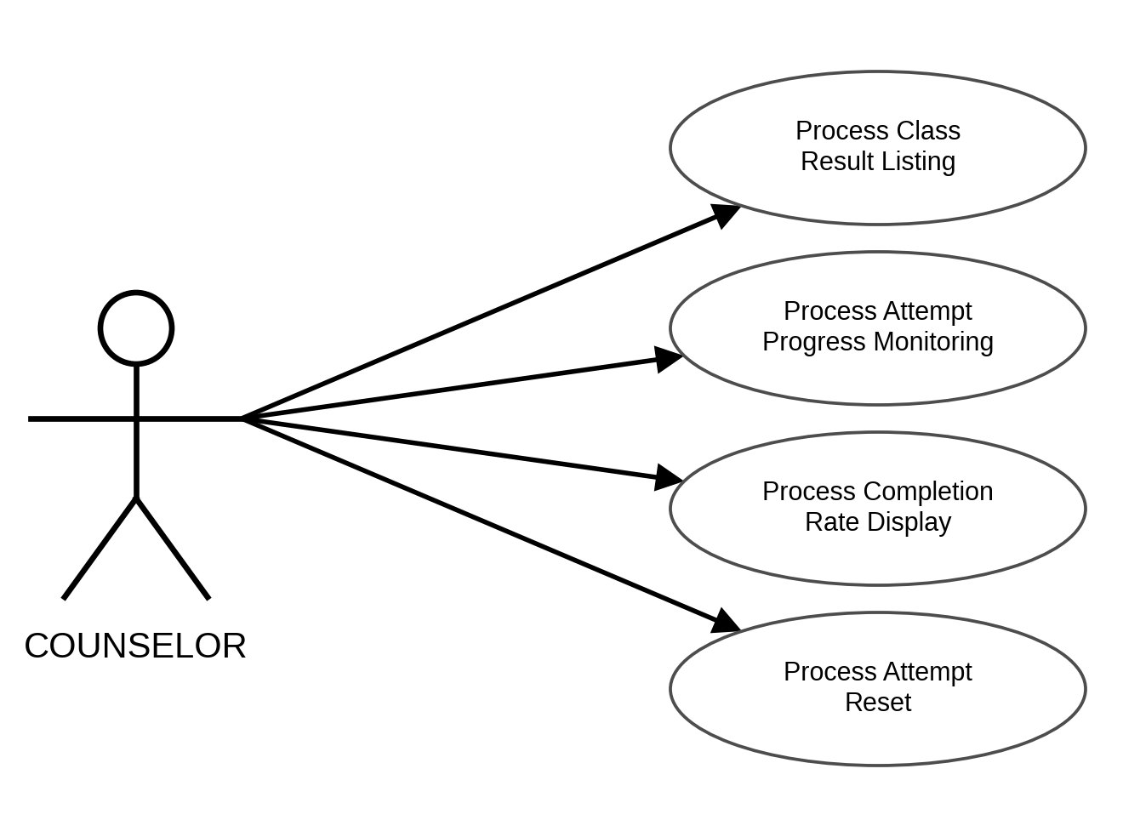
Figure 21. Use Case Diagram for Counselors Monitoring Class Results
USE CASE DIAGRAM INVOLVING COUNSELORS REVIEWING RECOMMENDATIONS
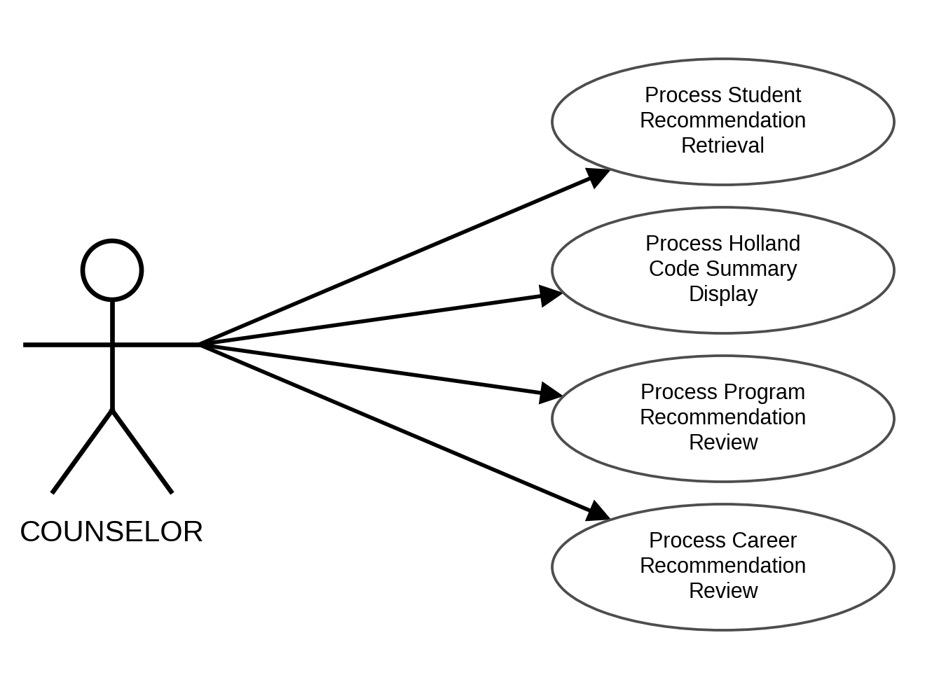
Figure 22. Use Case Diagram for Counselors Reviewing Recommendations
USE CASE DIAGRAM INVOLVING COUNSELORS VIEWING THEIR DASHBOARD
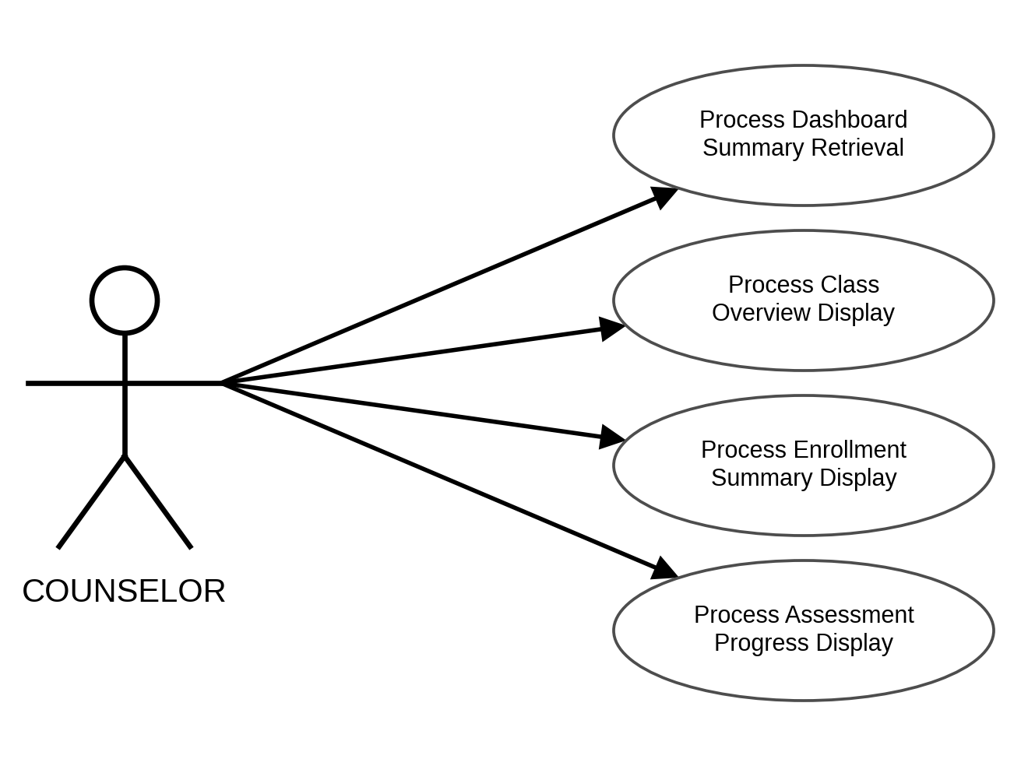
Figure 23. Use Case Diagram for Counselors Viewing Their Dashboard
USE CASE DIAGRAM INVOLVING ADMINISTRATORS LOGGING IN
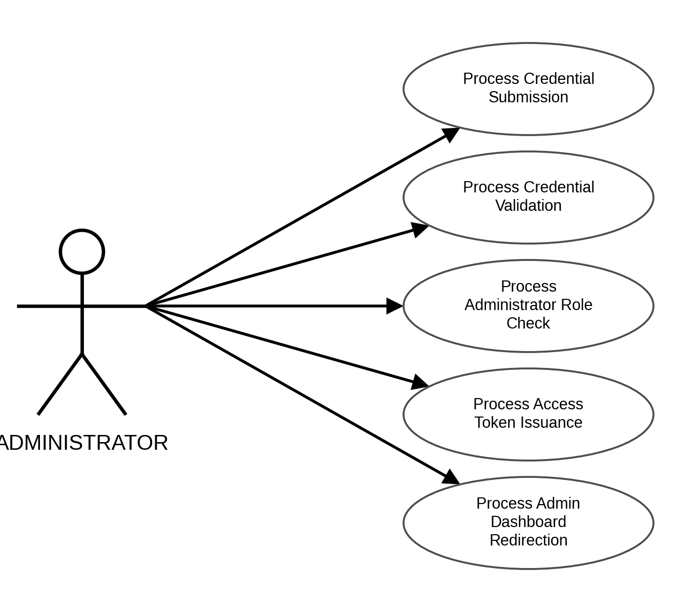
Figure 24. Use Case Diagram for Administrators Logging In
USE CASE DIAGRAM INVOLVING ADMINISTRATORS MANAGING COUNSELOR ACCOUNTS
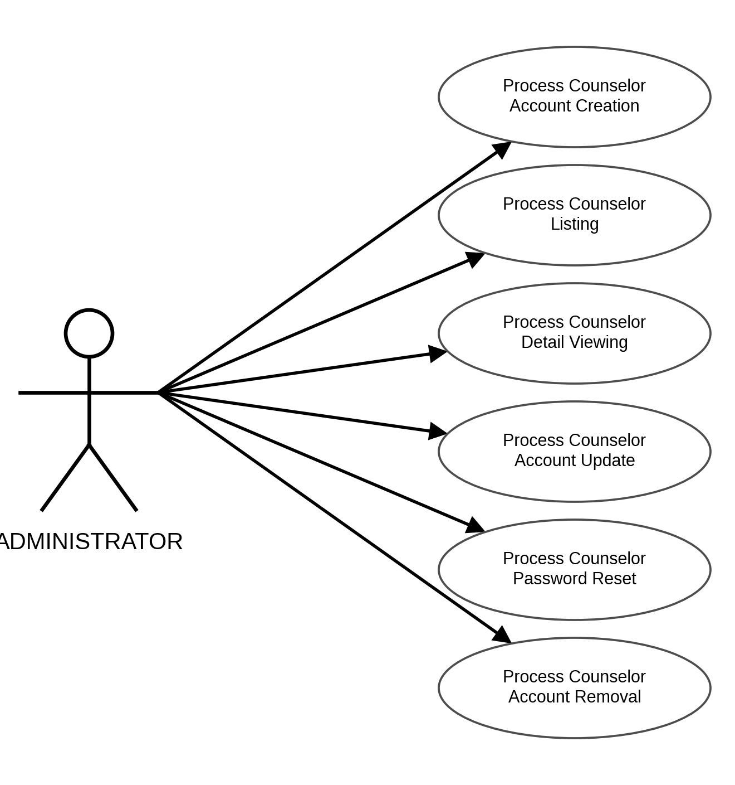
Figure 25. Use Case Diagram for Administrators Managing Counselor Accounts
USE CASE DIAGRAM INVOLVING ADMINISTRATORS MANAGING COLLEGES AND PROGRAMS
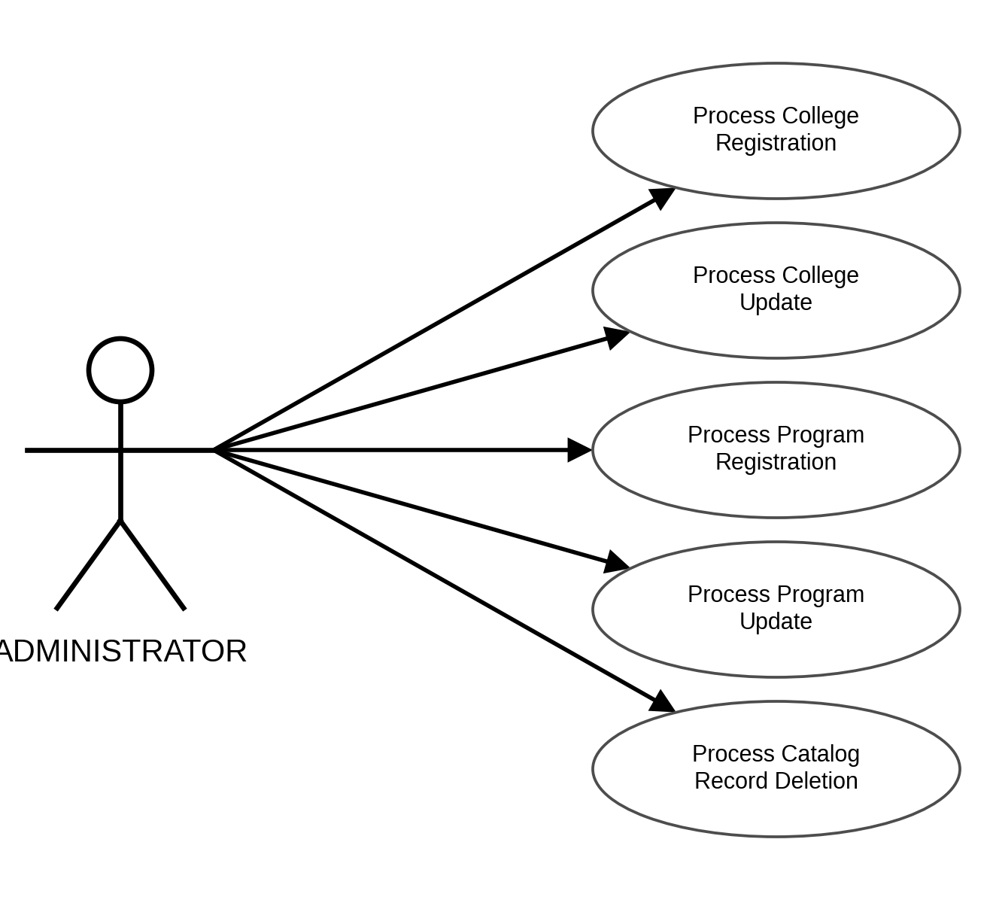
Figure 26. Use Case Diagram for Administrators Managing Colleges and Programs
USE CASE DIAGRAM INVOLVING ADMINISTRATORS MANAGING CAREERS
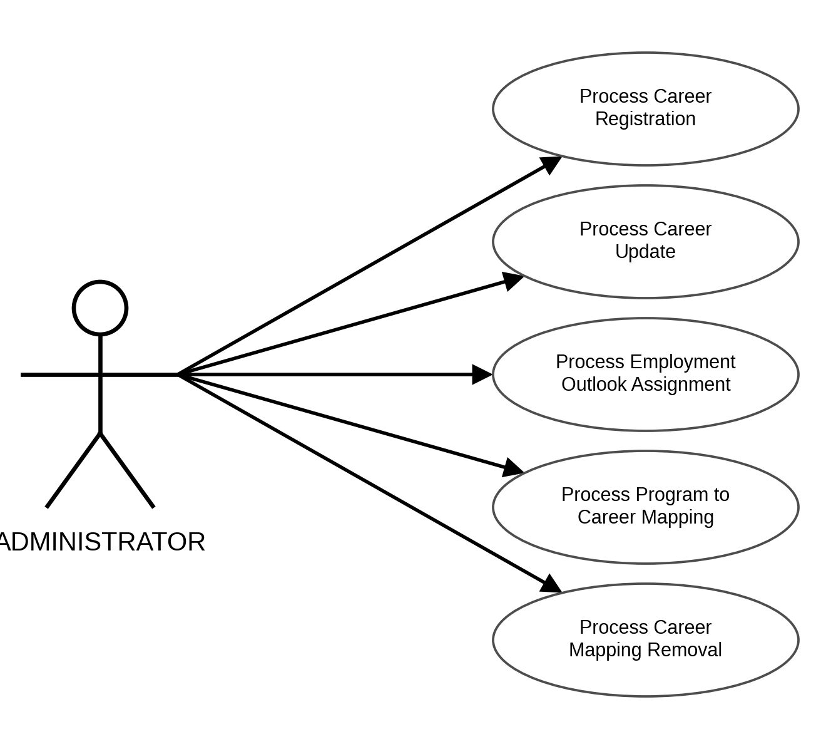
Figure 27. Use Case Diagram for Administrators Managing Careers
USE CASE DIAGRAM INVOLVING ADMINISTRATORS MANAGING CANONICAL PROGRAMS
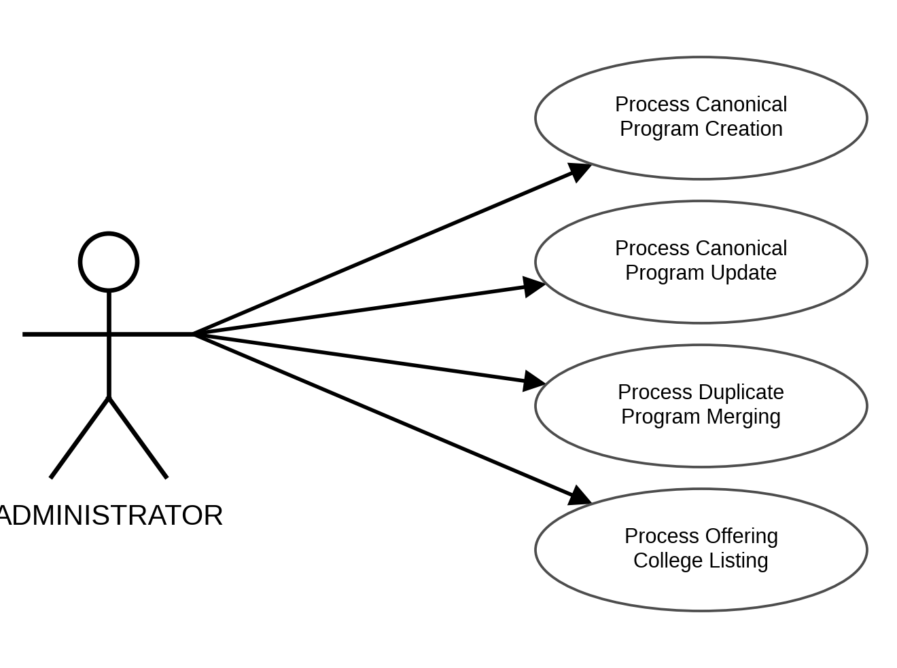
Figure 28. Use Case Diagram for Administrators Managing Canonical Programs
USE CASE DIAGRAM INVOLVING ADMINISTRATORS MANAGING ADDRESS RECORDS
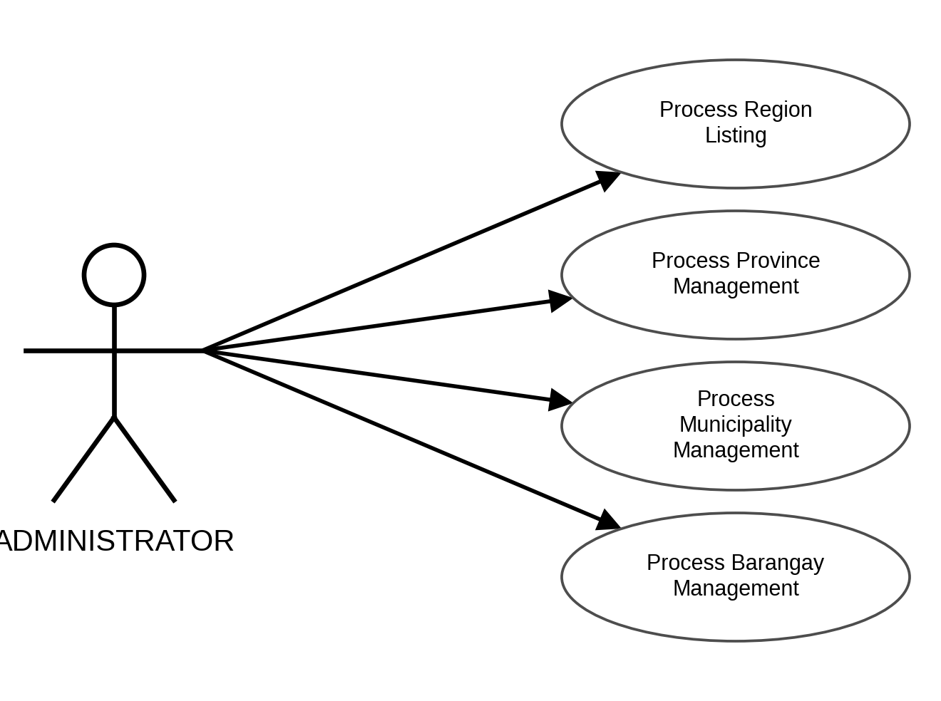
Figure 29. Use Case Diagram for Administrators Managing Address Records
USE CASE DIAGRAM INVOLVING ADMINISTRATORS MANAGING THE KNOWLEDGE BASE
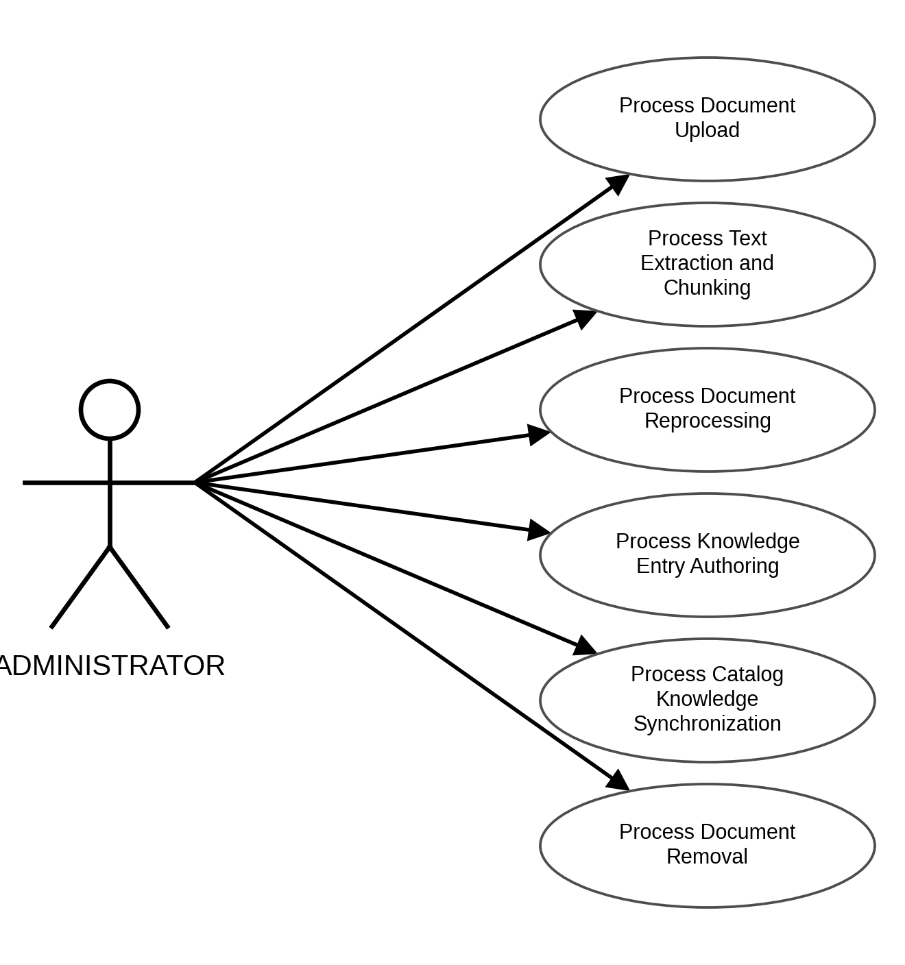
Figure 30. Use Case Diagram for Administrators Managing the Knowledge Base
USE CASE DIAGRAM INVOLVING ADMINISTRATORS MANAGING THE AI POLICY
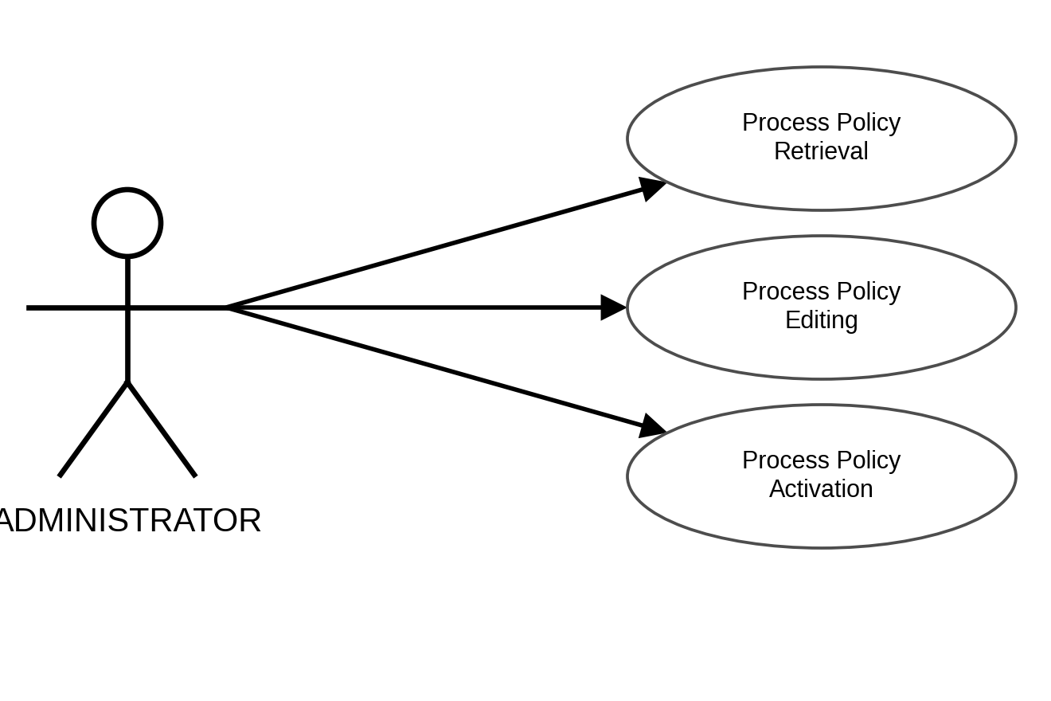
Figure 31. Use Case Diagram for Administrators Managing the AI Policy
USE CASE DIAGRAM INVOLVING ADMINISTRATORS MONITORING AI AND PLATFORM USAGE
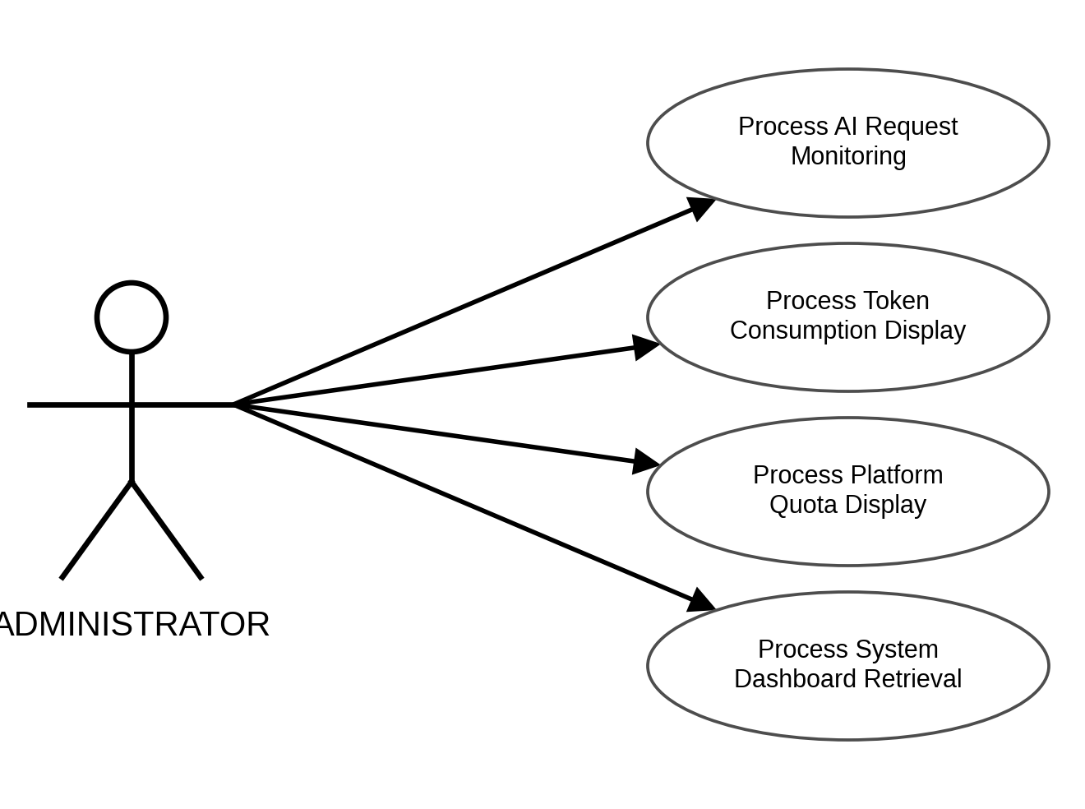
Figure 32. Use Case Diagram for Administrators Monitoring AI and Platform Usage
USE CASE DIAGRAM INVOLVING ADMINISTRATORS REVIEWING THE AUDIT LOG
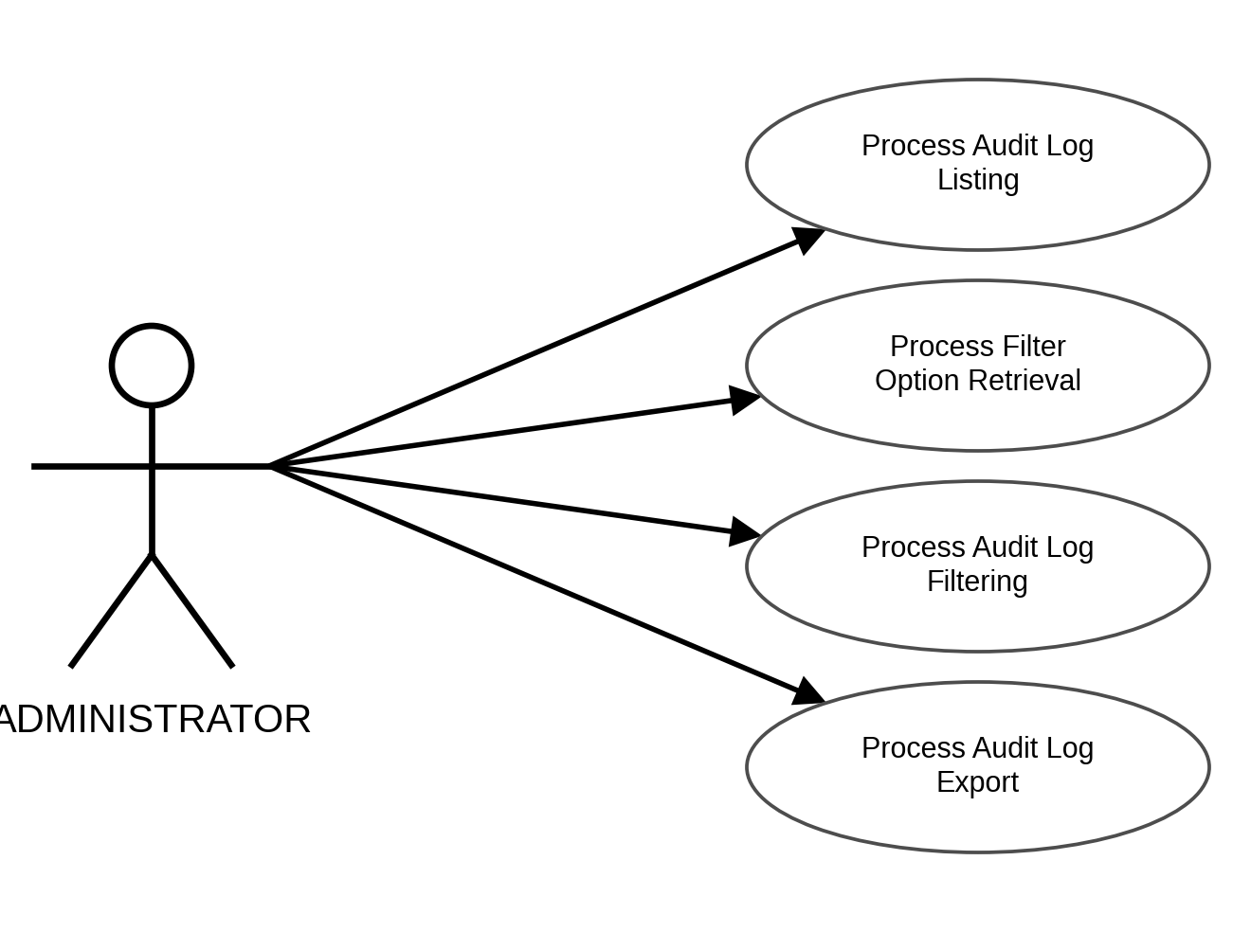
Figure 33. Use Case Diagram for Administrators Reviewing the Audit Log
Activity Diagram
The system provides an intuitive workflow that allows the students, counselors, and administrators to navigate CareerLinkAI with ease. The following flowcharts illustrate the logical sequence of actions that the system incorporates in each of its processes, including the decision points at which the system validates the inputs, checks the permissions of the signed-in role, and repeats a step until the required condition is satisfied.
ACTIVITY DIAGRAM INVOLVING STUDENTS JOINING A CLASS
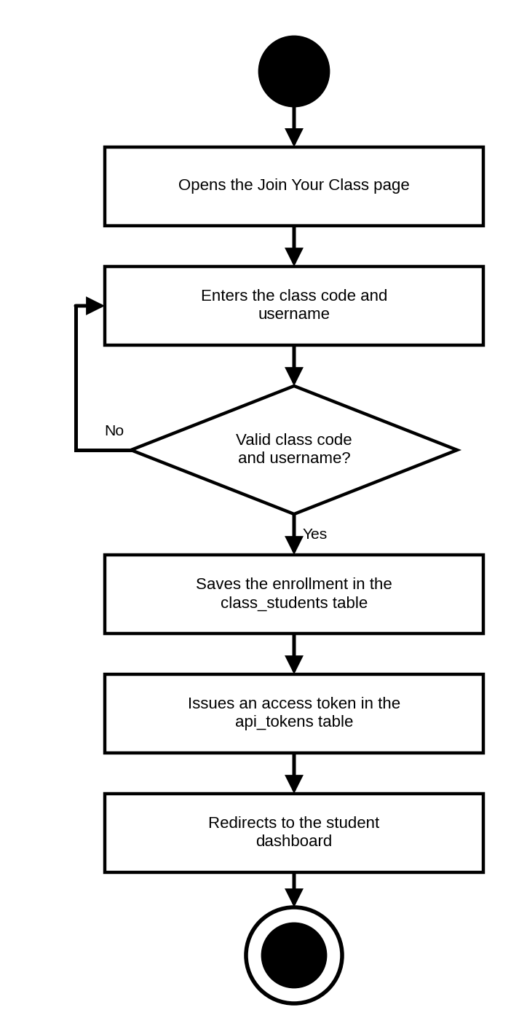
Figure 34. Activity Diagram for Students Joining a Class
ACTIVITY DIAGRAM INVOLVING STUDENTS COMPLETING THEIR PROFILE
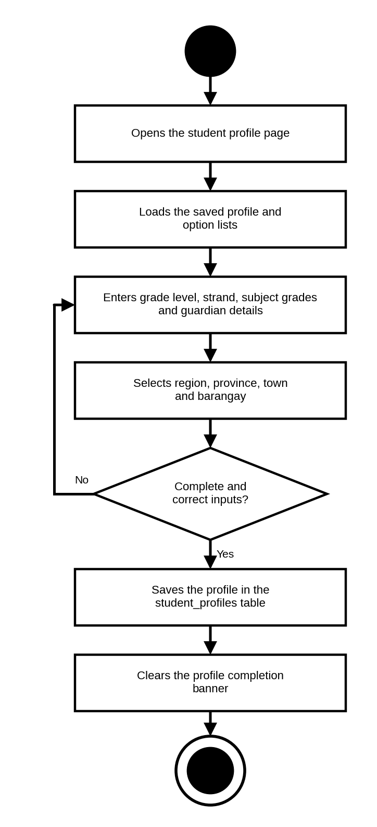
Figure 35. Activity Diagram for Students Completing Their Profile
ACTIVITY DIAGRAM INVOLVING STUDENTS VIEWING ASSIGNED ASSESSMENTS
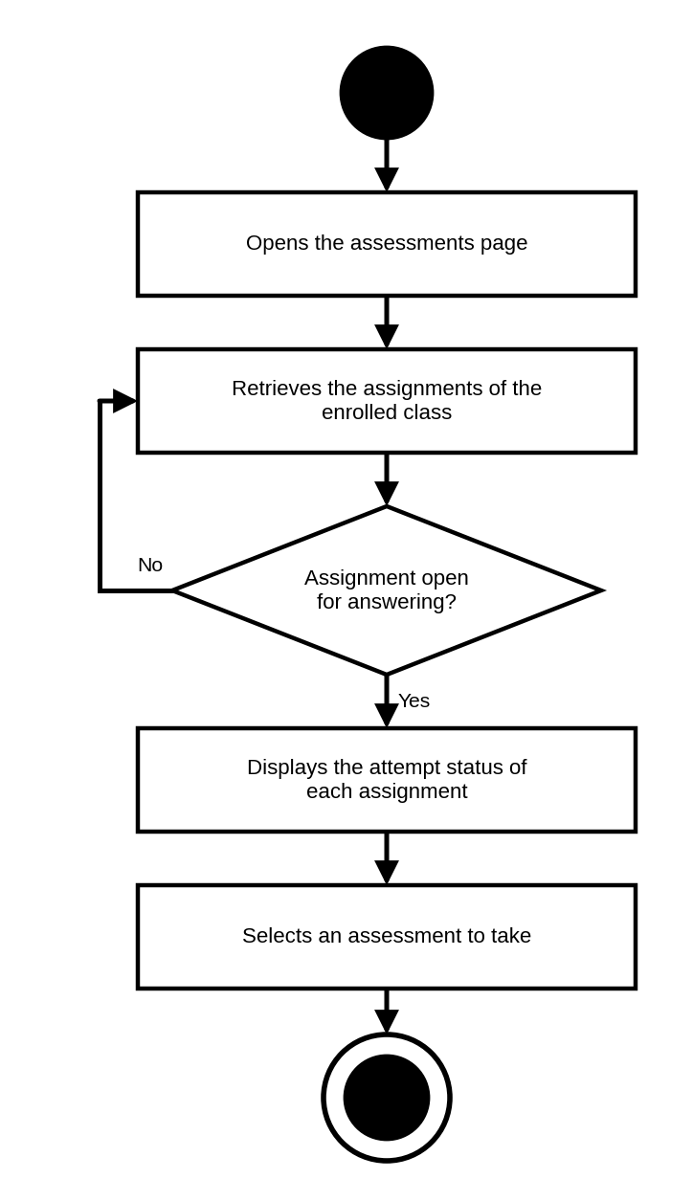
Figure 36. Activity Diagram for Students Viewing Assigned Assessments
ACTIVITY DIAGRAM INVOLVING STUDENTS TAKING AN ASSESSMENT
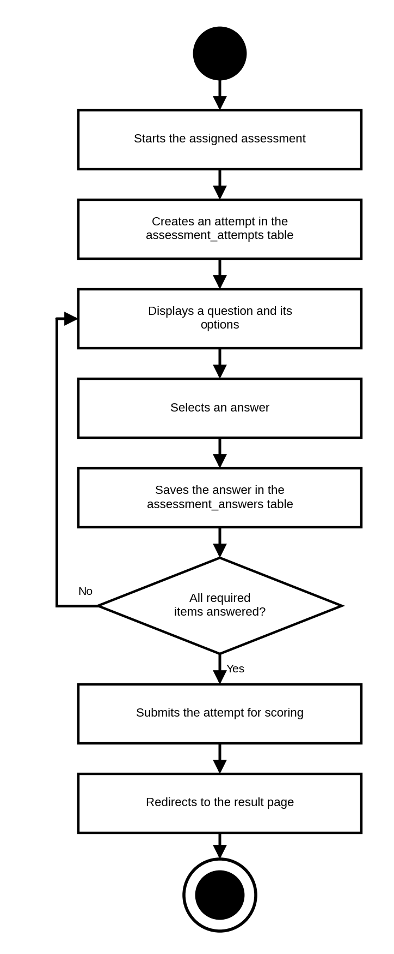
Figure 37. Activity Diagram for Students Taking an Assessment
ACTIVITY DIAGRAM INVOLVING STUDENTS VIEWING ASSESSMENT RESULTS
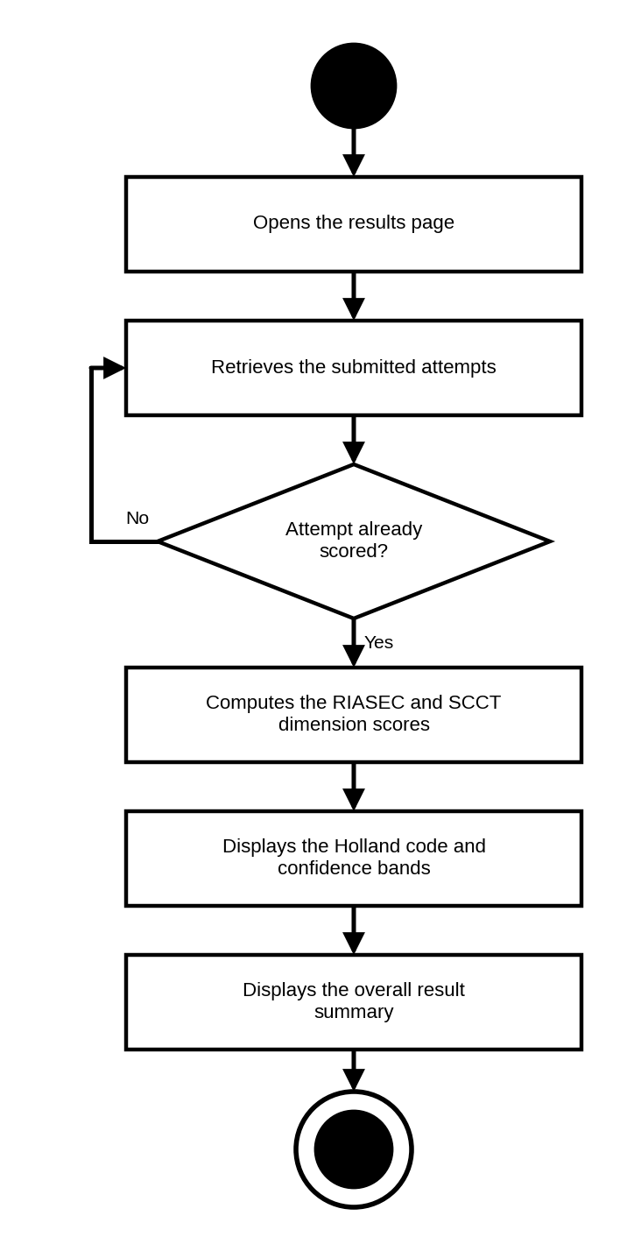
Figure 38. Activity Diagram for Students Viewing Assessment Results
ACTIVITY DIAGRAM INVOLVING STUDENTS VIEWING RECOMMENDATIONS
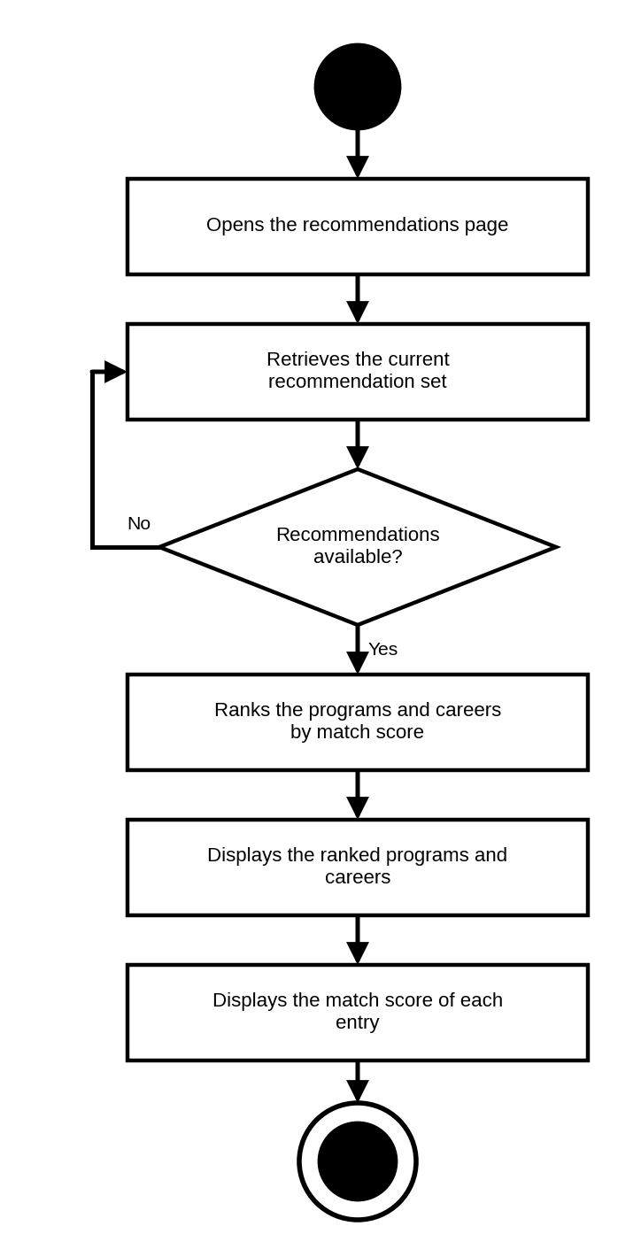
Figure 39. Activity Diagram for Students Viewing Recommendations
ACTIVITY DIAGRAM INVOLVING STUDENTS REQUESTING AN EXPLANATION
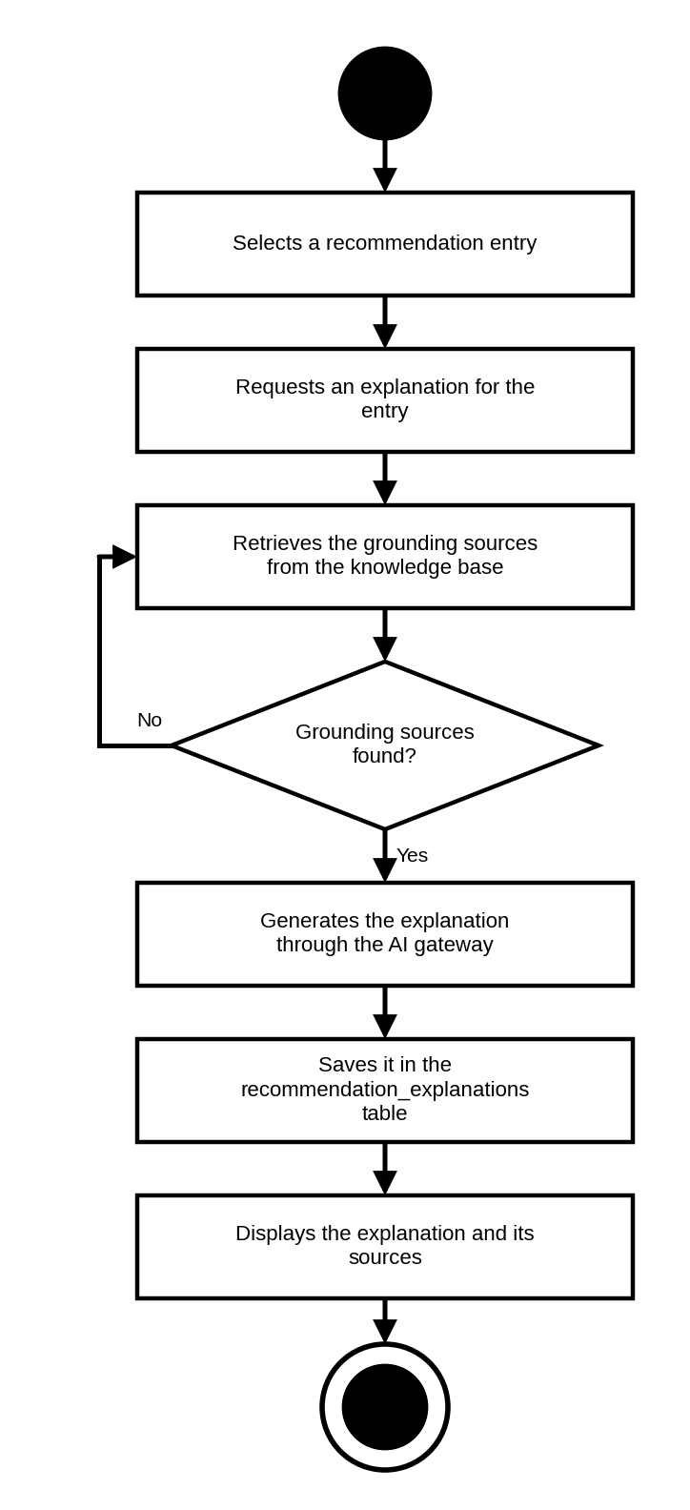
Figure 40. Activity Diagram for Students Requesting an Explanation
ACTIVITY DIAGRAM INVOLVING STUDENTS EXPLORING COLLEGES AND CAREERS
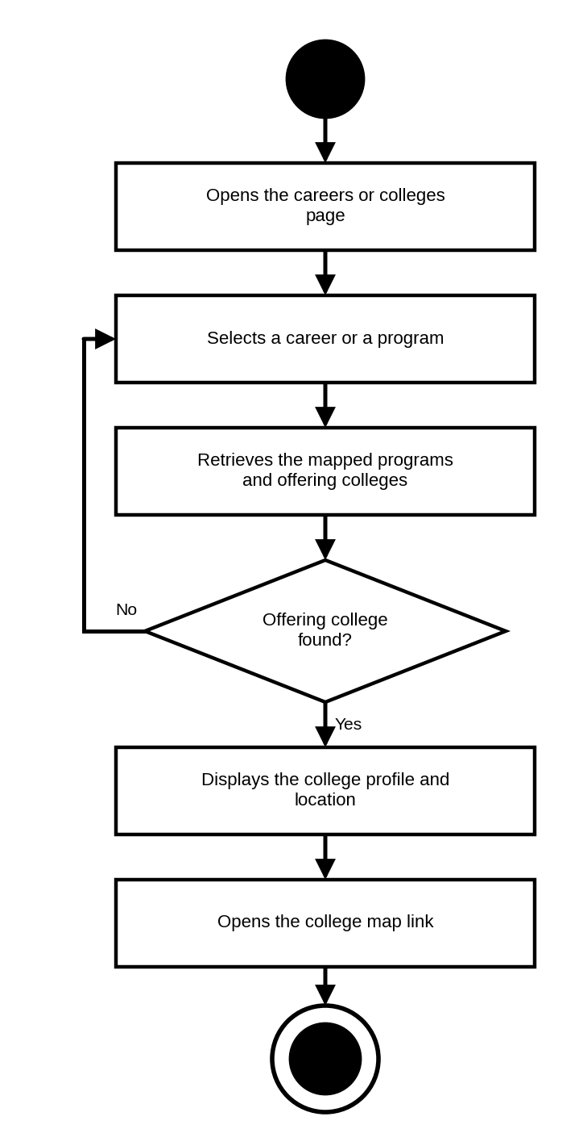
Figure 41. Activity Diagram for Students Exploring Colleges and Careers
ACTIVITY DIAGRAM INVOLVING STUDENTS USING THE AI CAREER ASSISTANT
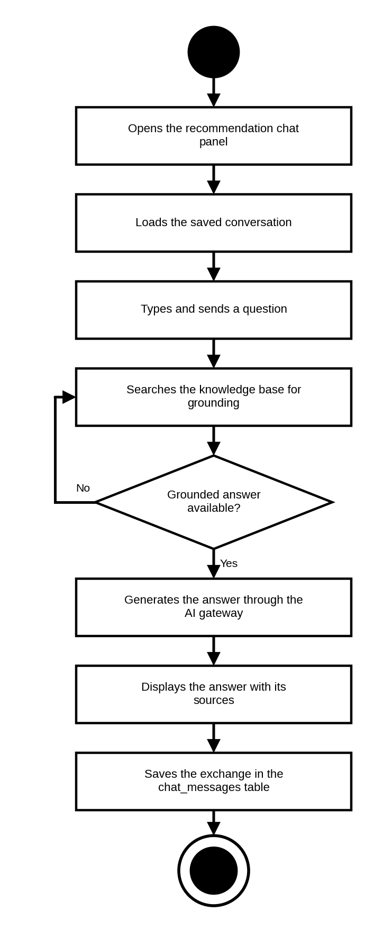
Figure 42. Activity Diagram for Students Using the AI Career Assistant
ACTIVITY DIAGRAM INVOLVING STUDENTS RECEIVING NOTIFICATIONS
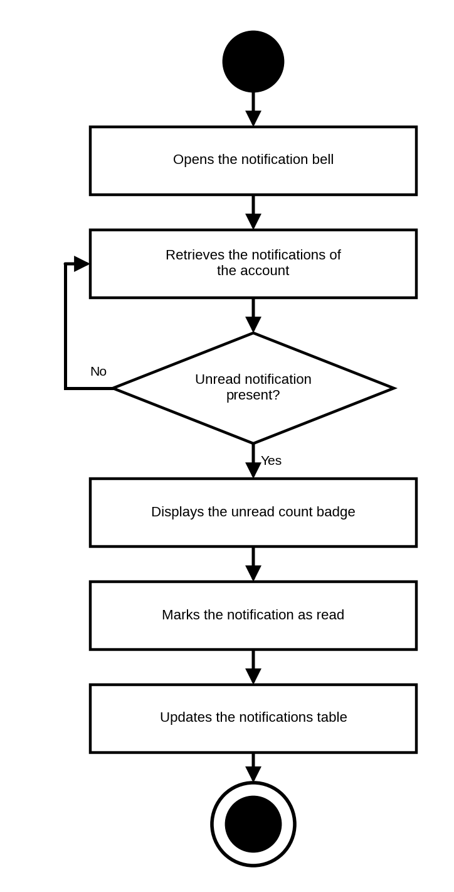
Figure 43. Activity Diagram for Students Receiving Notifications
ACTIVITY DIAGRAM INVOLVING STUDENTS VIEWING THEIR DASHBOARD
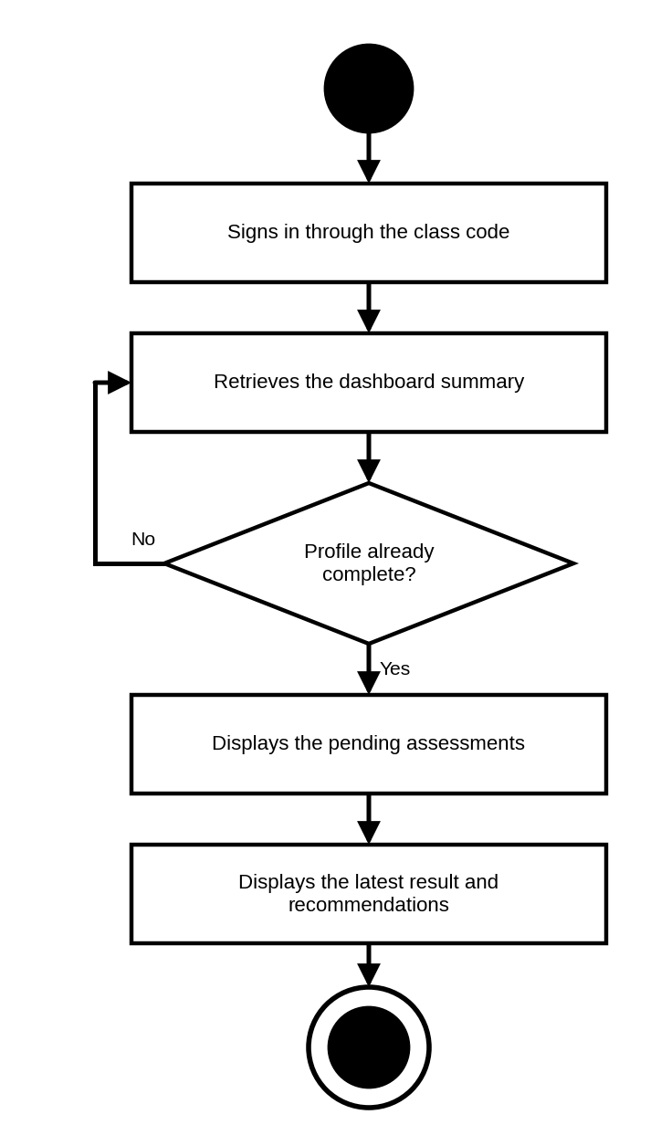
Figure 44. Activity Diagram for Students Viewing Their Dashboard
ACTIVITY DIAGRAM INVOLVING COUNSELORS LOGGING IN
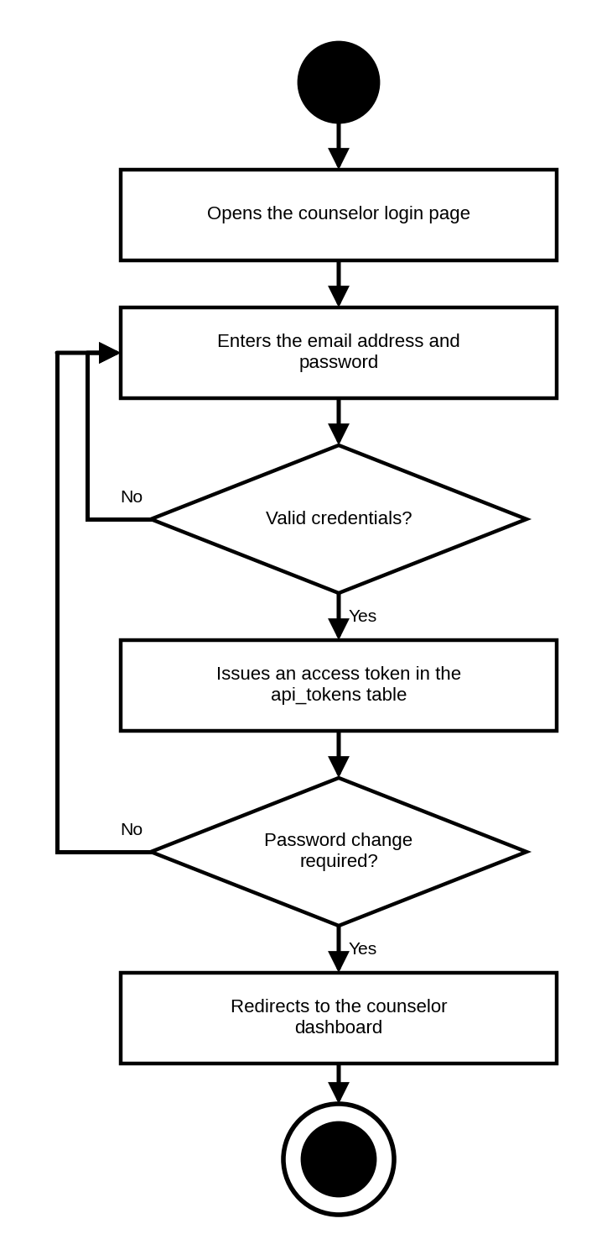
Figure 45. Activity Diagram for Counselors Logging In
ACTIVITY DIAGRAM INVOLVING COUNSELORS RESETTING PASSWORD
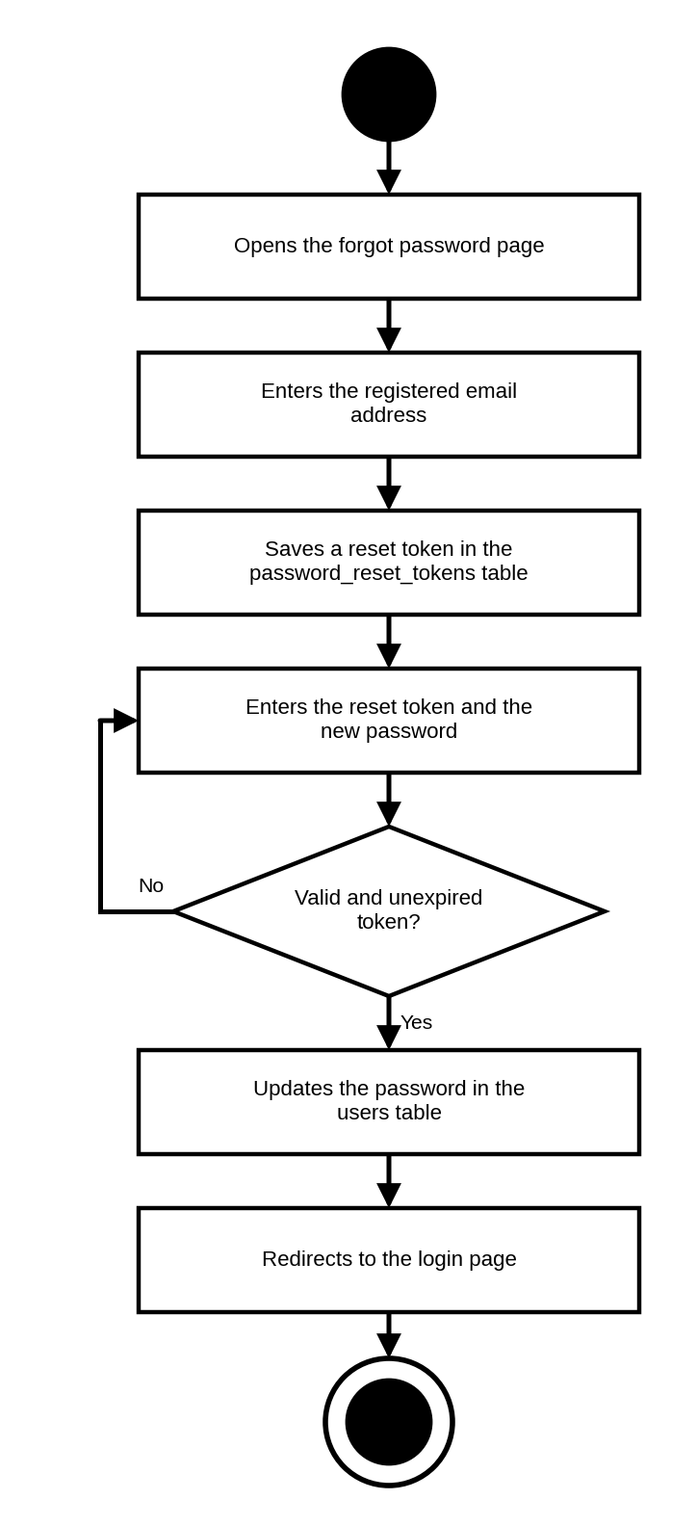
Figure 46. Activity Diagram for Counselors Resetting Password
ACTIVITY DIAGRAM INVOLVING COUNSELORS MANAGING CLASSES
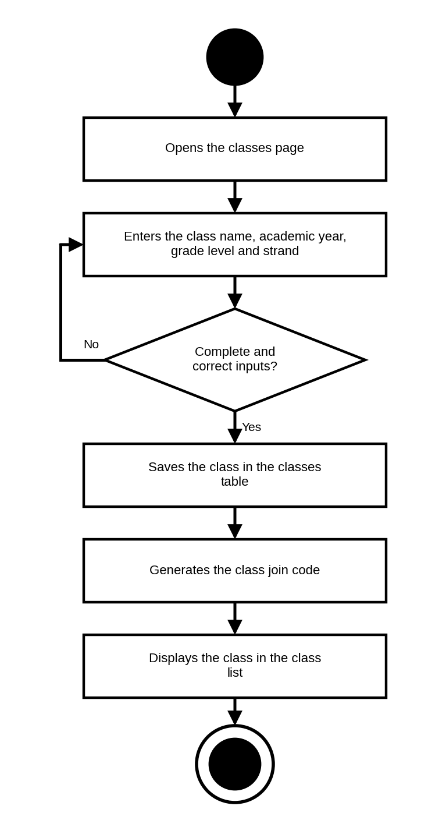
Figure 47. Activity Diagram for Counselors Managing Classes
ACTIVITY DIAGRAM INVOLVING COUNSELORS MANAGING THE JOIN CODE
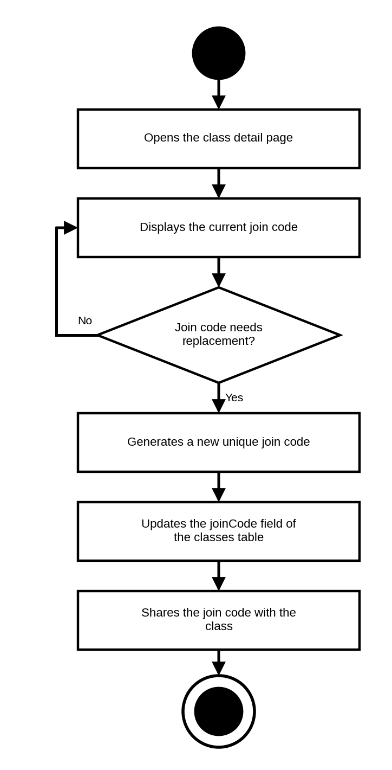
Figure 48. Activity Diagram for Counselors Managing the Join Code
ACTIVITY DIAGRAM INVOLVING COUNSELORS MANAGING THE CLASS ROSTER
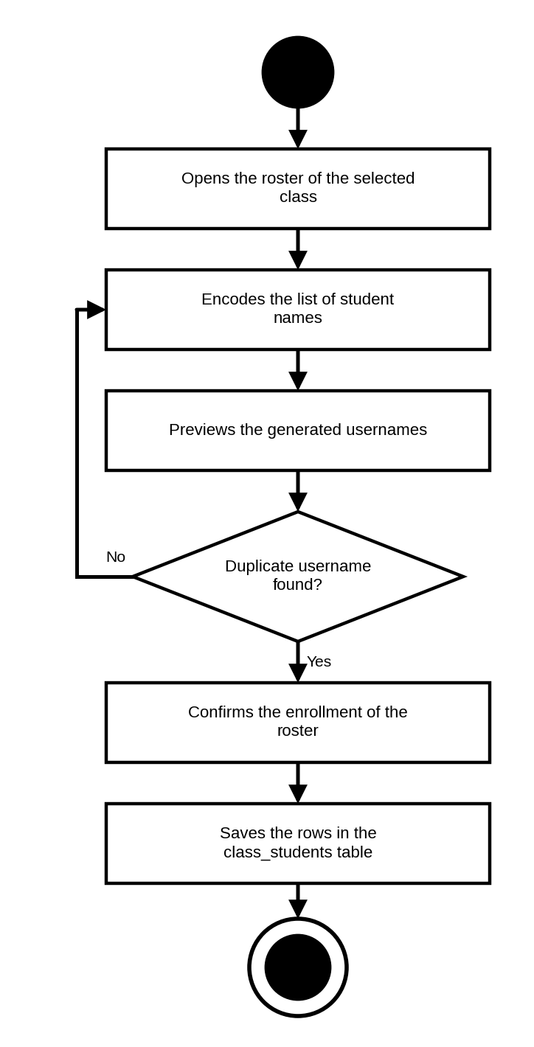
Figure 49. Activity Diagram for Counselors Managing the Class Roster
ACTIVITY DIAGRAM INVOLVING COUNSELORS ASSIGNING ASSESSMENTS
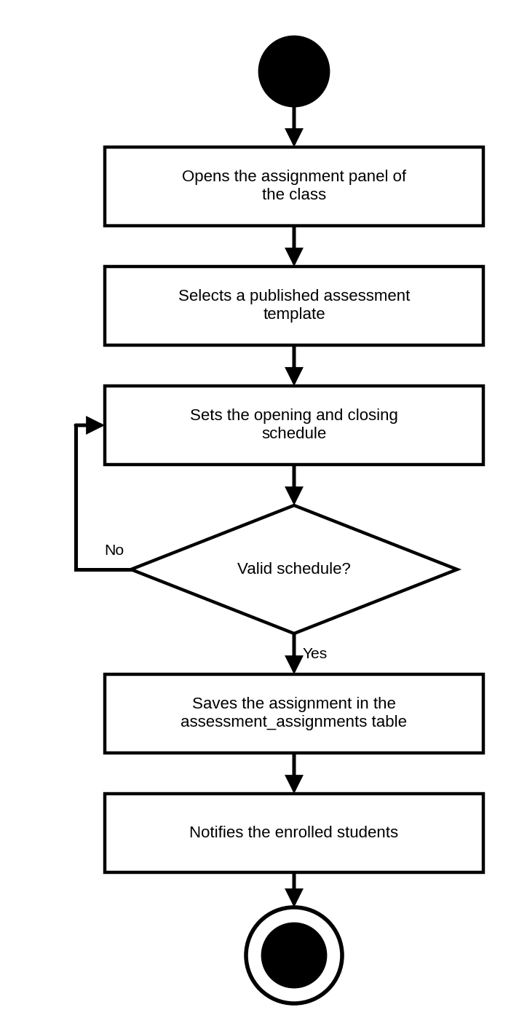
Figure 50. Activity Diagram for Counselors Assigning Assessments
ACTIVITY DIAGRAM INVOLVING COUNSELORS AUTHORING A CUSTOM ASSESSMENT
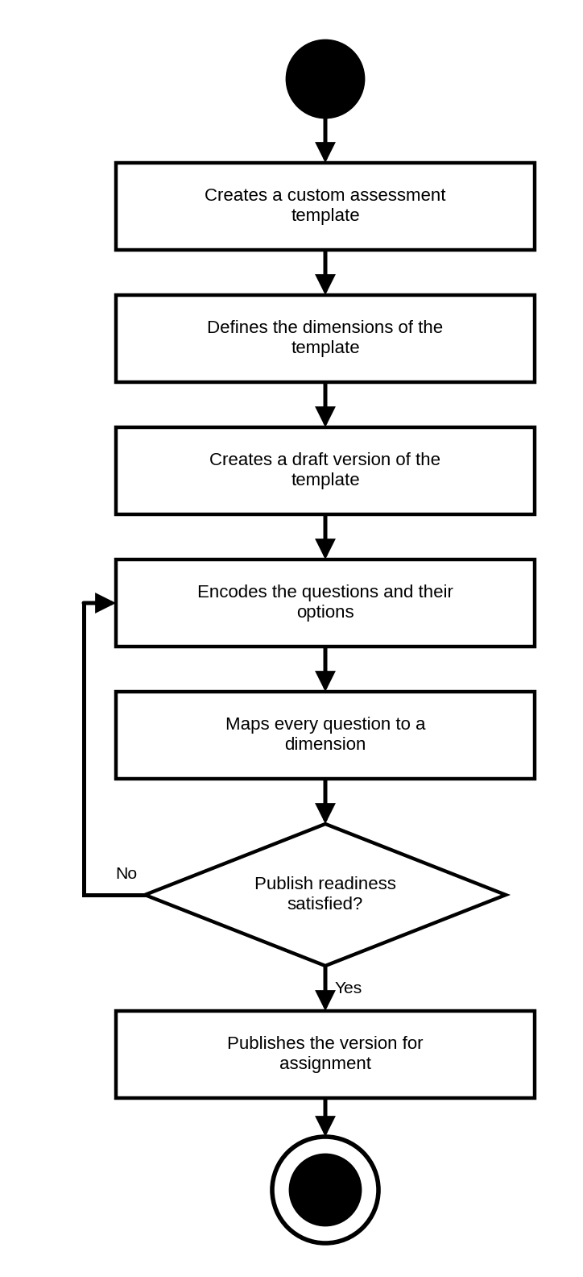
Figure 51. Activity Diagram for Counselors Authoring a Custom Assessment
ACTIVITY DIAGRAM INVOLVING COUNSELORS GENERATING ITEMS WITH AI
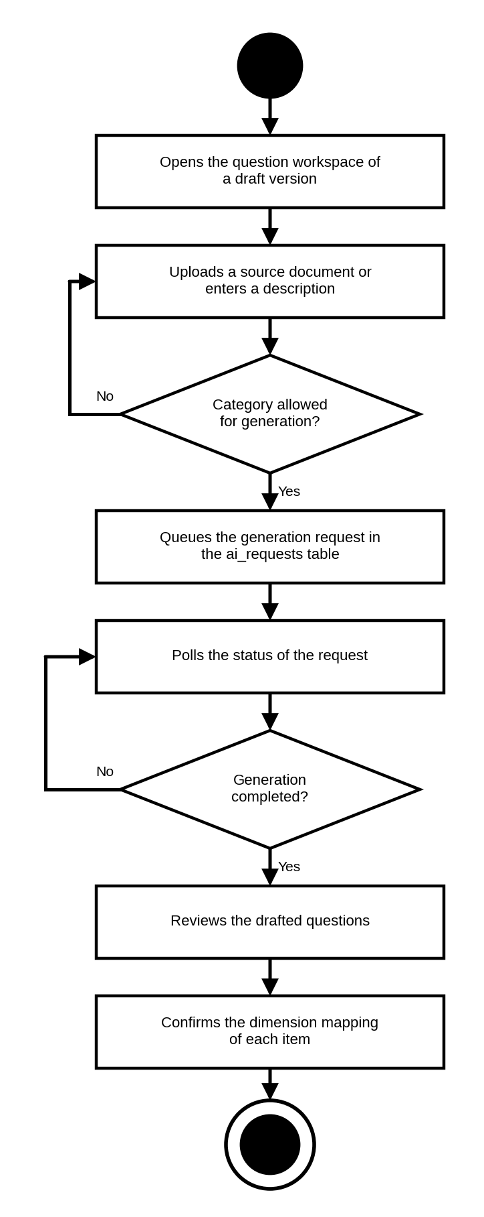
Figure 52. Activity Diagram for Counselors Generating Items with AI
ACTIVITY DIAGRAM INVOLVING COUNSELORS MONITORING CLASS RESULTS
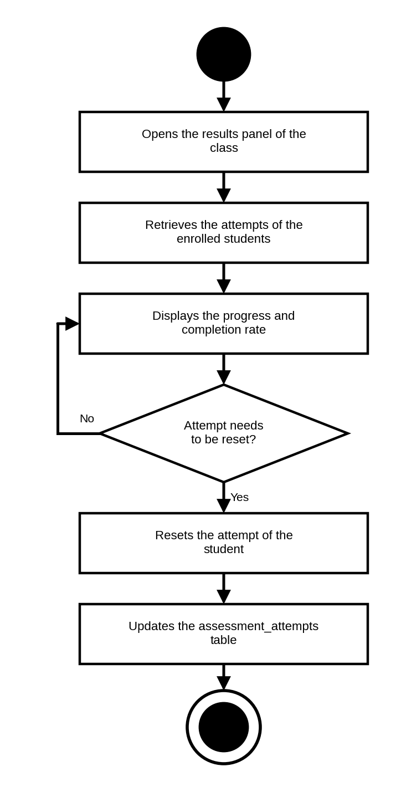
Figure 53. Activity Diagram for Counselors Monitoring Class Results
ACTIVITY DIAGRAM INVOLVING COUNSELORS REVIEWING RECOMMENDATIONS
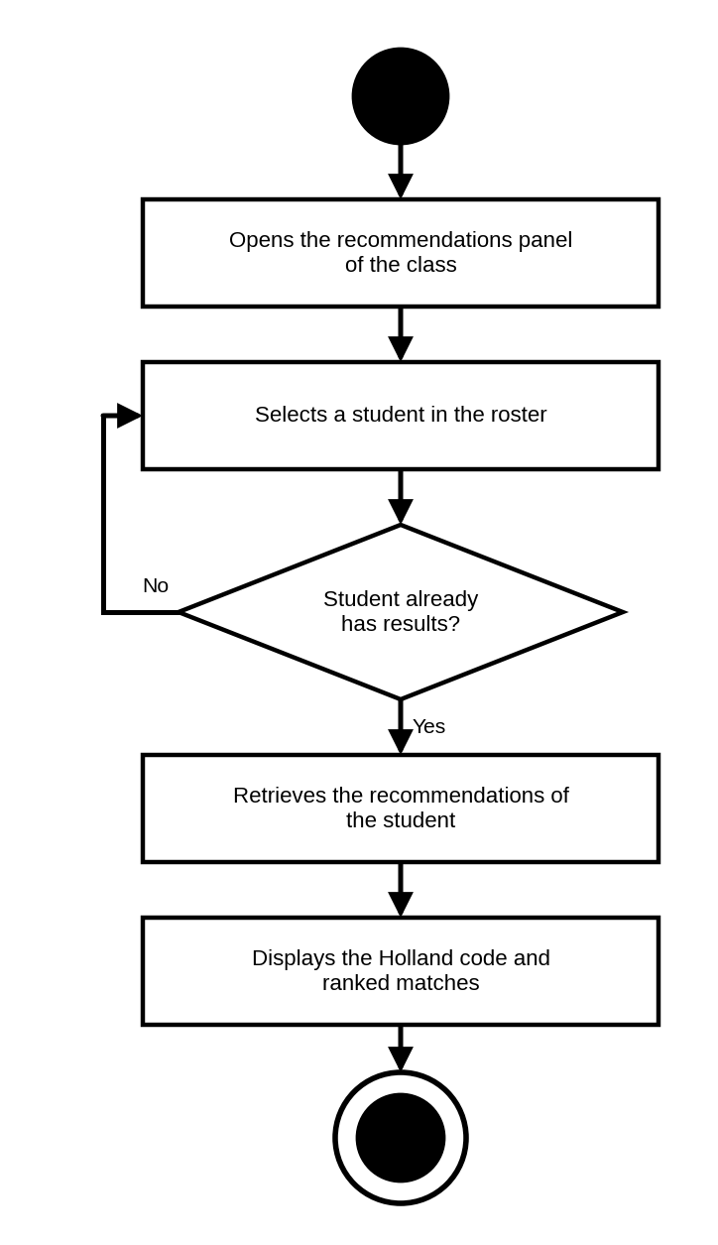
Figure 54. Activity Diagram for Counselors Reviewing Recommendations
ACTIVITY DIAGRAM INVOLVING COUNSELORS VIEWING THEIR DASHBOARD
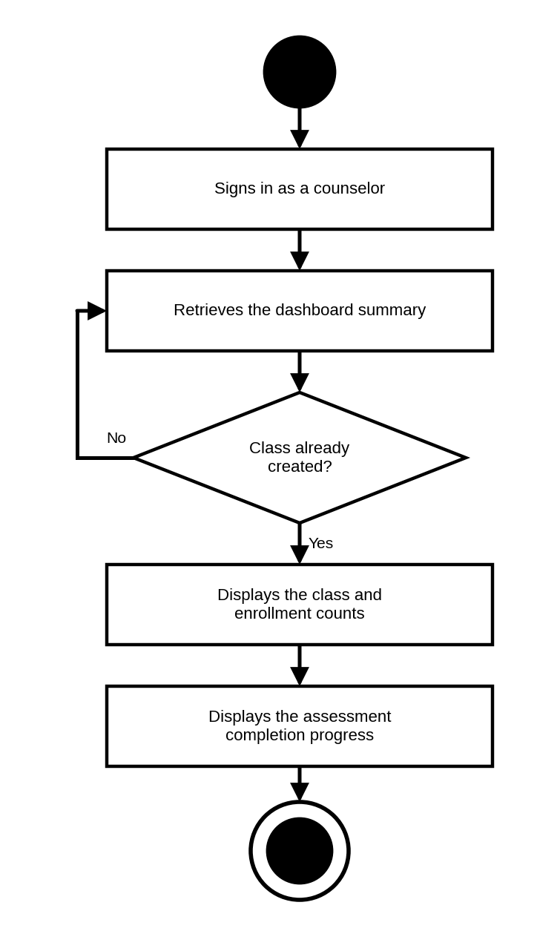
Figure 55. Activity Diagram for Counselors Viewing Their Dashboard
ACTIVITY DIAGRAM INVOLVING ADMINISTRATORS LOGGING IN
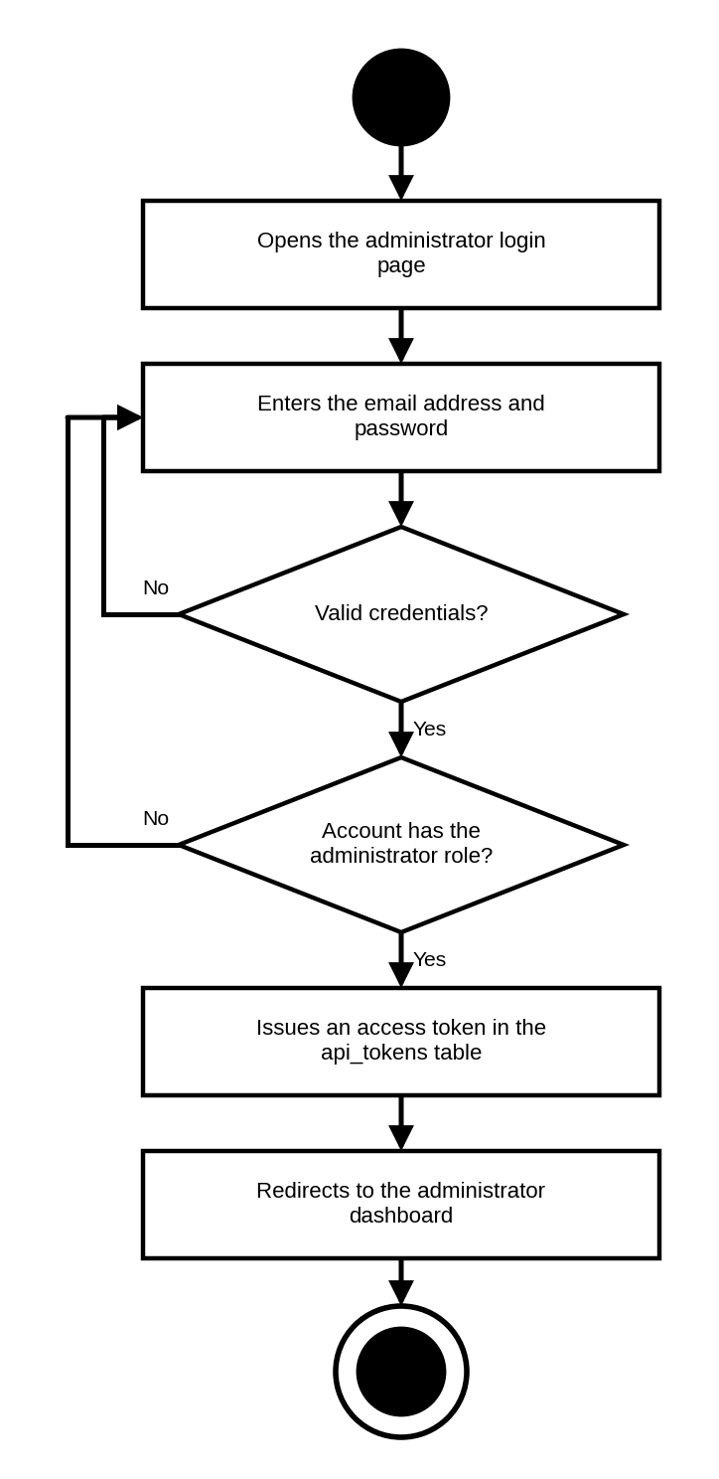
Figure 56. Activity Diagram for Administrators Logging In
ACTIVITY DIAGRAM INVOLVING ADMINISTRATORS MANAGING COUNSELOR ACCOUNTS
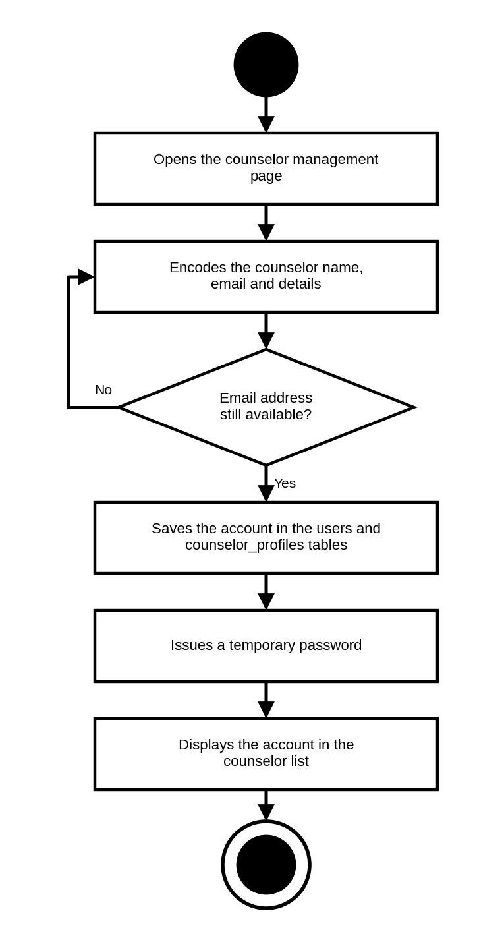
Figure 57. Activity Diagram for Administrators Managing Counselor Accounts
ACTIVITY DIAGRAM INVOLVING ADMINISTRATORS MANAGING COLLEGES AND PROGRAMS
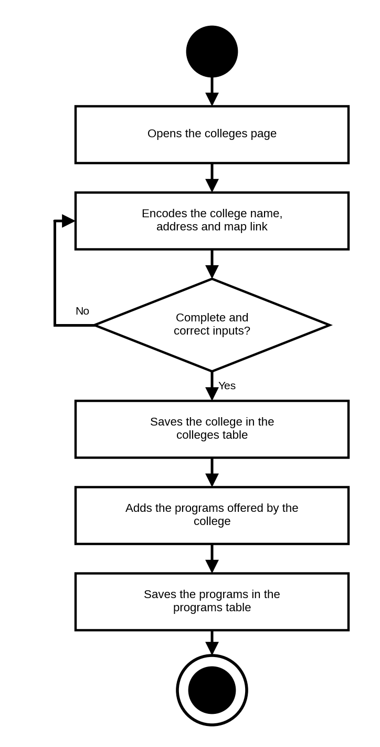
Figure 58. Activity Diagram for Administrators Managing Colleges and Programs
ACTIVITY DIAGRAM INVOLVING ADMINISTRATORS MANAGING CAREERS
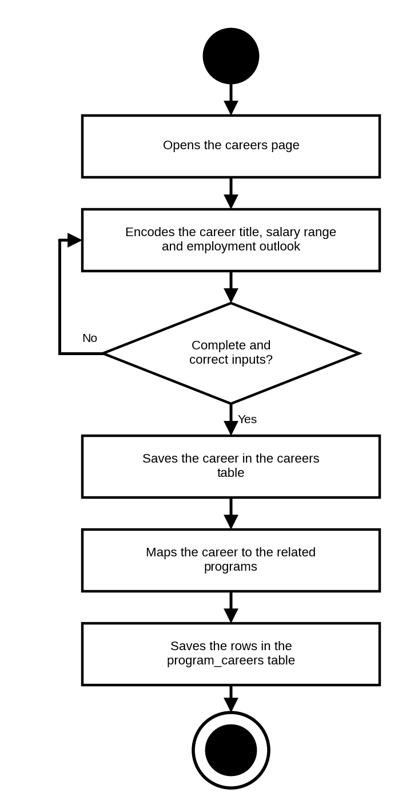
Figure 59. Activity Diagram for Administrators Managing Careers
ACTIVITY DIAGRAM INVOLVING ADMINISTRATORS MANAGING CANONICAL PROGRAMS
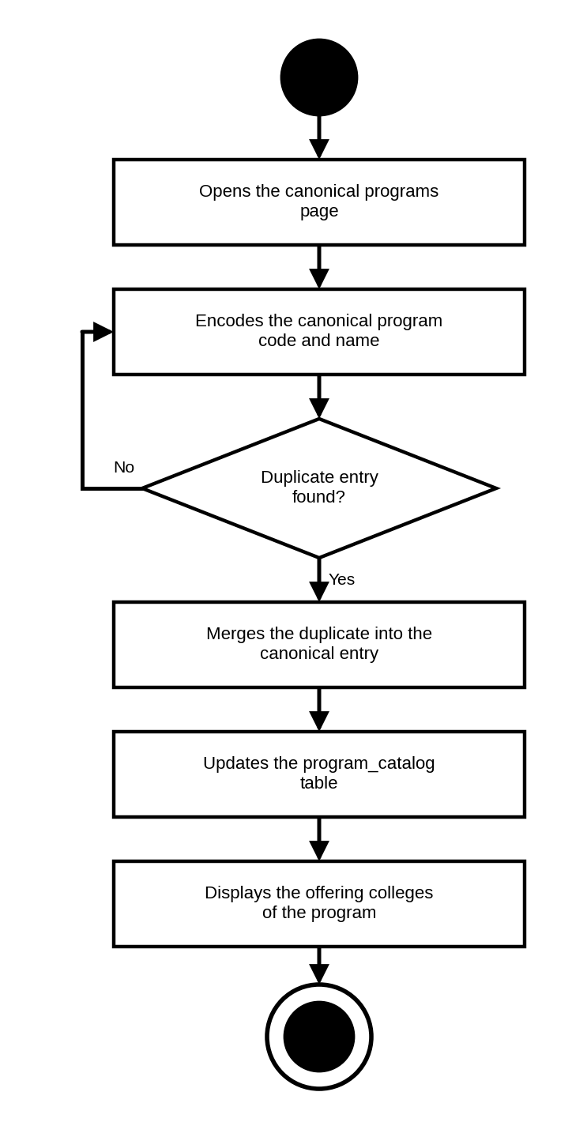
Figure 60. Activity Diagram for Administrators Managing Canonical Programs
ACTIVITY DIAGRAM INVOLVING ADMINISTRATORS MANAGING ADDRESS RECORDS
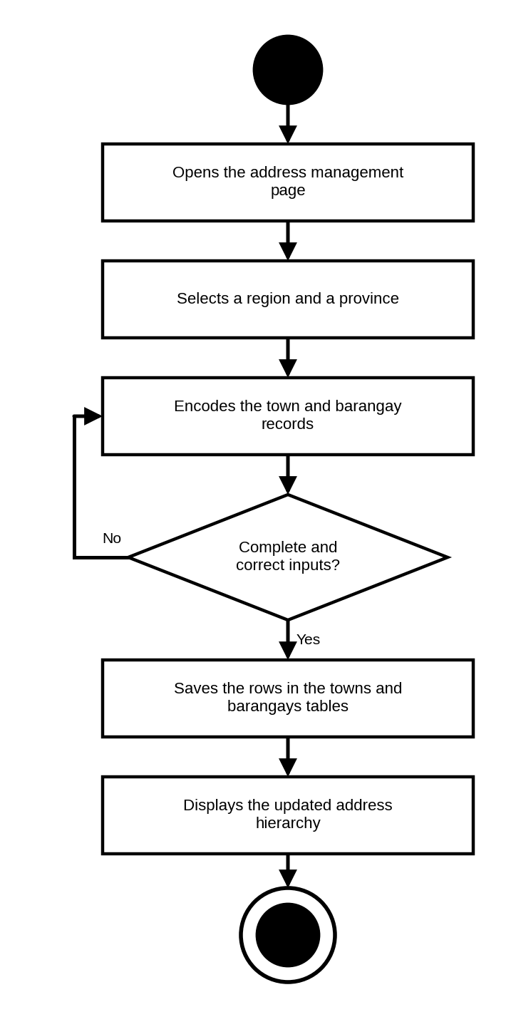
Figure 61. Activity Diagram for Administrators Managing Address Records
ACTIVITY DIAGRAM INVOLVING ADMINISTRATORS MANAGING THE KNOWLEDGE BASE
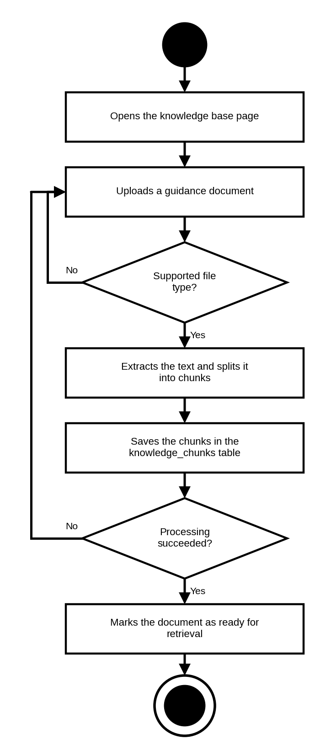
Figure 62. Activity Diagram for Administrators Managing the Knowledge Base
ACTIVITY DIAGRAM INVOLVING ADMINISTRATORS MANAGING THE AI POLICY
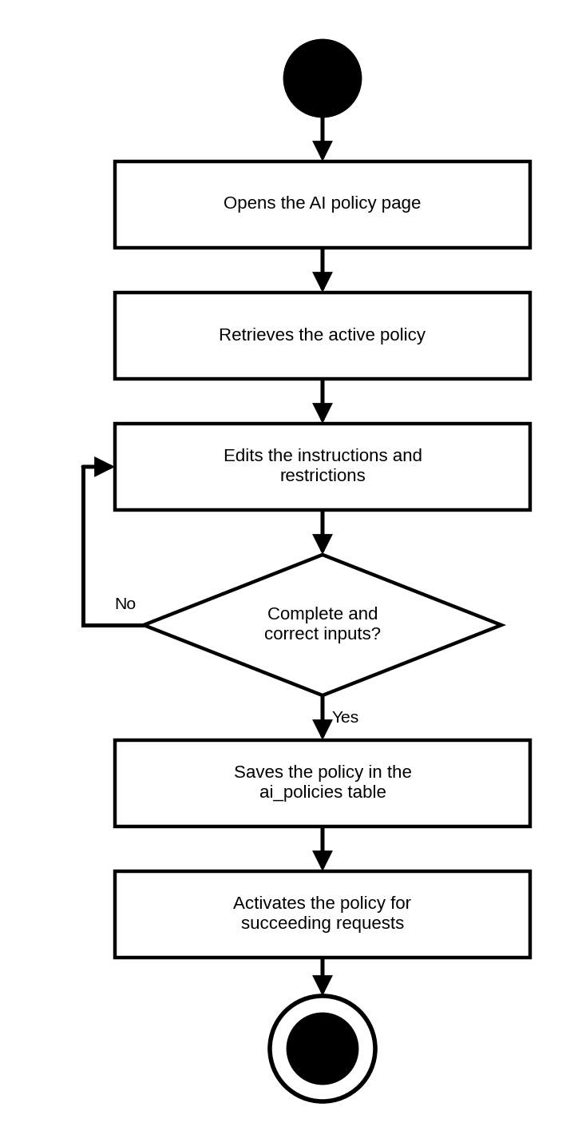
Figure 63. Activity Diagram for Administrators Managing the AI Policy
ACTIVITY DIAGRAM INVOLVING ADMINISTRATORS MONITORING AI AND PLATFORM USAGE
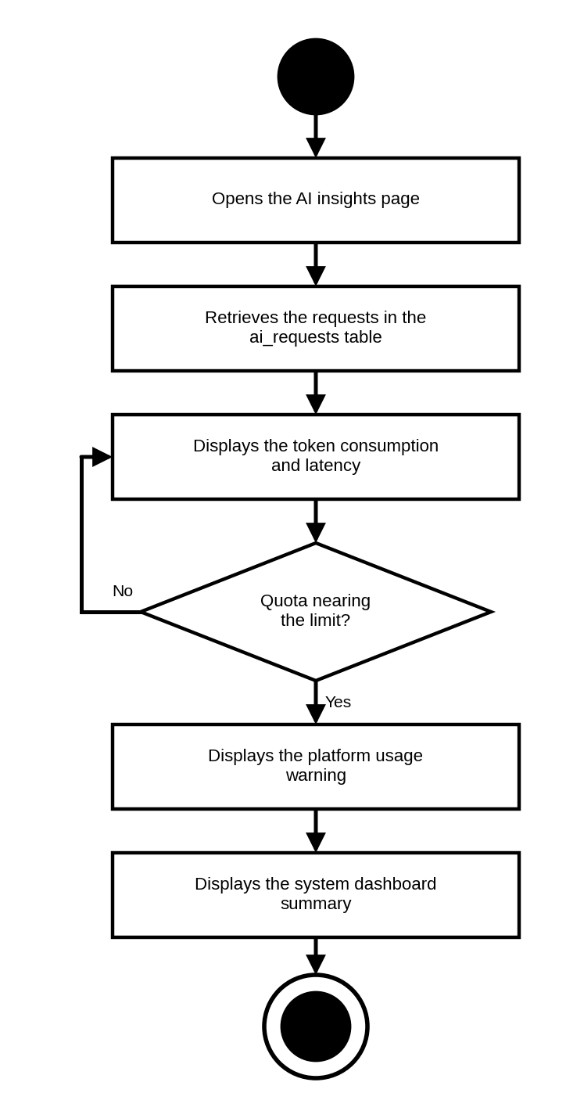
Figure 64. Activity Diagram for Administrators Monitoring AI and Platform Usage
ACTIVITY DIAGRAM INVOLVING ADMINISTRATORS REVIEWING THE AUDIT LOG
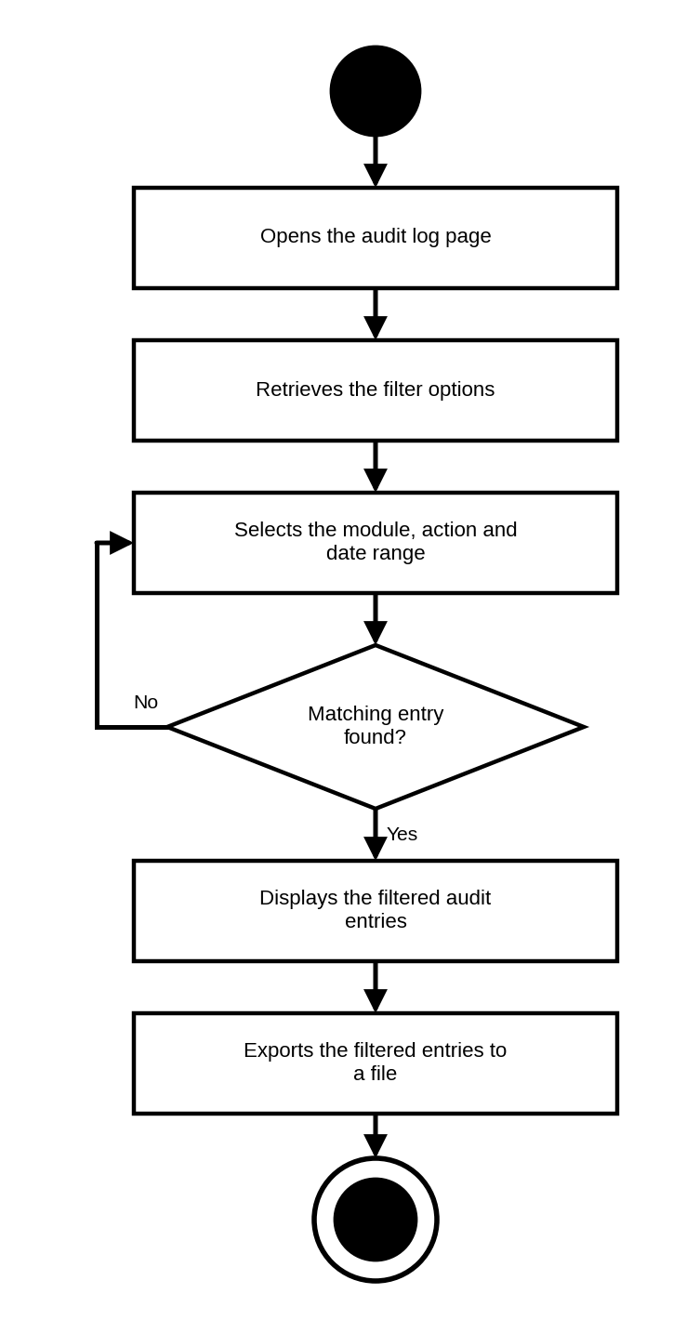
Figure 65. Activity Diagram for Administrators Reviewing the Audit Log
Sequence Diagram
The sequence diagrams depict the interaction between the students, counselors, administrators, and the database tables of CareerLinkAI, highlighting processes such as authentication, class enrollment, assessment administration, deterministic scoring, recommendation matching, and artificial intelligence grounding. These diagrams provide a detailed visualization of how a user action is translated into the operations performed on each table and what the system returns in response.
SEQUENCE DIAGRAM INVOLVING STUDENTS JOINING A CLASS
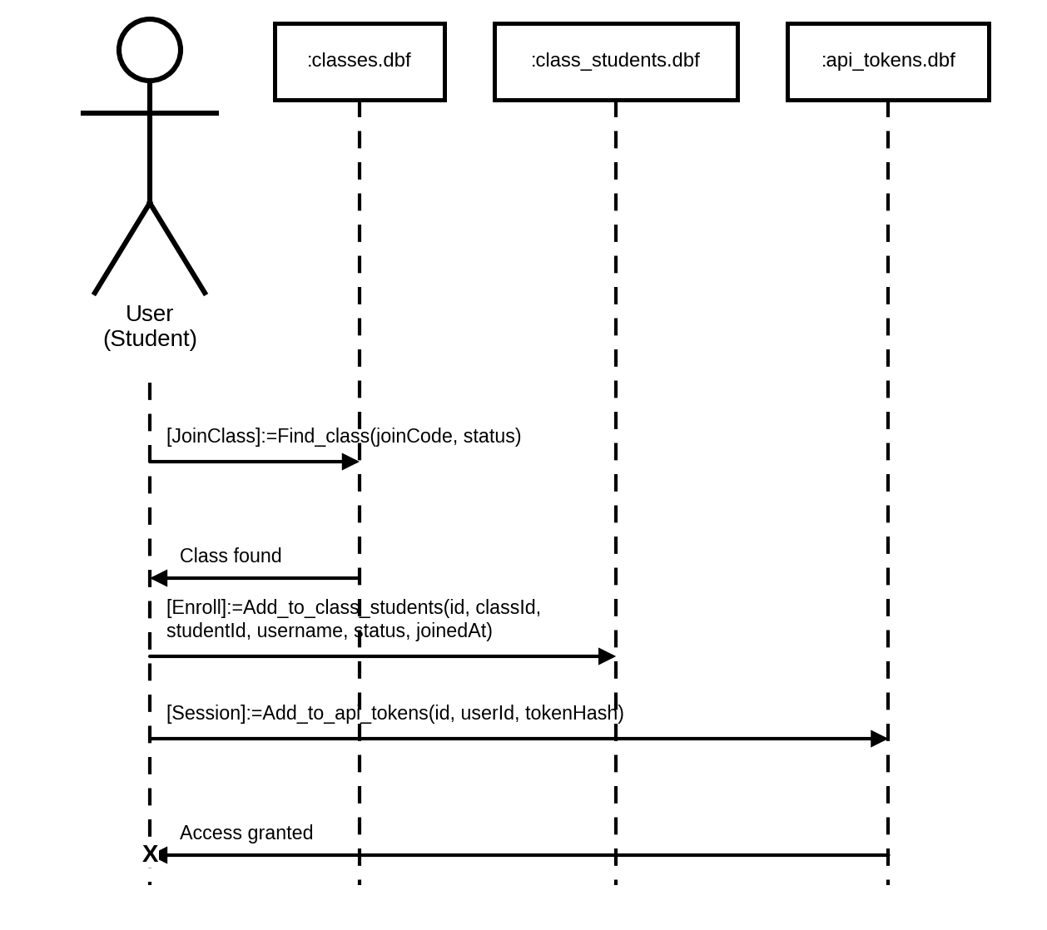
Figure 66. Sequence Diagram for Students Joining a Class
SEQUENCE DIAGRAM INVOLVING STUDENTS COMPLETING THEIR PROFILE
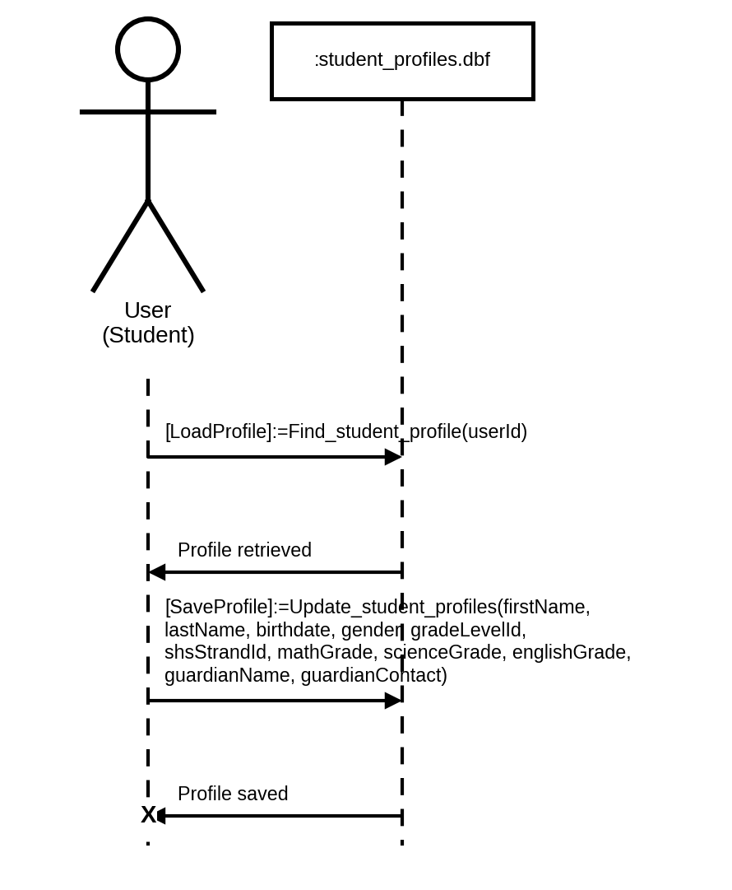
Figure 67. Sequence Diagram for Students Completing Their Profile
SEQUENCE DIAGRAM INVOLVING STUDENTS VIEWING ASSIGNED ASSESSMENTS
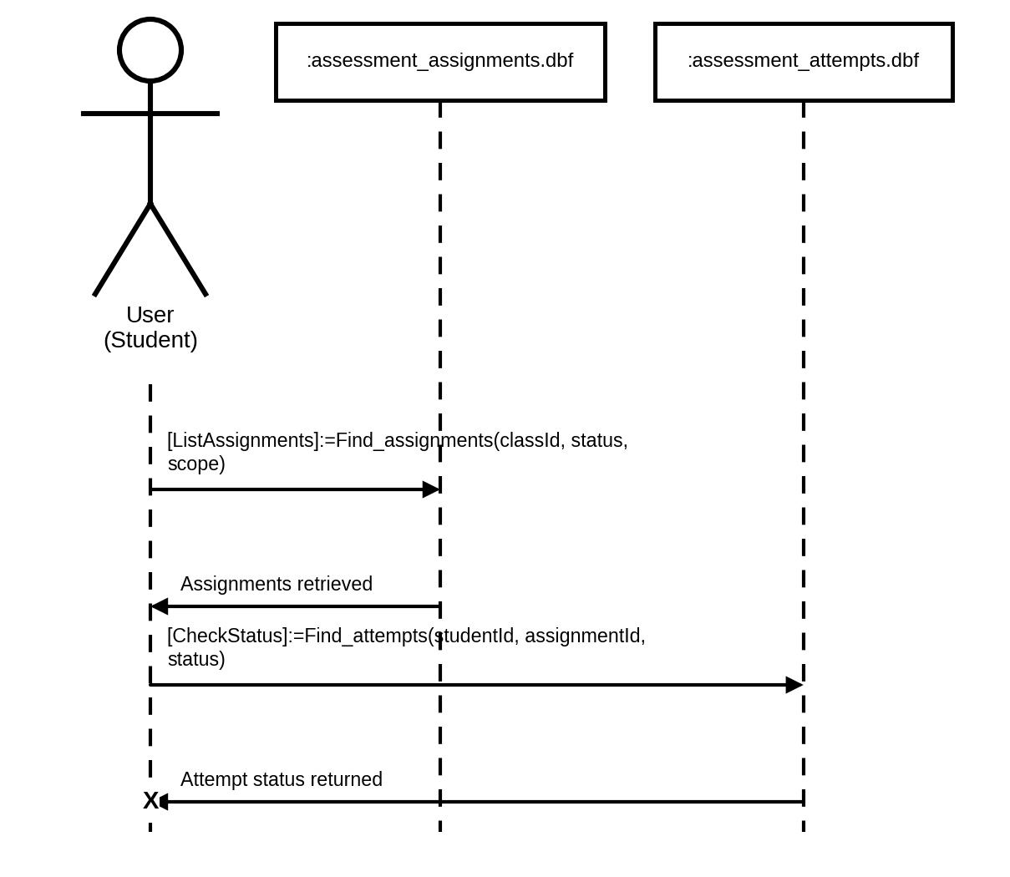
Figure 68. Sequence Diagram for Students Viewing Assigned Assessments
SEQUENCE DIAGRAM INVOLVING STUDENTS TAKING AN ASSESSMENT
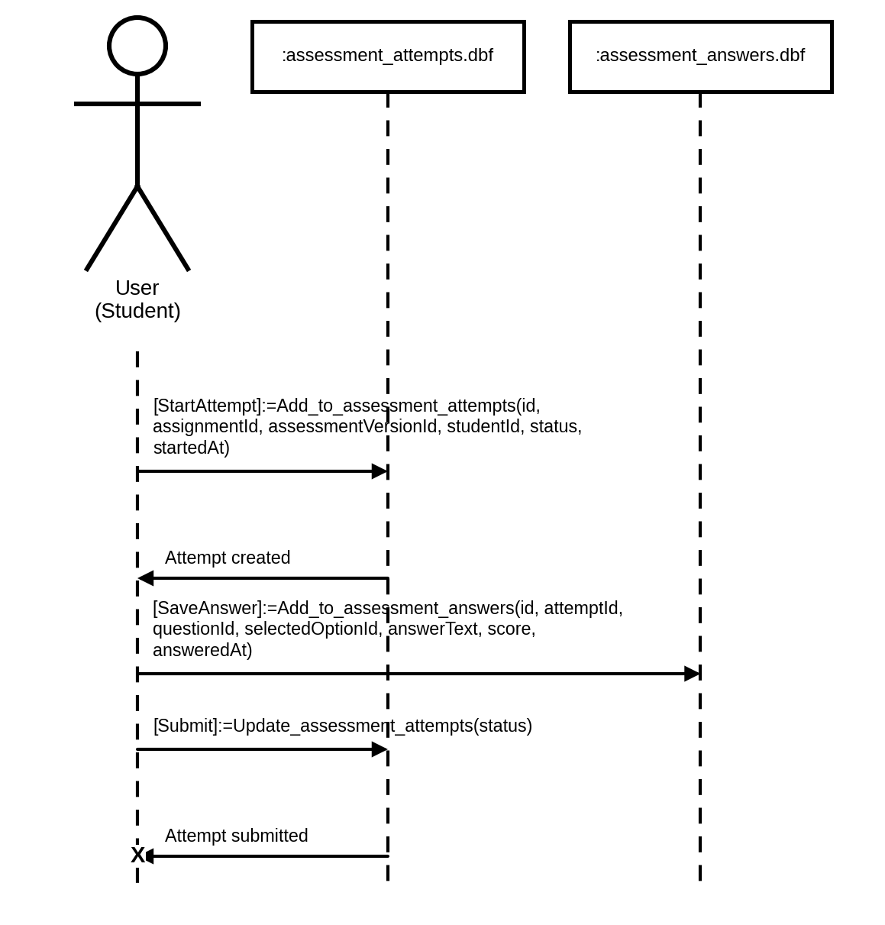
Figure 69. Sequence Diagram for Students Taking an Assessment
SEQUENCE DIAGRAM INVOLVING STUDENTS VIEWING ASSESSMENT RESULTS
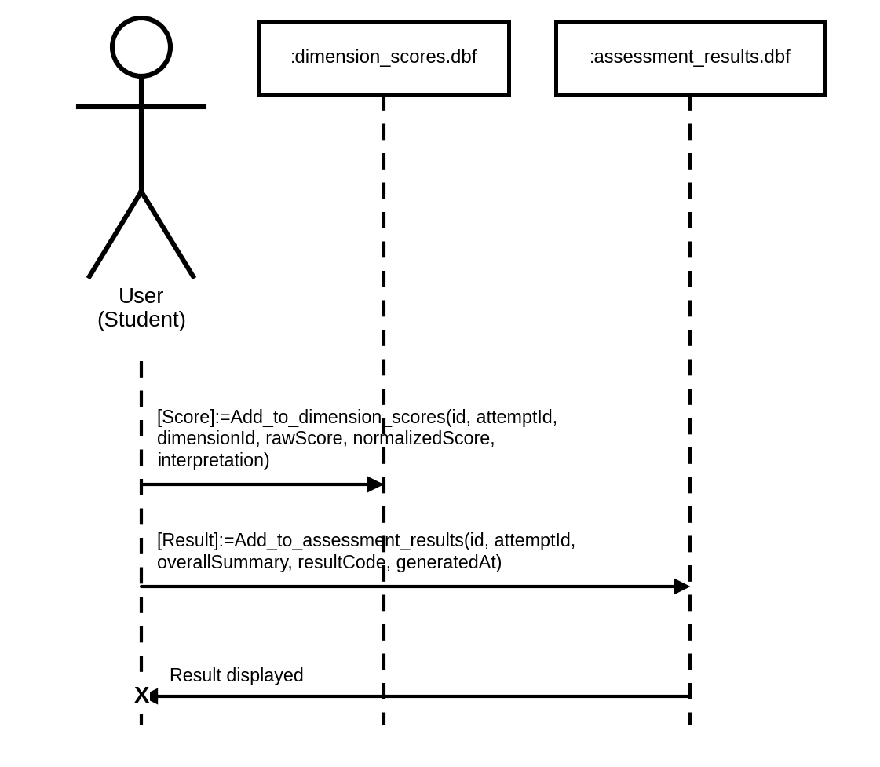
Figure 70. Sequence Diagram for Students Viewing Assessment Results
SEQUENCE DIAGRAM INVOLVING STUDENTS VIEWING RECOMMENDATIONS
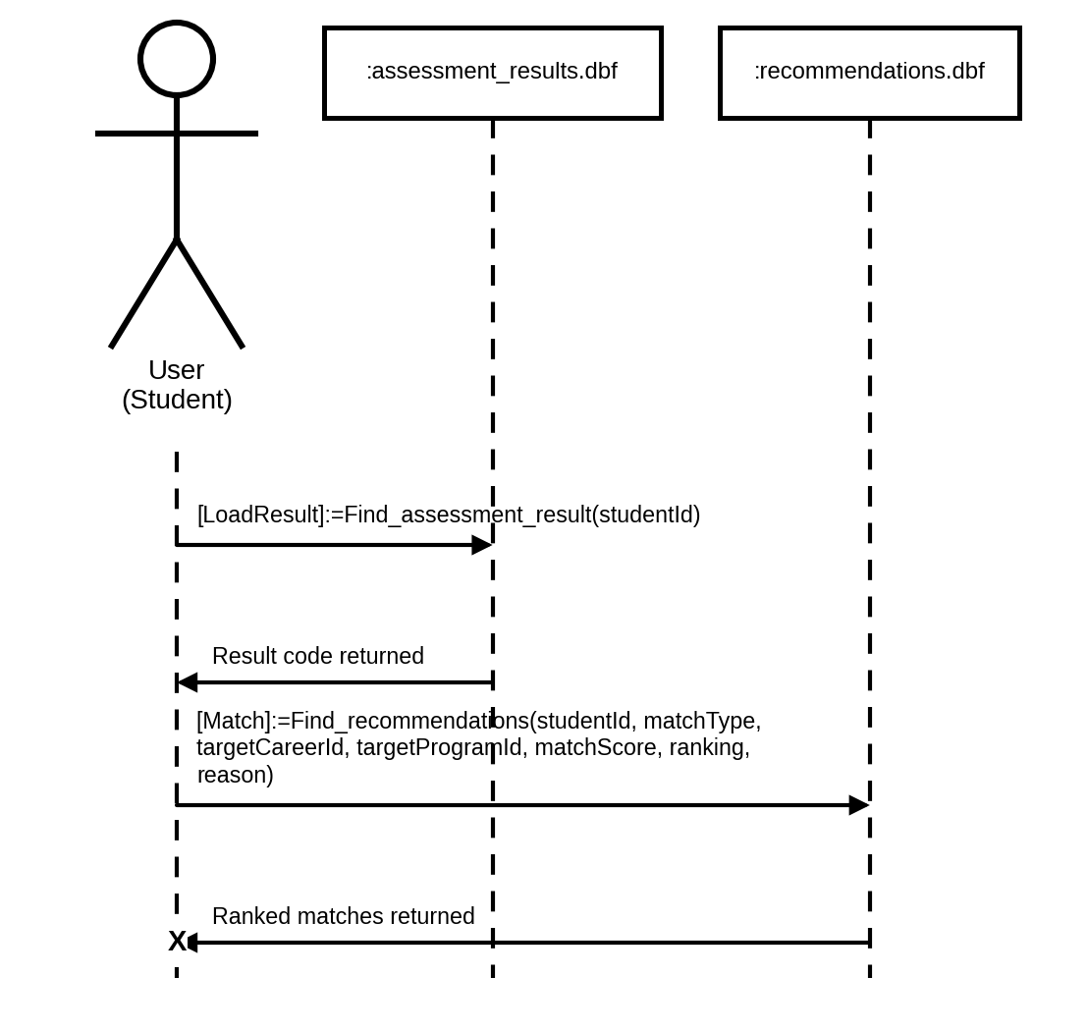
Figure 71. Sequence Diagram for Students Viewing Recommendations
SEQUENCE DIAGRAM INVOLVING STUDENTS REQUESTING AN EXPLANATION
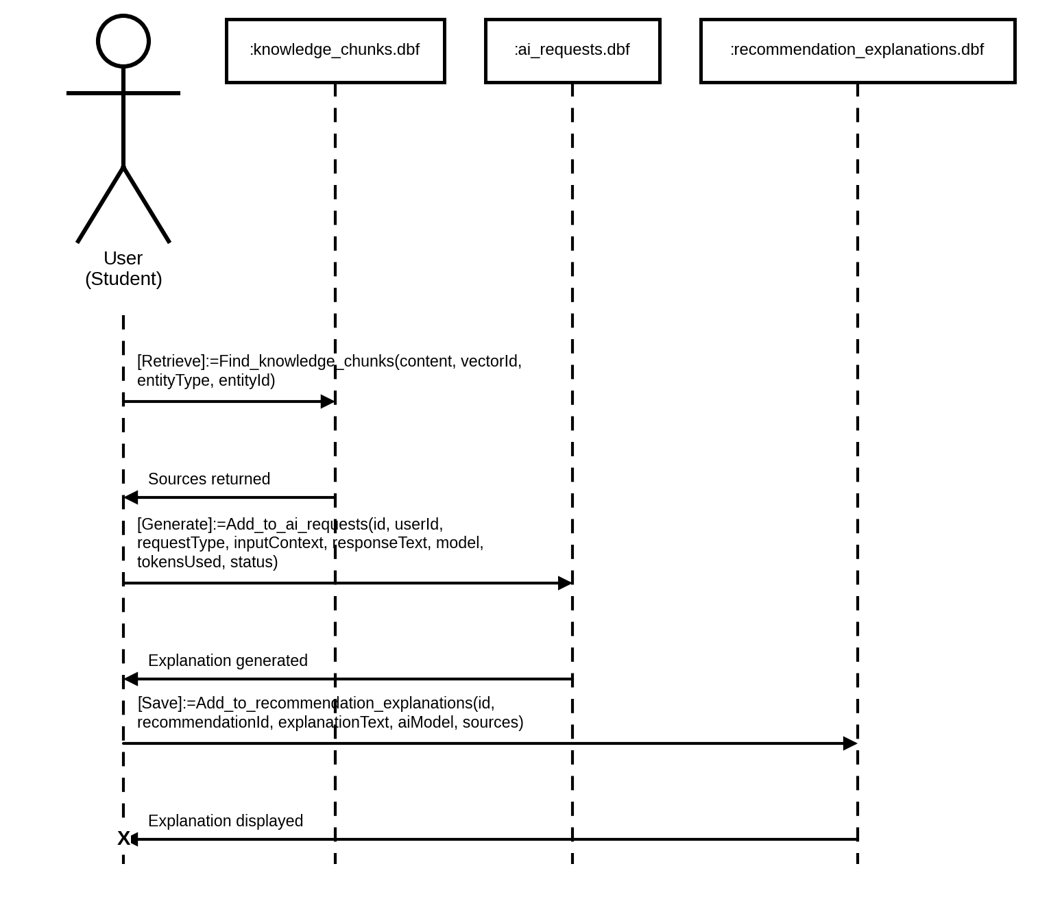
Figure 72. Sequence Diagram for Students Requesting an Explanation
SEQUENCE DIAGRAM INVOLVING STUDENTS EXPLORING COLLEGES AND CAREERS
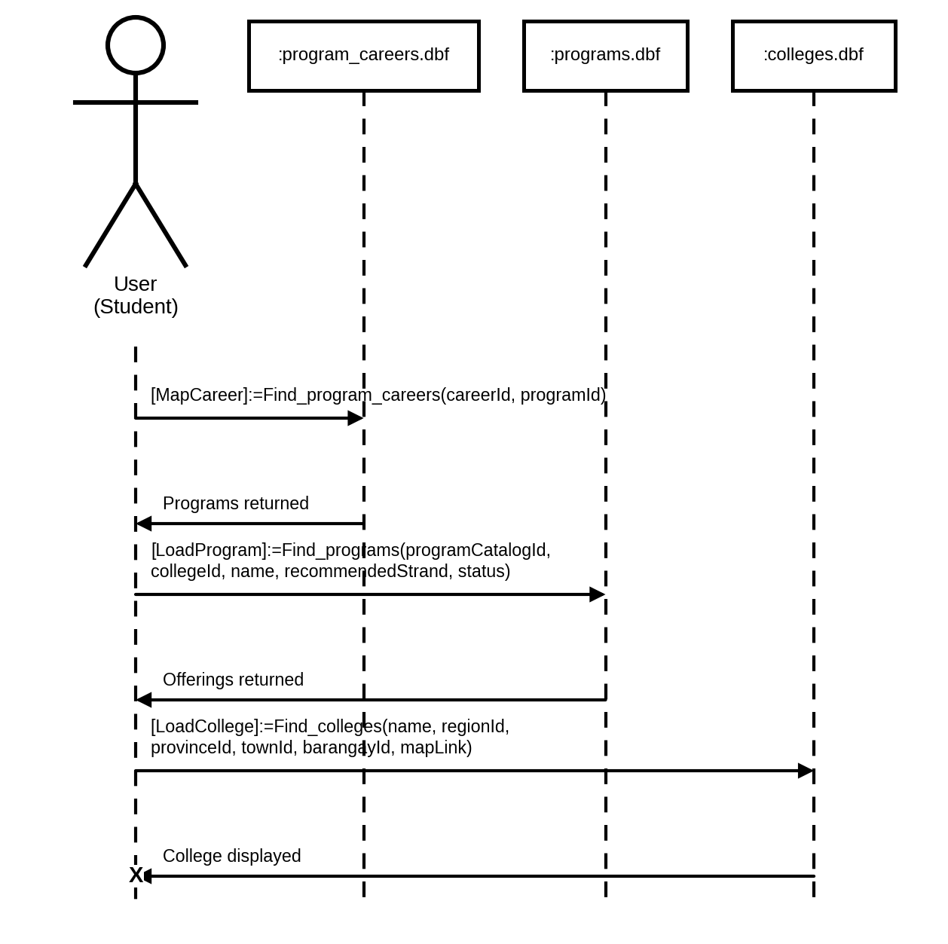
Figure 73. Sequence Diagram for Students Exploring Colleges and Careers
SEQUENCE DIAGRAM INVOLVING STUDENTS USING THE AI CAREER ASSISTANT
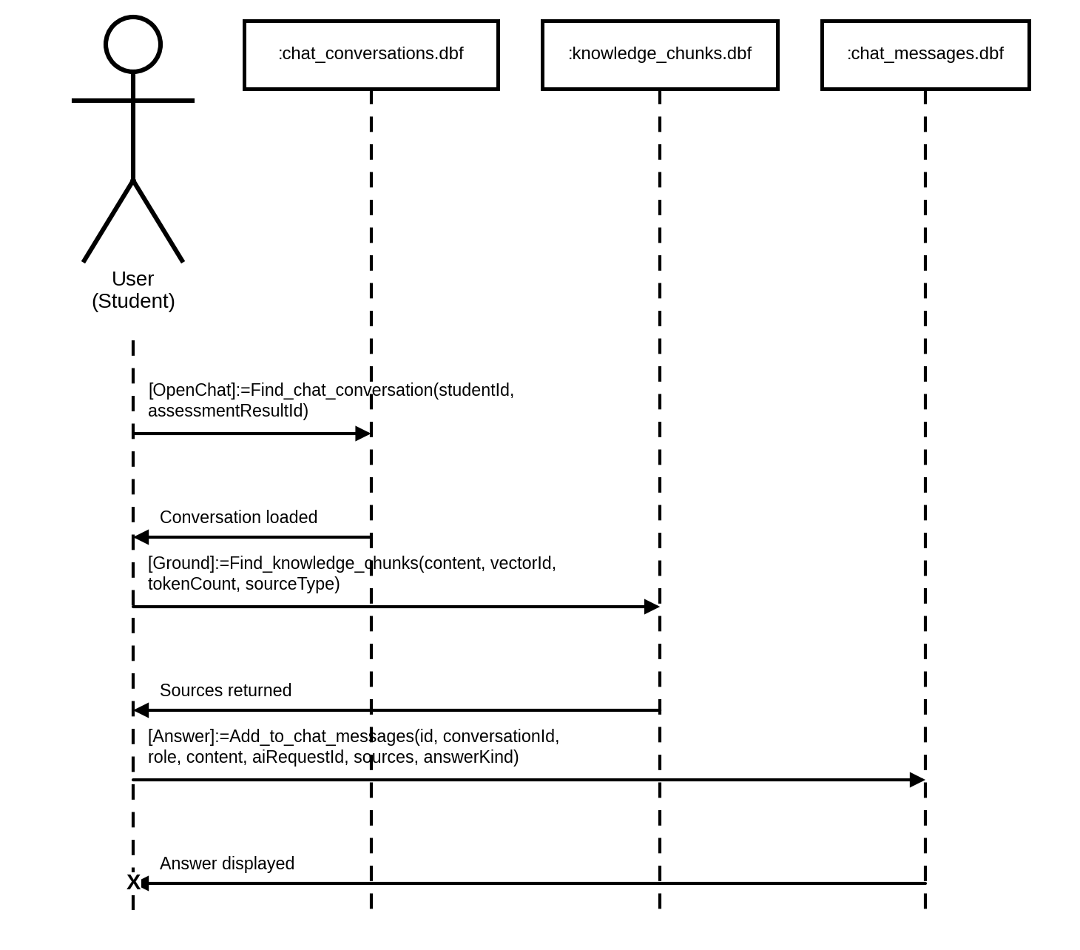
Figure 74. Sequence Diagram for Students Using the AI Career Assistant
SEQUENCE DIAGRAM INVOLVING STUDENTS RECEIVING NOTIFICATIONS
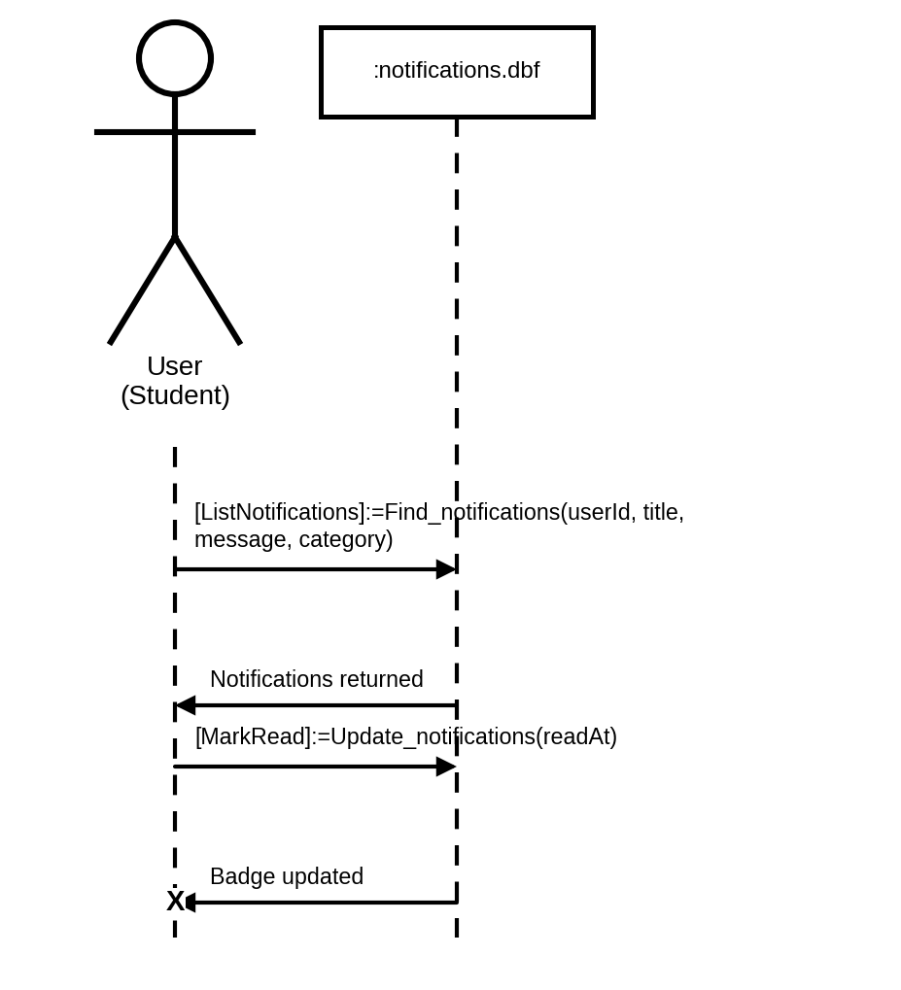
Figure 75. Sequence Diagram for Students Receiving Notifications
SEQUENCE DIAGRAM INVOLVING STUDENTS VIEWING THEIR DASHBOARD
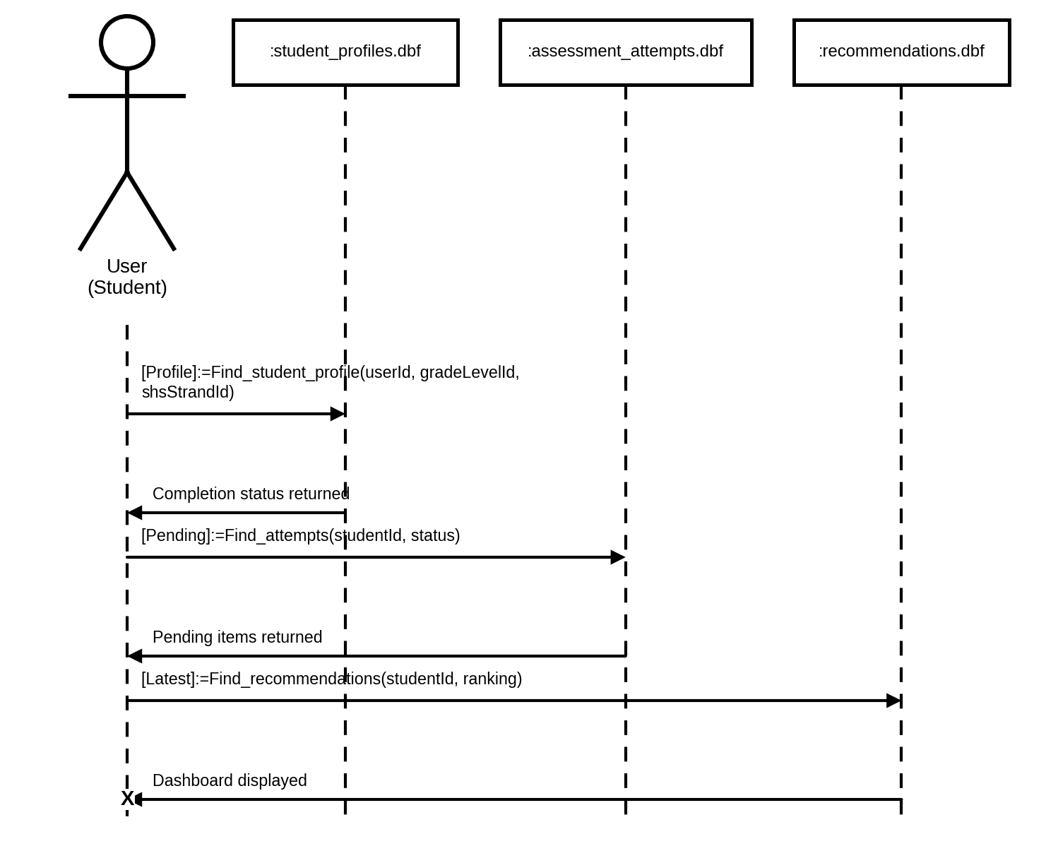
Figure 76. Sequence Diagram for Students Viewing Their Dashboard
SEQUENCE DIAGRAM INVOLVING COUNSELORS LOGGING IN
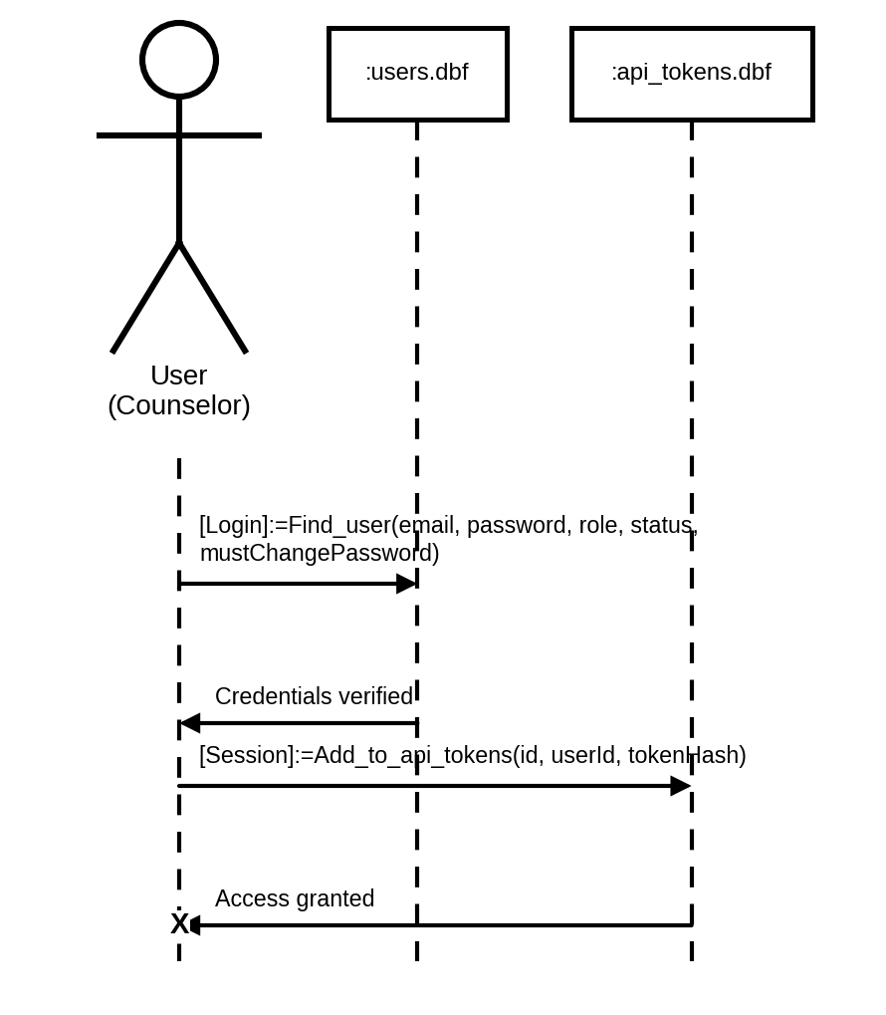
Figure 77. Sequence Diagram for Counselors Logging In
SEQUENCE DIAGRAM INVOLVING COUNSELORS RESETTING PASSWORD
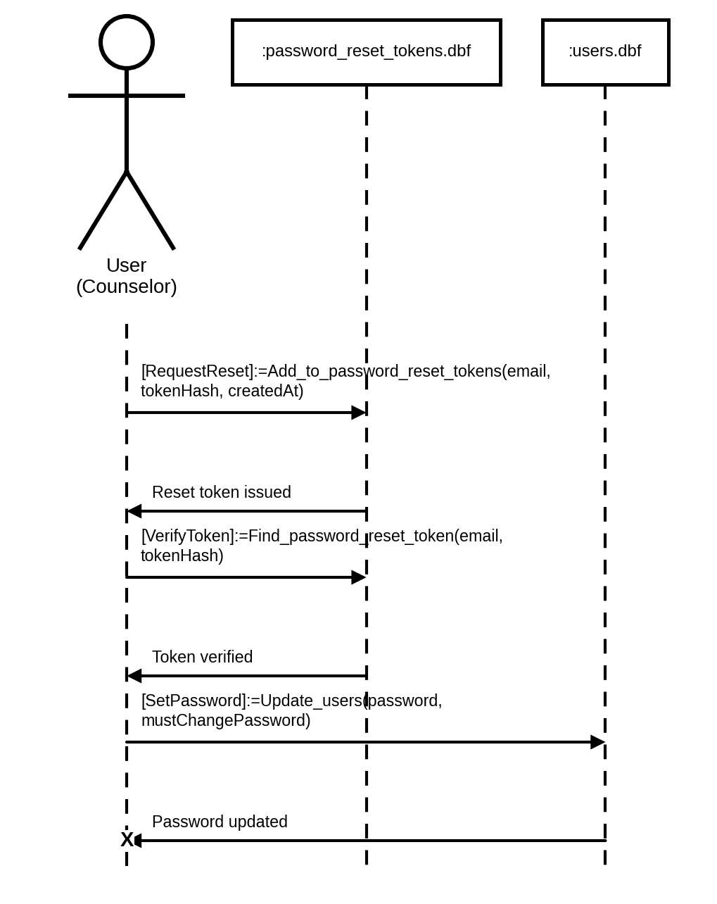
Figure 78. Sequence Diagram for Counselors Resetting Password
SEQUENCE DIAGRAM INVOLVING COUNSELORS MANAGING CLASSES
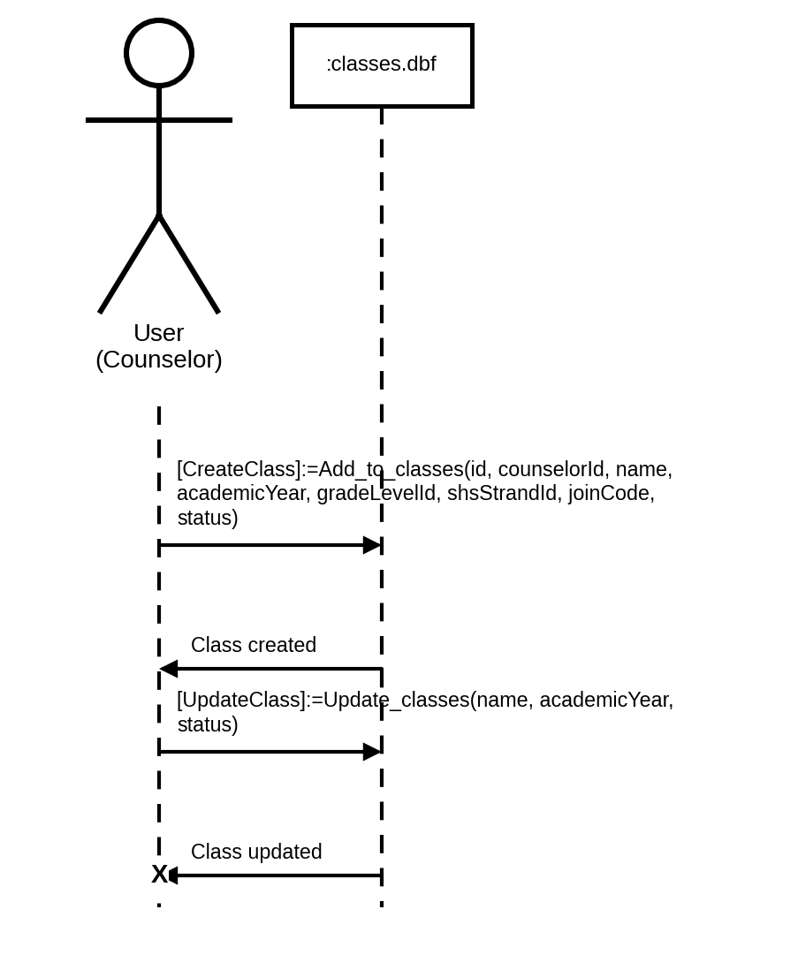
Figure 79. Sequence Diagram for Counselors Managing Classes
SEQUENCE DIAGRAM INVOLVING COUNSELORS MANAGING THE JOIN CODE
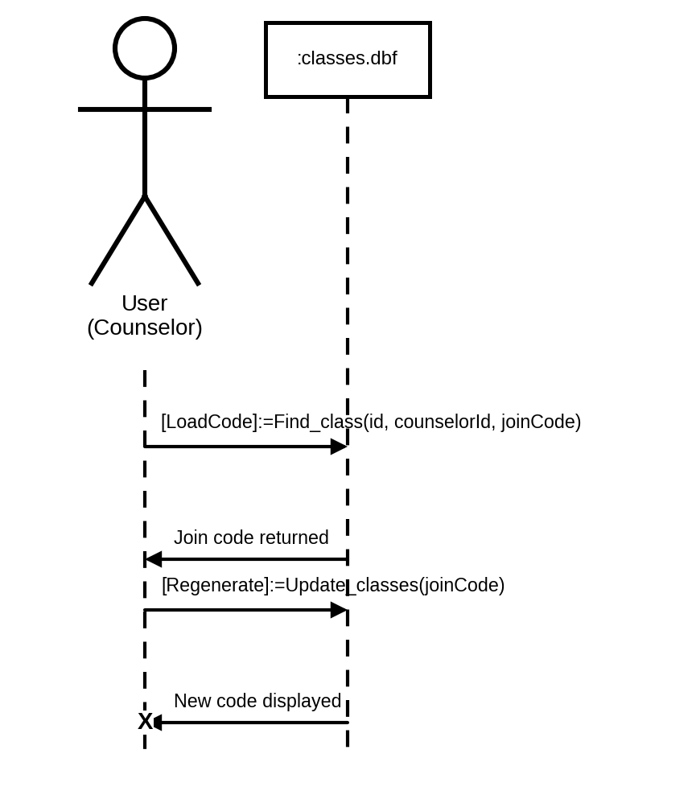
Figure 80. Sequence Diagram for Counselors Managing the Join Code
SEQUENCE DIAGRAM INVOLVING COUNSELORS MANAGING THE CLASS ROSTER
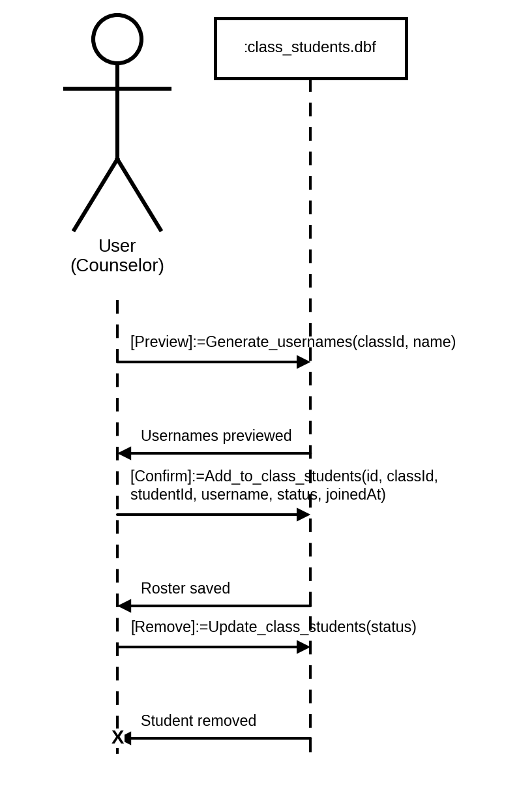
Figure 81. Sequence Diagram for Counselors Managing the Class Roster
SEQUENCE DIAGRAM INVOLVING COUNSELORS ASSIGNING ASSESSMENTS
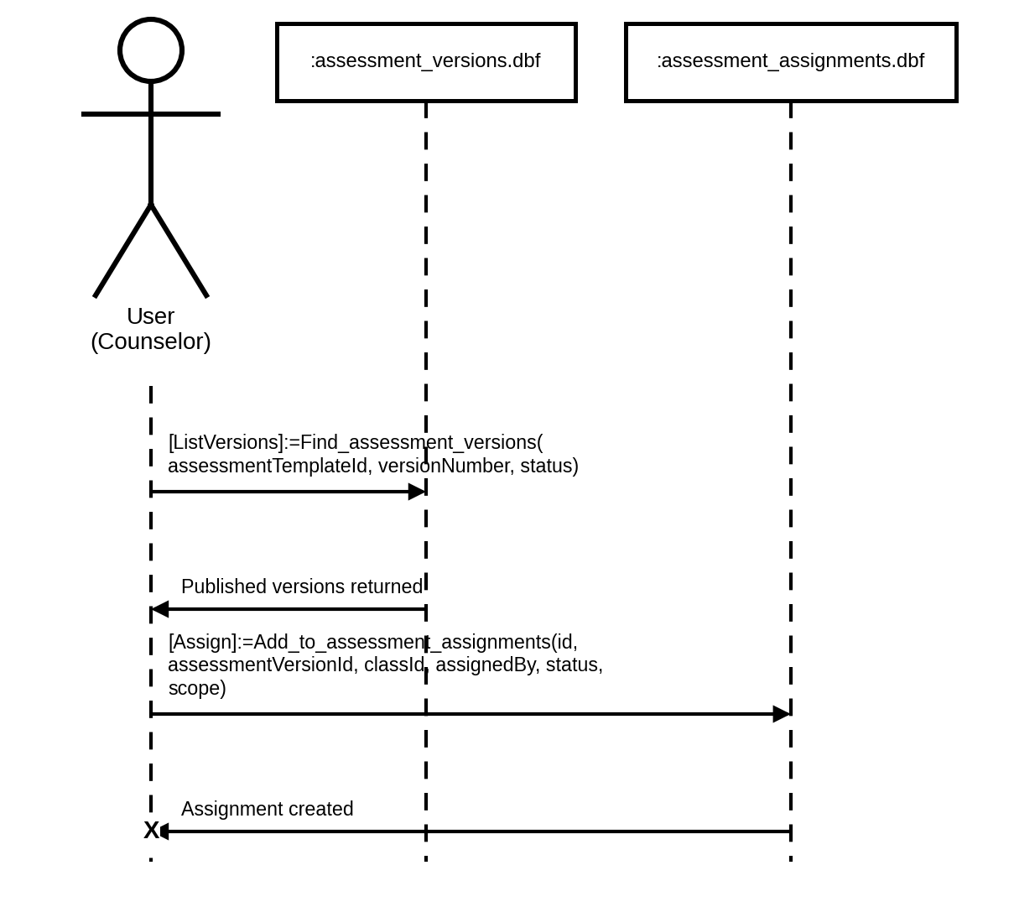
Figure 82. Sequence Diagram for Counselors Assigning Assessments
SEQUENCE DIAGRAM INVOLVING COUNSELORS AUTHORING A CUSTOM ASSESSMENT
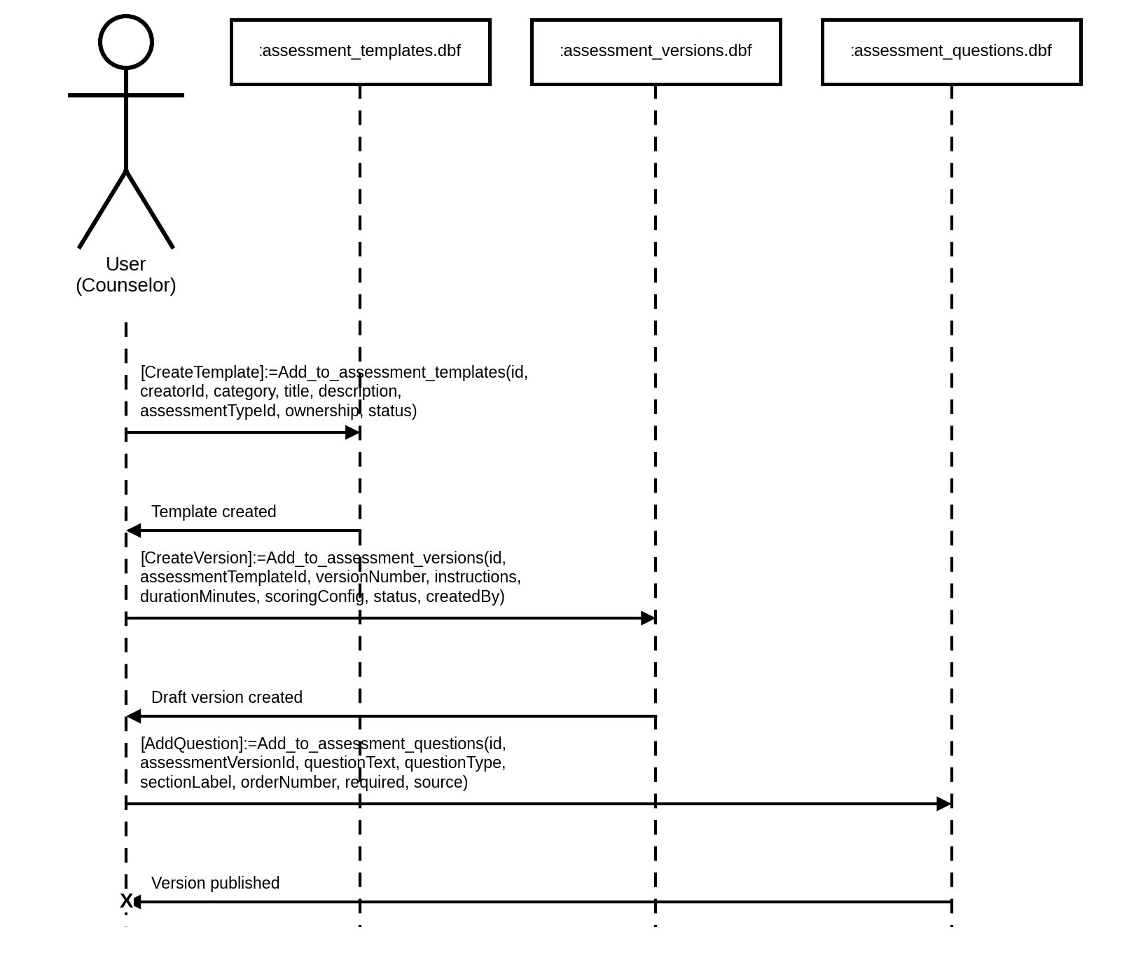
Figure 83. Sequence Diagram for Counselors Authoring a Custom Assessment
SEQUENCE DIAGRAM INVOLVING COUNSELORS GENERATING ITEMS WITH AI
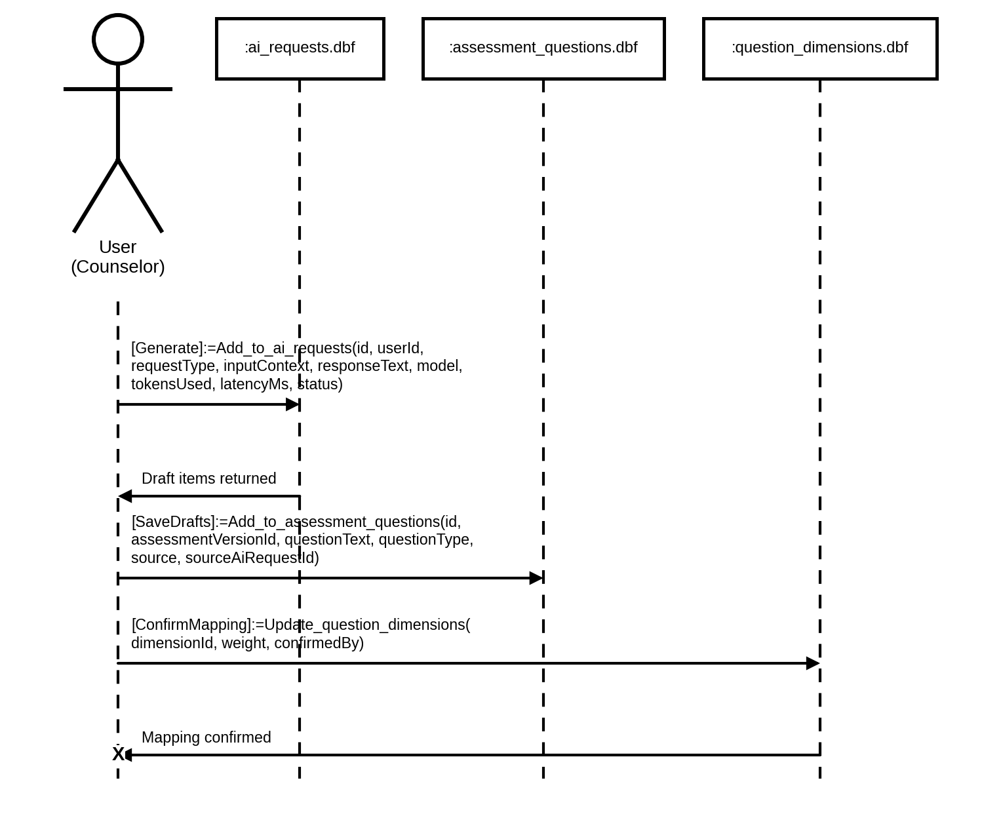
Figure 84. Sequence Diagram for Counselors Generating Items with AI
SEQUENCE DIAGRAM INVOLVING COUNSELORS MONITORING CLASS RESULTS
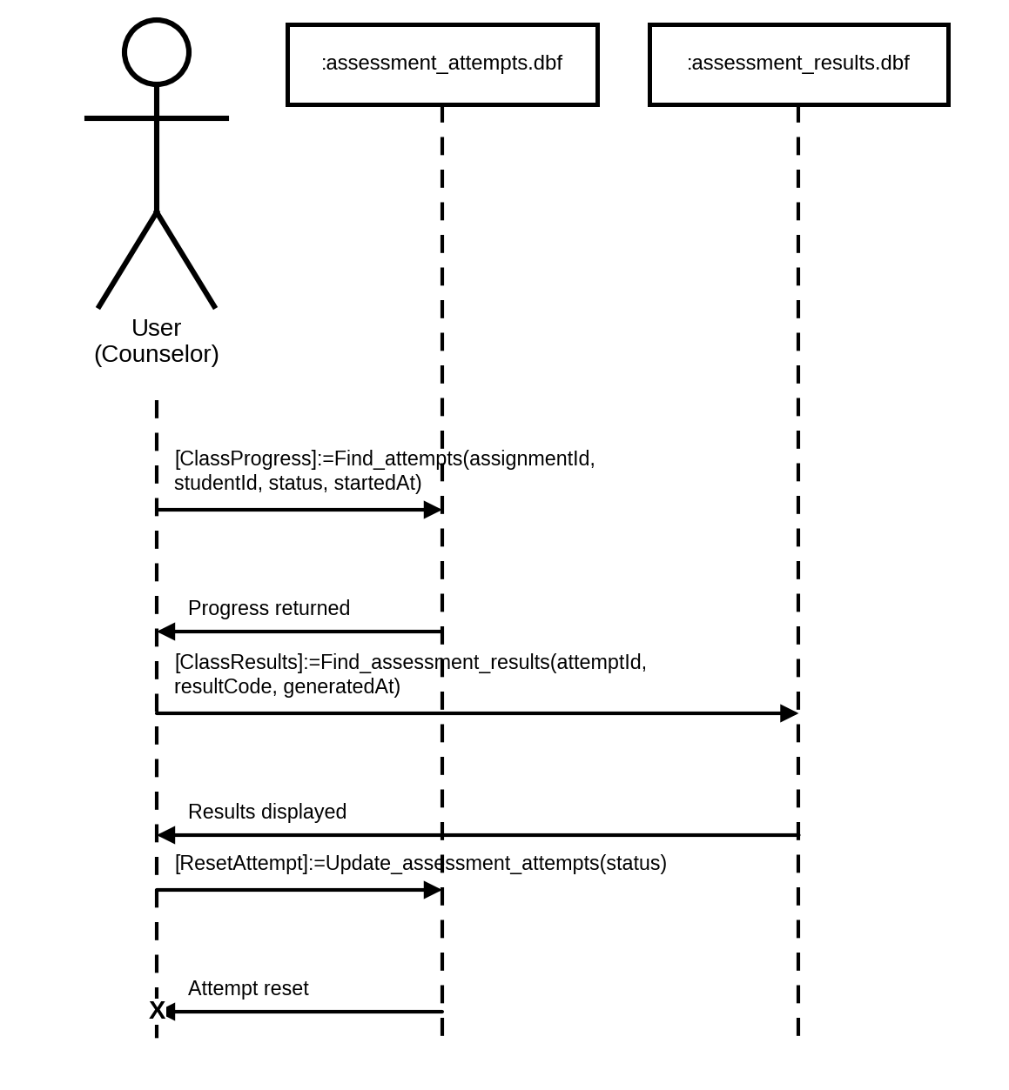
Figure 85. Sequence Diagram for Counselors Monitoring Class Results
SEQUENCE DIAGRAM INVOLVING COUNSELORS REVIEWING RECOMMENDATIONS
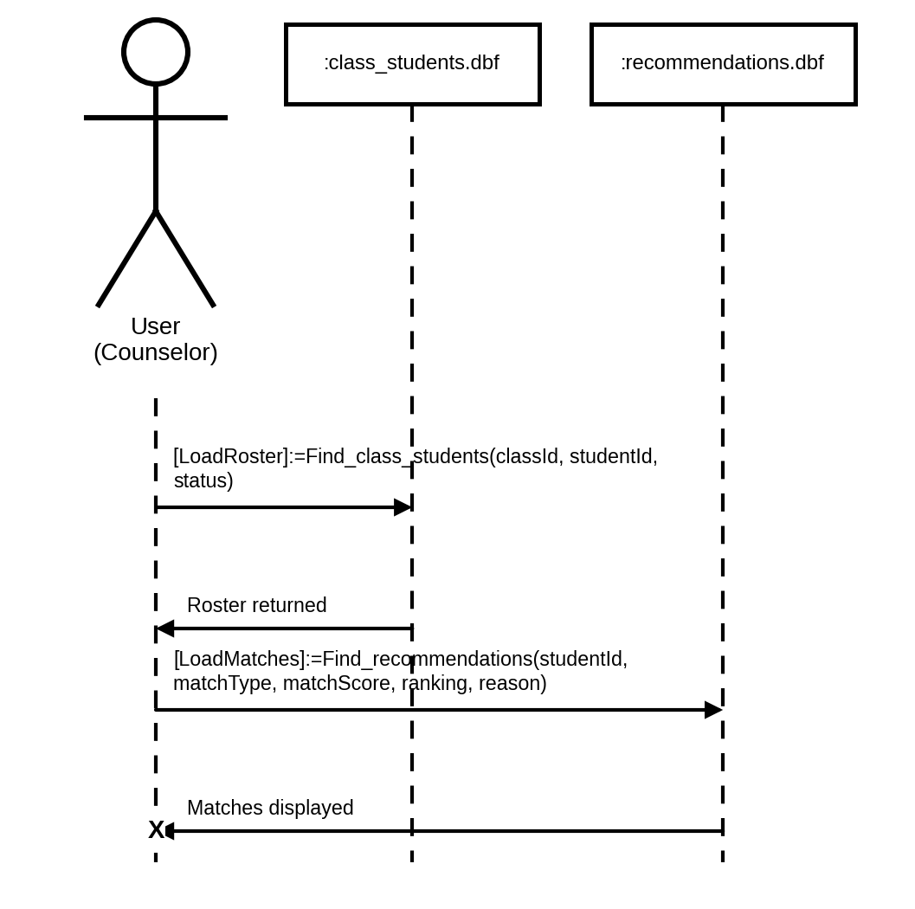
Figure 86. Sequence Diagram for Counselors Reviewing Recommendations
SEQUENCE DIAGRAM INVOLVING COUNSELORS VIEWING THEIR DASHBOARD
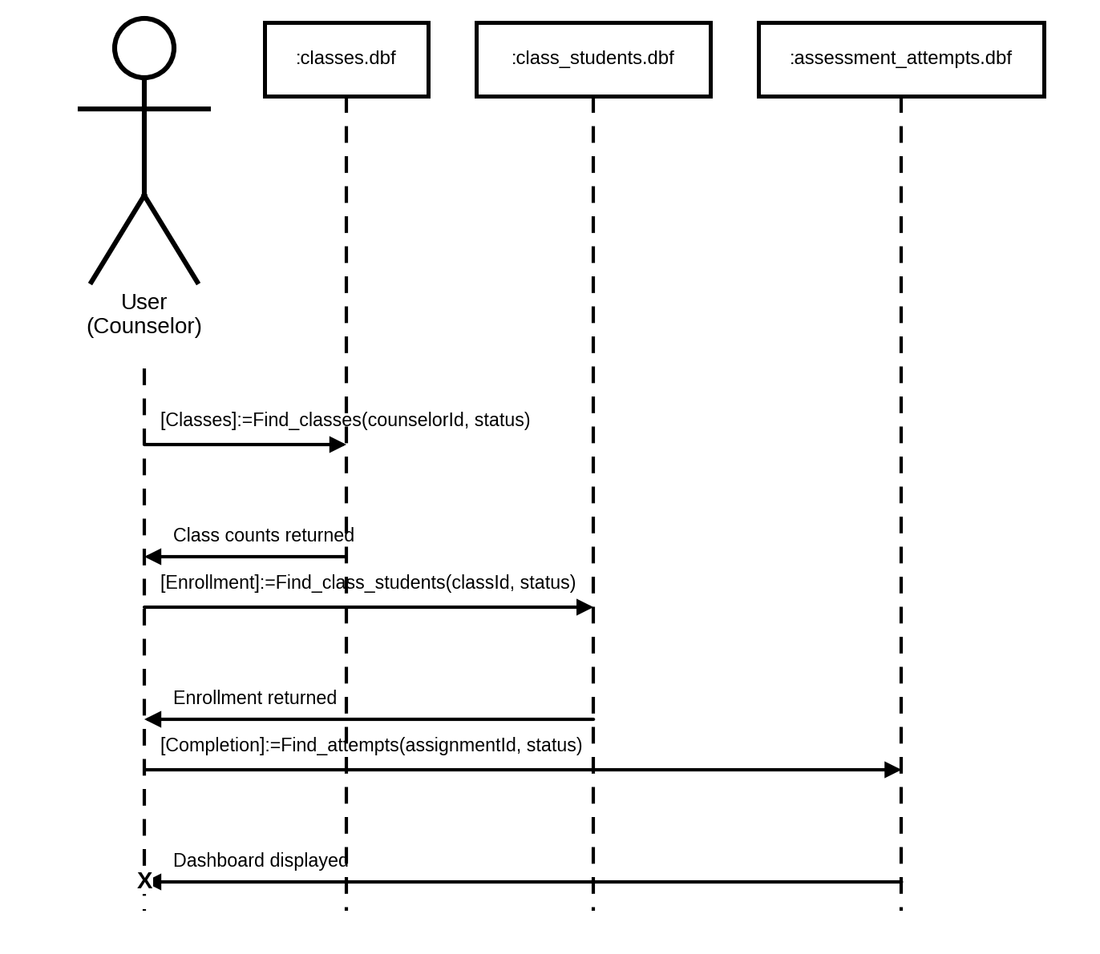
Figure 87. Sequence Diagram for Counselors Viewing Their Dashboard
SEQUENCE DIAGRAM INVOLVING ADMINISTRATORS LOGGING IN
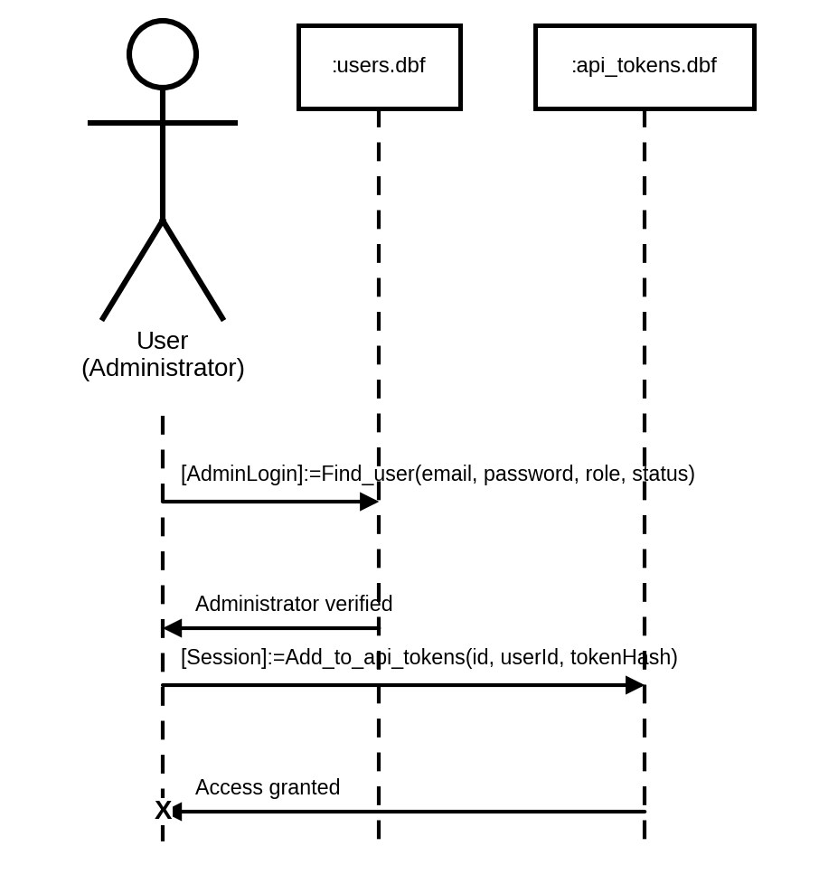
Figure 88. Sequence Diagram for Administrators Logging In
SEQUENCE DIAGRAM INVOLVING ADMINISTRATORS MANAGING COUNSELOR ACCOUNTS
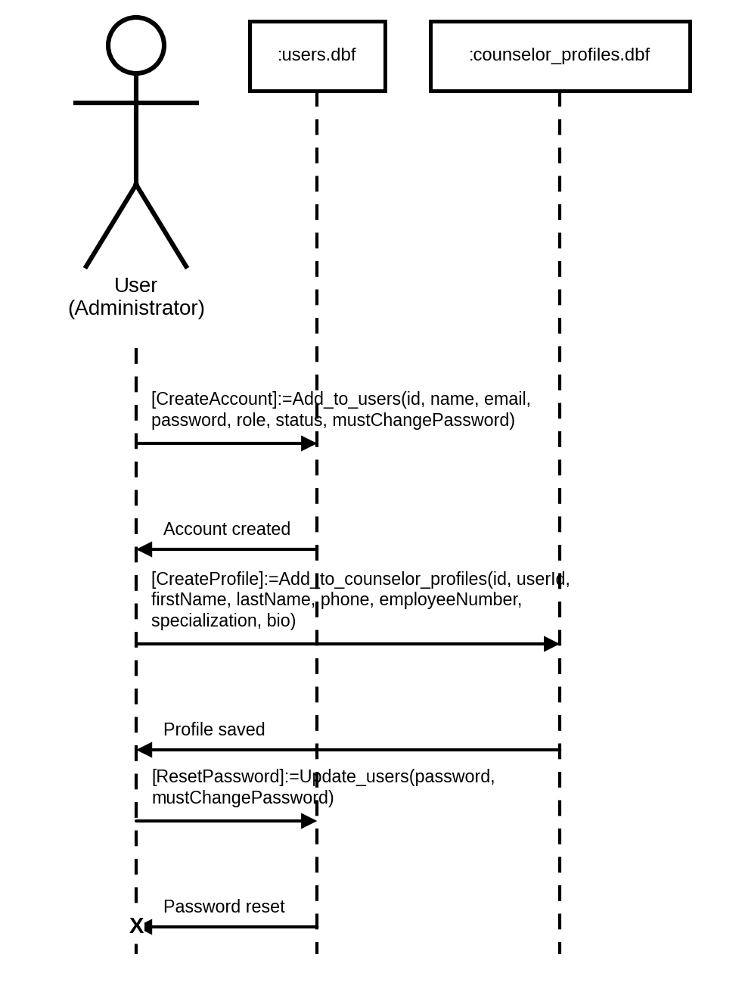
Figure 89. Sequence Diagram for Administrators Managing Counselor Accounts
SEQUENCE DIAGRAM INVOLVING ADMINISTRATORS MANAGING COLLEGES AND PROGRAMS
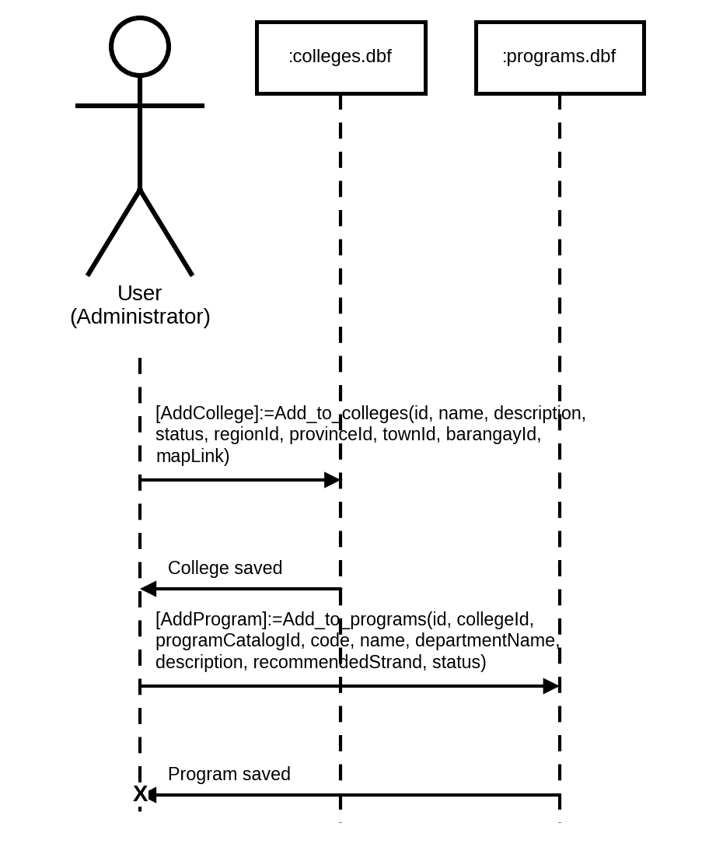
Figure 90. Sequence Diagram for Administrators Managing Colleges and Programs
SEQUENCE DIAGRAM INVOLVING ADMINISTRATORS MANAGING CAREERS
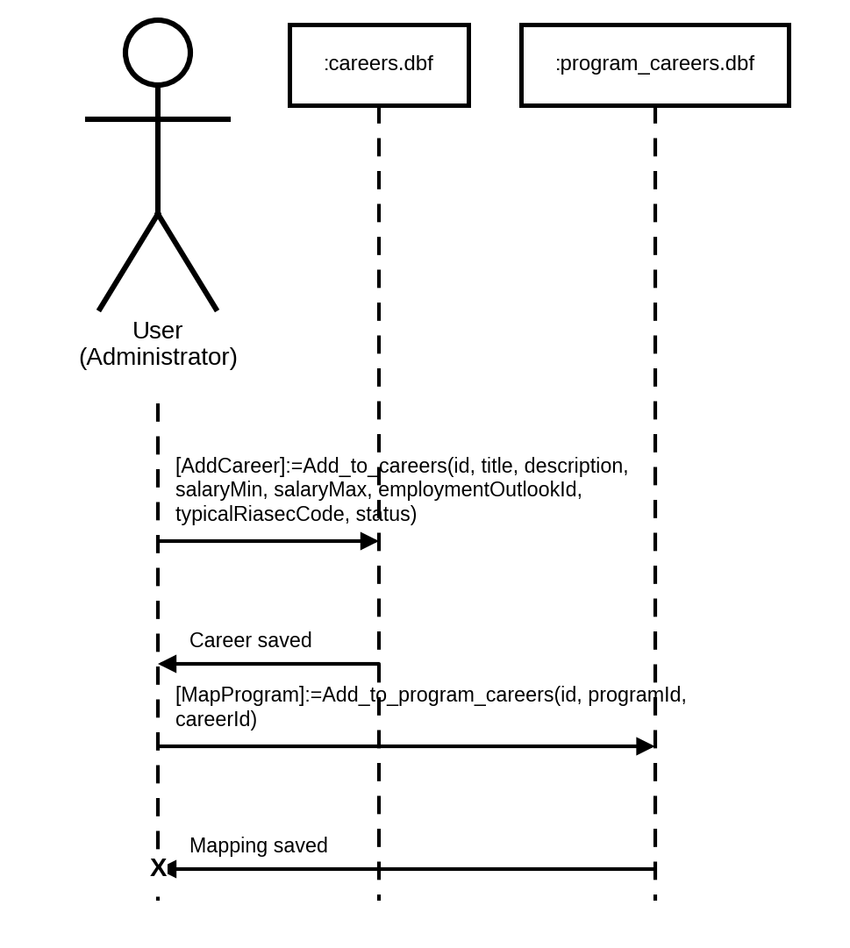
Figure 91. Sequence Diagram for Administrators Managing Careers
SEQUENCE DIAGRAM INVOLVING ADMINISTRATORS MANAGING CANONICAL PROGRAMS
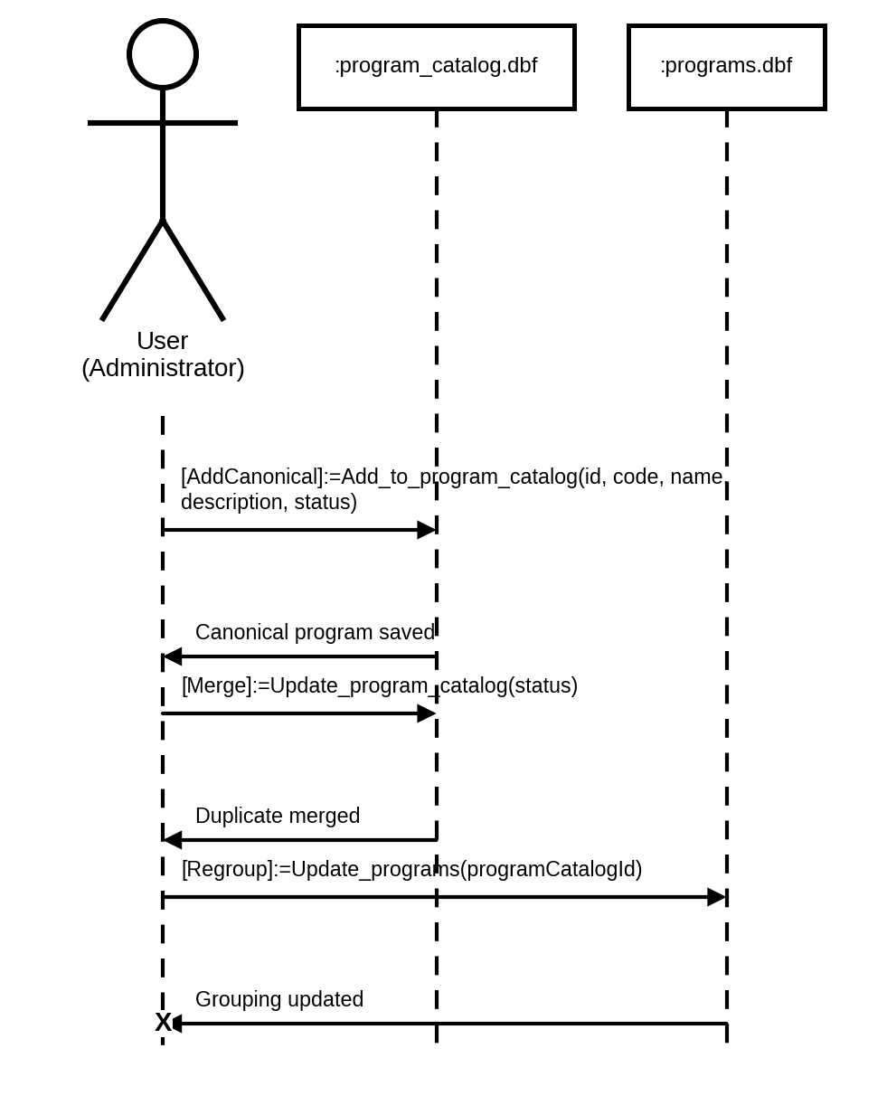
Figure 92. Sequence Diagram for Administrators Managing Canonical Programs
SEQUENCE DIAGRAM INVOLVING ADMINISTRATORS MANAGING ADDRESS RECORDS
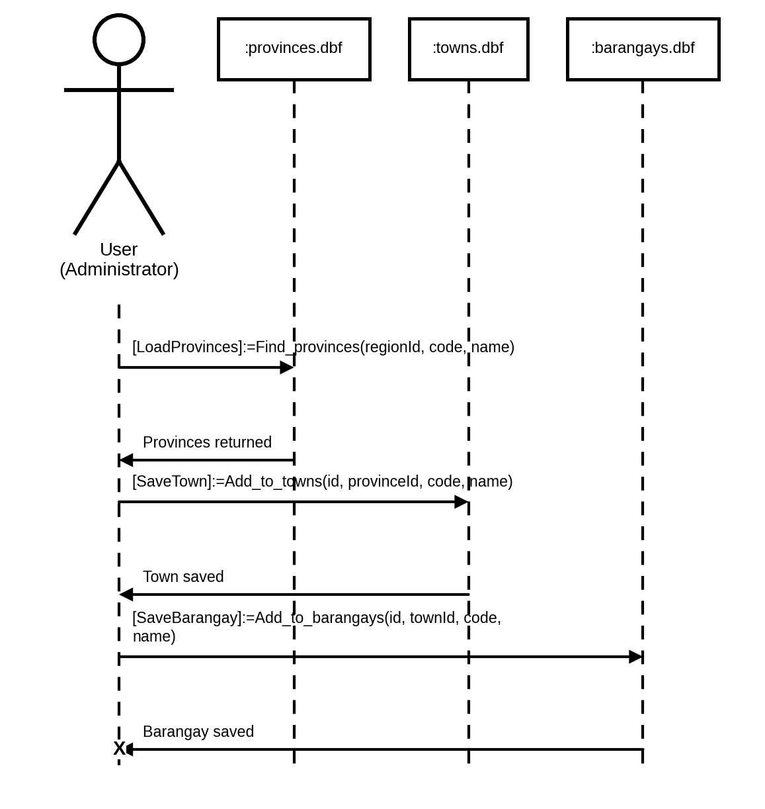
Figure 93. Sequence Diagram for Administrators Managing Address Records
SEQUENCE DIAGRAM INVOLVING ADMINISTRATORS MANAGING THE KNOWLEDGE BASE
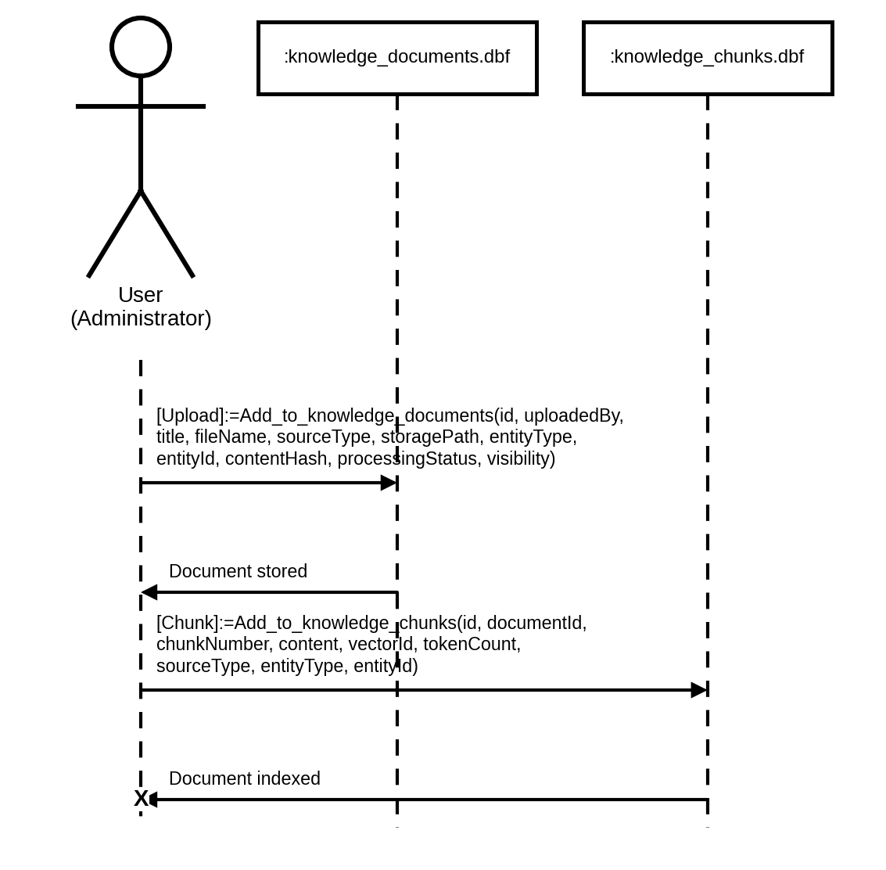
Figure 94. Sequence Diagram for Administrators Managing the Knowledge Base
SEQUENCE DIAGRAM INVOLVING ADMINISTRATORS MANAGING THE AI POLICY
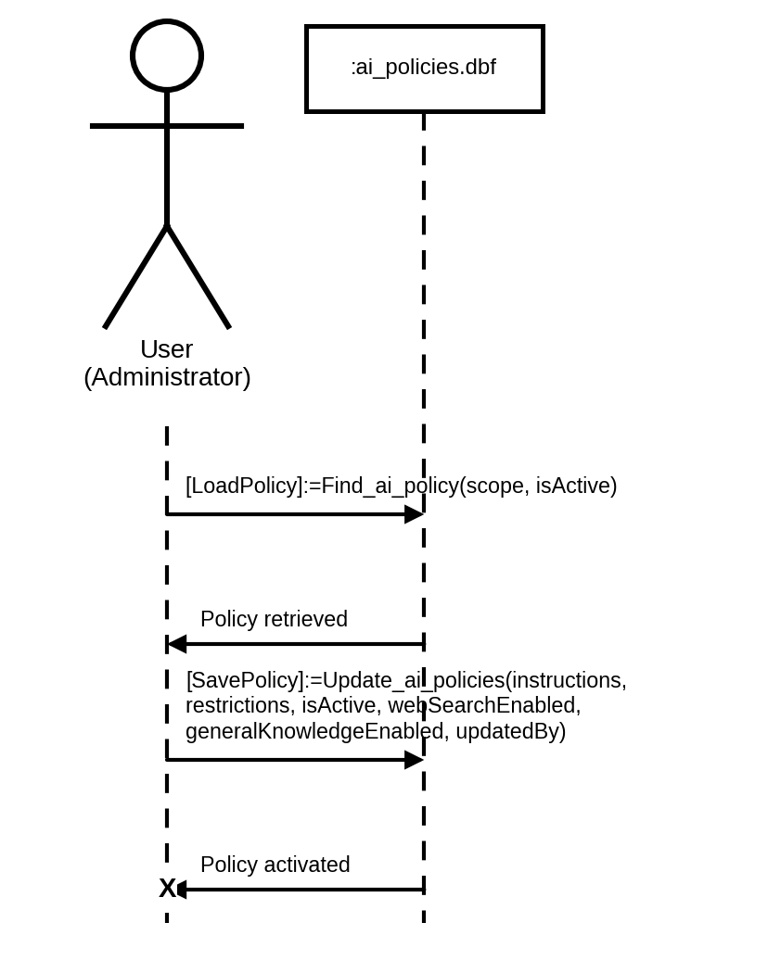
Figure 95. Sequence Diagram for Administrators Managing the AI Policy
SEQUENCE DIAGRAM INVOLVING ADMINISTRATORS MONITORING AI AND PLATFORM USAGE
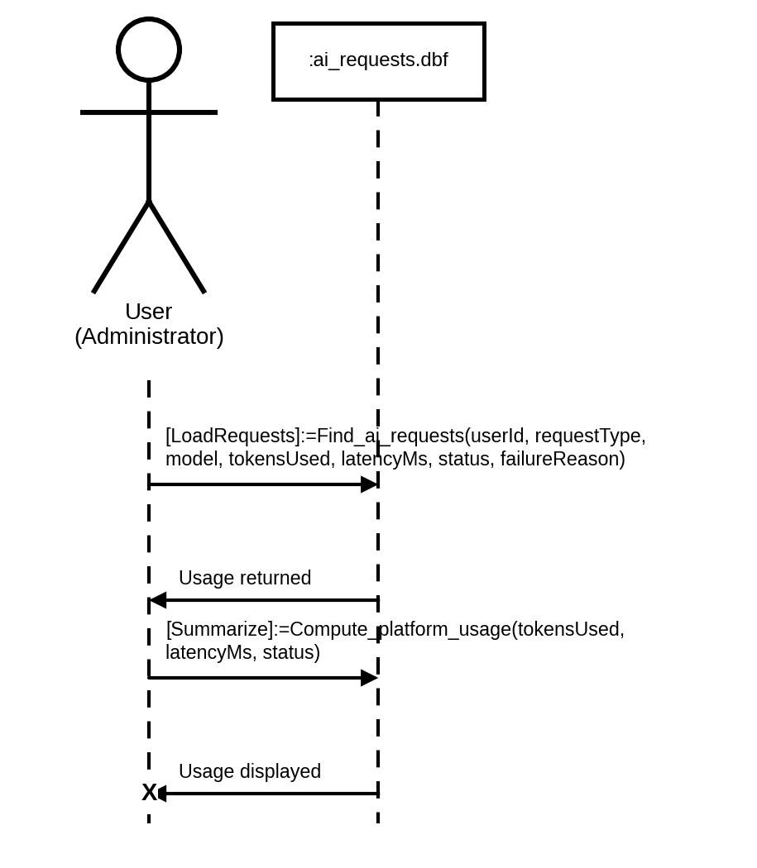
Figure 96. Sequence Diagram for Administrators Monitoring AI and Platform Usage
SEQUENCE DIAGRAM INVOLVING ADMINISTRATORS REVIEWING THE AUDIT LOG
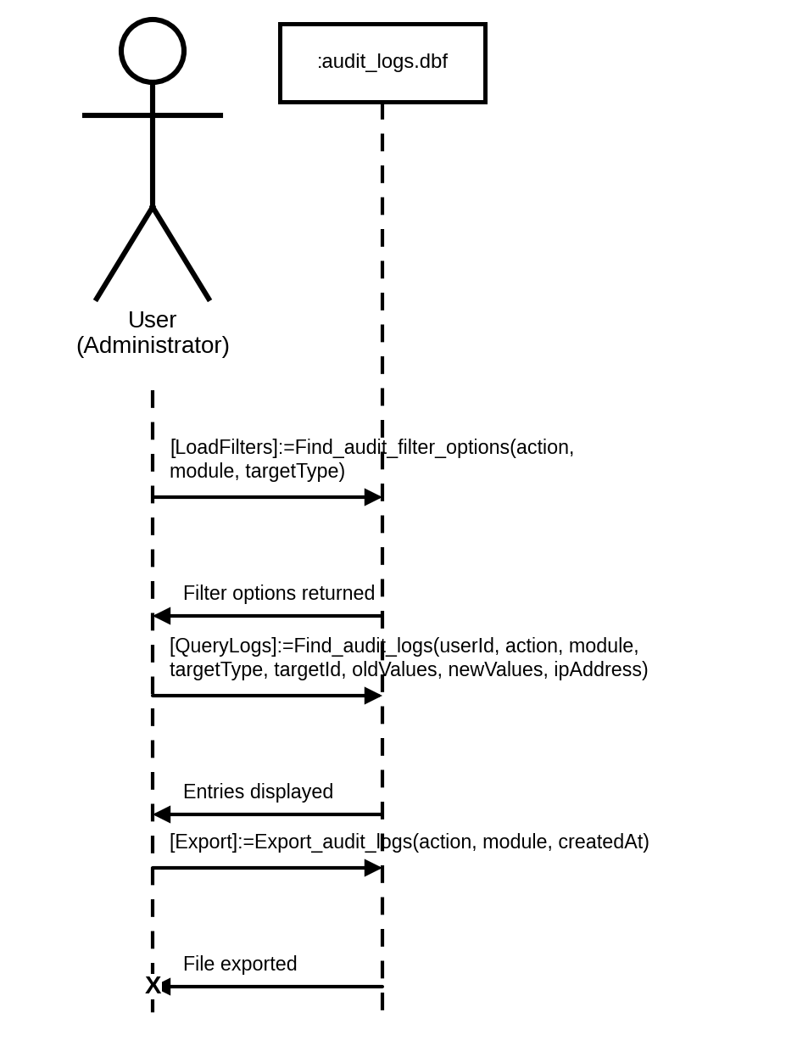
Figure 97. Sequence Diagram for Administrators Reviewing the Audit Log
REFERENCES
Acoba, E. A., Fuentes, N. A., & Jorda, J. L. (2023). An intelligent career guidance system for senior high school students using a rule-based expert system. International Journal of Advanced Computer Science and Applications, 14(6), 203–212. https://doi.org/10.14569/IJACSA.2023.0140621
Bandura, A. (1986). Social foundations of thought and action: A social cognitive theory. Prentice Hall.
Barrera, M. L. (2024). Career guidance programs and their impact on students' career decision-making readiness in Philippine secondary schools. Asia Pacific Journal of Education Research, 7(1), 22–38.
Faruque, M., Ahmed, S., & Rahman, T. (2024). Career prediction using natural language processing and machine learning for higher education students. IEEE Transactions on Learning Technologies, 17(2), 401–415. https://doi.org/10.1109/TLT.2024.3364721
Holland, J. L. (1997). Making vocational choices: A theory of vocational personalities and work environments (3rd ed.). Psychological Assessment Resources.
Ibrahim, M. (2023). Artificial intelligence in education: Principles, applications, and ethical considerations. Educational Technology Research and Development, 71(3), 1289–1315. https://doi.org/10.1007/s11423-022-10143-z
Jemini Gashi, L., Bërxulli, D., Konjufca, J., & Cakolli, L. (2023). Effectiveness of career guidance workshops on the career self-efficacy, outcome expectations, and career goals of adolescents: An intervention study. International Journal of Adolescence and Youth, 28(1), 689–702. https://doi.org/10.1080/02673843.2023.2281421
Lahoud, C., Daher, M., & Khalil, P. (2023). Comparative analysis of recommender system approaches in academic and career contexts. Computers & Education: Artificial Intelligence, 4, Article 100127. https://doi.org/10.1016/j.caeai.2023.100127
Lasselle, L., Schelfhout, S., Fonteyne, L., Kirby, G., Smith, I., & Duyck, W. (2021). An examination of gender imbalance in Scottish adolescents' vocational interests. PLOS ONE, 16(9), Article e0257723. https://doi.org/10.1371/journal.pone.0257723
Lee, S., Lee, Y., & Lim, H. (2021). Socioeconomic inequality and career guidance participation: Evidence from secondary school students. Journal of Career Development, 48(5), 672–688. https://doi.org/10.1177/0894845319895546
Lent, R. W., & Brown, S. D. (2019). Social cognitive career theory at 25: Empirical status of the interest, choice, and performance models. Journal of Vocational Behavior, 115, Article 103316. https://doi.org/10.1016/j.jvb.2019.06.004
Lent, R. W., Brown, S. D., & Hackett, G. (1994). Toward a unifying social cognitive theory of career and academic interest, choice, and performance. Journal of Vocational Behavior, 45(1), 79–122. https://doi.org/10.1006/jvbe.1994.1027
Lent, R. W., Brown, S. D., & Hackett, G. (2000). Contextual supports and barriers to career choice: A social cognitive analysis. Journal of Counseling Psychology, 47(1), 36–49. https://doi.org/10.1037/0022-0167.47.1.36
Nava-Macali, J. L., Tiangco, C. A., & Tus, J. (2019). Career development and guidance program: Its effects on the academic performance of senior high school students. International Journal of Research in Education, Humanities and Commerce, 1(2), 10–22.
Nguyen, T., Tran, L., & Vo, H. (2024). Personalized learning and recommendation system using hybrid filtering for educational platforms. Journal of Educational Data Mining, 16(1), 55–74.
Reddy, P., Chaudhary, K., & Hussein, S. (2025). AI-driven career guidance platforms: A systematic review of features, effectiveness, and ethical considerations. Computers & Education, 207, Article 104913. https://doi.org/10.1016/j.compedu.2024.104913
Singh, R., Rani, P., & Gupta, N. (2024). Course recommendation system using machine learning for higher education. Expert Systems with Applications, 241, Article 122589. https://doi.org/10.1016/j.eswa.2023.122589
Ullauri, J., Soria, K., & Terán, L. (2025). Soft skills-based academic and career recommender system using psychometric modeling and machine learning. Education and Information Technologies, 30(2), 1875–1899. https://doi.org/10.1007/s10639-024-12975-8
Uyen, B. P., & Thu, N. T. A. (2025). Career guidance programs and student preparedness for higher education: Evidence from Vietnamese secondary schools. Education Sciences, 15(1), 34. https://doi.org/10.3390/educsci15010034
Wang, D., Liu, X., & Deng, H. (2022). The perspectives of the social cognitive career theory approach in current times. Frontiers in Psychology, 13, Article 1023994. https://doi.org/10.3389/fpsyg.2022.1023994
Wei, R. (2024). Examining the influence of the RIASEC theory within the Holland code on students' academic performance in their chosen disciplines in the context of higher education. Cogent Education, 11(1), Article 2391274. https://doi.org/10.1080/2331186X.2024.2391274
Zeb, S., Akbar, A., & Hussain, A. (2021). Teacher as a career role model: How teachers' guidance shapes students' career aspirations. Journal of Education and Practice, 12(9), 107–117.

